

**Payments Plugin for**

**Magento 2**

User guide

Version 2.4.6-p8

January 2025

Contents

Introduction 5

Overview of features 5

Before you start 6

How to get started 6

If you need support 7

Basic configuration 7

Main configurations 10

Credit card configurations 10

Order notifications 11

Intelligent Account Verification (IAV) 12

How to configure 3DS 16

Activate 3DS 16

Credit card configurations 20

Previously saved card not working after 3DS2 activation 20

US and Canadian domestic acquiring 20

Issuer Insights 20

ACH Direct Debit (USA Only) 21

Prime Routing (USA Only) 28

Level 2/3 Data 32

Latin American payments 36

Latin America configurations 36

The shopper’s experience 39

Recommendation for Brazil only 40

Exemption engine 41

How to configure the Exemption Engine 41

FraudSight 42

Configure Fraudsight 42

FraudSight Response 42

Order Review 44

Errors 44

Capture 45

Tokenization and stored credentials 46

How to configure tokenization and stored credentials 46

The shopper’s experience with stored credentials enabled 48

Hosted payment page 53

Hosted payment page with 3D Secure 57

Mobile Wallets 58

Apple Pay 58

Apple Pay HPP 65

Google Pay 69

Samsung Pay 77

Chrome Pay: payment request API 84

MOTO payments 87

Alternative payment methods 89

Dynamic narratives 90

The shopper’s experience 90

Payment XML changes 91

KLARNA 92

Klarna configurations 92

Message Code 95

The shopper’s experience 98

How to configure instant purchase 100

How to set up Instant Purchase 100

Multiple partial capture 103

Implementing multiple partial capture 103

How to execute partial capture from Magento 103

Merchant profile override 106

How to synchronize order status with Worldpay 106

Executing the cron job for Worldpay-specific orders 107

How to set up cron jobs in periodic time 108

Dynamic currency exponents 108

How to setup dynamic exponent 108

How to setup currency code exponents 109

Subscriptions and recurring payments 110

How to configure subscription and payment plans 111

The shopper’s experience 113

Recurring orders 114

Country-code spoofing 115

How does it work? 115

Configurable alert messages 116

How to set up configurable alerts 116

The shopper’s experience 117

Extended response codes 118

How to customize Worldpay response messages 118

The shopper’s experience 119

Configurable labels 120

Checkout Labels 120

My account labels 120

Admin labels 121

Custom logo for payment 123

Global APM API Call 124

Worldpay API security alerts 124

Worldpay Multi Shipping 125

The shopper’s experience 125

Worldpay Pay by Link 127

The shopper’s experience 127

Eftpos Payments Australia 132

Admin Configuration 132

Least Cost Routing 133

3ds Process 133

The Shopper’s Experience: 135

Invoice Processing, Shipments, Refunds: 135

How to report bugs 136

# Introduction

The Worldpay Payments Plugin for Magento 2 is highly customisable and offers a comprehensive suite of payment and admin features, and we built it with your integration and business needs in mind. It features:

* **Quick and easy installation**. Clear, succinct documentation enables developers to be as productive as possible
* **Lowest possible PCI DSS burden**. We’ll help you reach and maintain compliance with minimum effort
* **Full support whenever you need it**. Our support teams are there for you – 24/7 for payment incident support and 24/5 for any other issues. Please get in touch with your Worldpay support contact. If they’re not available, call our customer service team on 0800 096 3997.

## Overview of features

The table below lists the main features of our plugin.

|  |  |
| --- | --- |
| **Features** | **Description** |
| **Supported credit cards** | Visa, MasterCard, Maestro, American Express, Diners, Discover,  JCB, Carte Bancaire, Carte Bleue, Dankort |
| **3DS authentication** | 3D Secure authentication (strong customer authentication) for direct credit card integration and hosted payment pages. |
| **Exemption engine** | Request real-time risk analysis of transactions to exempt as many as possible from strong customer authentication. |
| **Tokenization** | Token creation for sending authorization requests with stored card details that are PCI compliant. |
| **Stored credentials** | With detailed ways of improving authorisation rates and ensuring compliance. |
| **Stored credentials: disclaimer message** | Ask for shoppers’ consent before saving their card during checkout. |
| **Hosted payment page** | Redirection to the PCI-compliant payment page that Worldpay hosts. |
| **Apple Pay and Google Pay** | Process Apple Pay and Google Pay payments. |
| **Google Chrome: payment service API** | A payment service API for Chrome that helps shoppers with express checkout. |
| **MOTO** | Your customer service team can make mail orders and telephone orders using the Create Order interface in Magento. |
| **Supported APMs** | PayPal, Klarna, Union Pay, IDEAL, Qiwi, Yandex, GiroPay, Boleto  Bancairo, AliPay, SEPA, P24, Mistercash/Bancontact, Sofort/Pay.Now |
| **Instant page checkout** | Express checkout |
| **Multiple partial capture** | Support for multiple partial capture with Worldpay, allowing you to ship goods as they are available and capture only the funds required at that time. |
| **Merchant profile override** | Override your merchant profile so you can (for example) support different payment methods in different stores using one merchant ID. |
| **Repeat payments** | Support for regular payments (such as subscriptions) and for recurring orders. |

## Before you start

**Prerequisite**: You need to have installed and correctly set up your Magento 2 store. If you have any problems with your Magento set-up, please visit the [Magento support centre.](https://support.magento.com/hc/en-us)

## How to get started

Make sure your Implementation Manager or support contact has given you:

* A merchant code (or codes)
* A username and password for the [Worldpay Merchant Administration Interface](https://secure-test.worldpay.com/sso/public/auth/login.html?serviceIdentifier=merchantadmin)

Once you receive your login credentials to login to the [Merchant Administration Interface,](https://secure-test.worldpay.com/sso/public/auth/login.html?serviceIdentifier=merchantadmin) follow the steps below to configure your XML connection credentials:

1. Click **ACCOUNT**, then select **Profile** from the top menu.
2. Note your new username for the connection.
3. Click the pencil icon next to **XML Password**.
4. Enter your new password and click **Save XML Password.**

## If you need support

Please get in touch with your Worldpay support contact. If they’re not available, call our customer service team on 0800 096 3997.

# Basic configuration

After you’ve installed the extension, follow this menu path to configure it:

Stores/Configuration/Sales/Worldpay

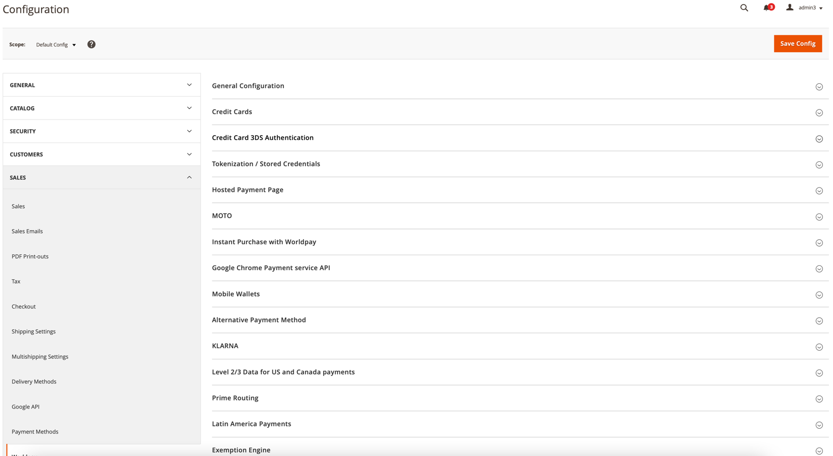

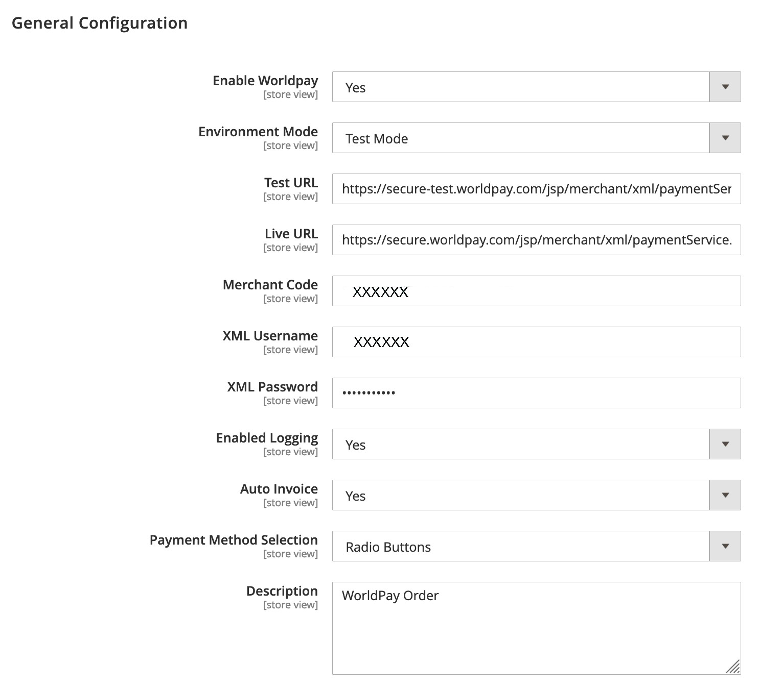

The table below describes all the fields, and what you’ll need to input to complete basic configuration.

|  |  |
| --- | --- |
| **Features** | **Description** |
| **Enable Worldpay** | When set to **Yes**, shoppers will be able to process transactions using the Worldpay Payment Gateway at checkout. |
| **Environment Mode** | Toggles between test and live modes. Set it to **Live** after testing is completed and before production launch. |
| **Test URL** | The Worldpay test environment’s URL. |
| **Live URL** | The Worldpay production environment’s URL. |
| **Merchant Code** | Your Worldpay merchant code, which your Worldpay support contact provides. |
| **XML Username** | Your Worldpay XML username, which you will find in [the Worldpay Merchant Admin Interface.](http://support.worldpay.com/support/kb/gg/merchantadmininterface/Merchant%20Interface%20Guide.htm?_ga=2.23790074.1103078547.1565872530-1698651642.1565872530#html_files/using_the_merchant_admin_interface.htm%3FTocPath%3D_____1) |
| **XML Password** | Your Worldpay XML password, which you can set in [the Worldpay Merchant Admin Interface.](http://support.worldpay.com/support/kb/gg/merchantadmininterface/Merchant%20Interface%20Guide.htm?_ga=2.23790074.1103078547.1565872530-1698651642.1565872530#html_files/using_the_merchant_admin_interface.htm%3FTocPath%3D_____1) |
| **Enable Logging** | If this is enabled, all requests and responses, along with other debug information, are logged at the **Magento2Root/var/log/worldpay.log** file. You should disable logging on production and enable it on staging for debugging. If you are troubleshooting, you might be asked to enable this feature. |
| **Auto Invoice** | If set to **Yes**, Magento automatically creates an invoice. This occurs so long as Worldpay authorises the transaction and sends a Capture request. If set to **No**, an invoice will not be created until a capture order notification is received. |
| **Payment Method Selection** | This has two options: payment methods can either be displayed as radio buttons or dropdowns in the payment section. |

# Main configurations

## Credit card configurations

The screenshot and the table below it describe your options for setting credit card configurations. The blue highlighted fields in the screenshot below show that you can select multiple items.

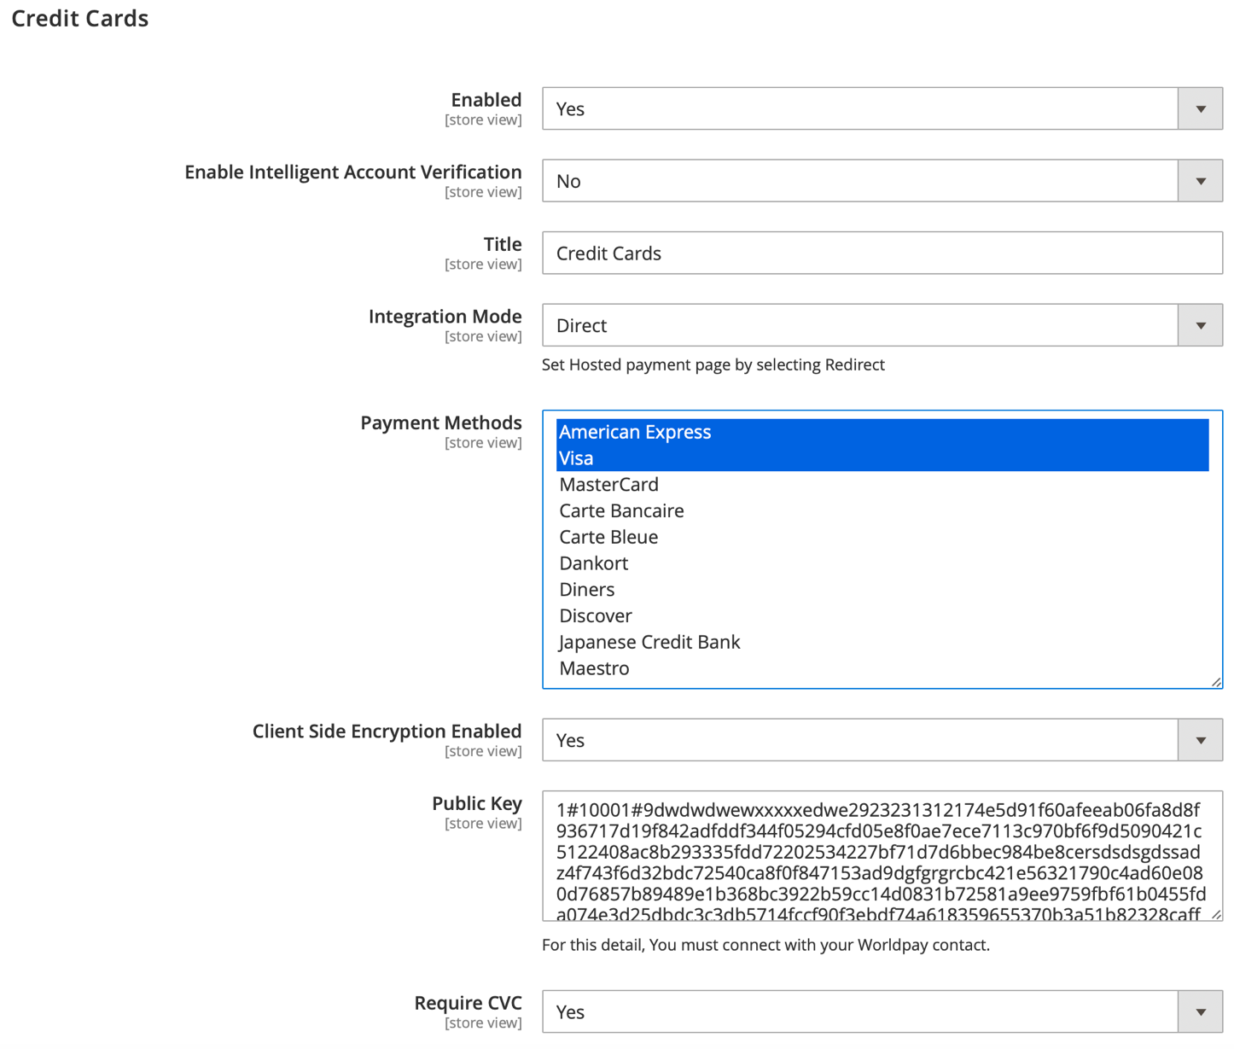

|  |  |
| --- | --- |
| **Credit card configuration** | **Description** |
| **Enabled** | When set to **Yes**, credit card payments are available to shoppers at checkout. |
| **Enable Intelligent Account Verification** | When set to **Yes**, Intelligent Account Verification (IAV) feature will validate a credit card using zero/nominal auth. |
| **Title** | The title that appears above the credit card payment section at checkout. |
| **Integration Mode** | There are two integration modes for credit cards:   1. **Direct integration mode**   Card information is saved at the Magento online store and passed to Worldpay by server-to-server transfer in XML format. No card information is saved by the Worldpay plugin. This integration requires the highest level of PCI DSS compliance.   1. **Redirect integration mode**   The shopper will be redirected to the Worldpay payment page, and their card information will be captured at the Worldpay end. This integration requires the lowest level of PCI DSS compliance. |
| **Payment Methods** | Select which credit cards are available to shoppers at checkout. |
| **Client Side Encryption Enabled** | If enabled, all card details are securely transferred to Worldpay in encrypted format. This is only required when using the direct integration mode. Using CSE with direct integration reduces the level of PCI DSS compliance that’s required. |
| **Public Key** | Only required if client-side encryption is enabled. You can get this key from the [Worldpay Merchant Admin Interface.](http://support.worldpay.com/support/kb/gg/merchantadmininterface/Merchant%20Interface%20Guide.htm?_ga=2.23790074.1103078547.1565872530-1698651642.1565872530#html_files/using_the_merchant_admin_interface.htm%3FTocPath%3D_____1) If you do not see the option for it, contact your Worldpay representative for help. |
| **Require CVC** | If enabled, a mandatory CVC form field appears in the card-detail entry form. |

### Order notifications

Note: You must set up order notifications to make sure this plugin works properly.

Order notifications are transaction-status updates that Worldpay pushes to the Magento store.

To enable your Magento store to receive order notifications, you need to enter the URL below in your Worldpay merchant profile:

https://<brand url>/worldpay/notification/index

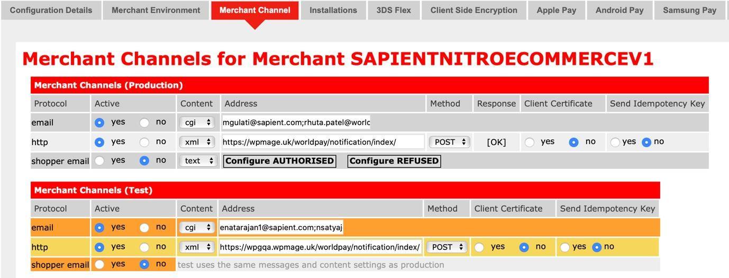

If transactions are being processed asynchronously, you may notice some details of the transaction among your Magento order details.

The fully updated order details (Sales/Orders/Order View/Information) appear after Magento has received the order notification from Worldpay. Under **Payment Information** you should see:

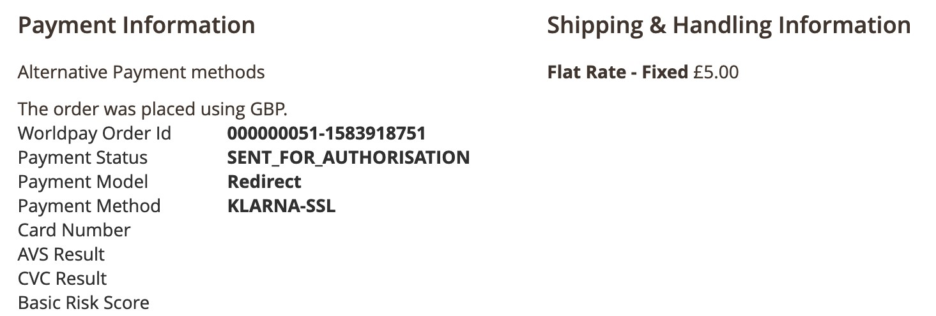

### Intelligent Account Verification (IAV)

Intelligent Account Verification (IAV) is a feature to validate a credit card.

Cardholders submit a zero or nominal value (a payment with a value greater than zero) while Worldpay determine the amount with the best chance of approval. Any value above zero is automatically reversed following verification.

The processing of a nominal value (or zero) is an important part of verifying that an account is real and set up for transactions. Contact Worldpay Support to enable IAV for your company or organization.

##### How to configure IAV

Follow the steps below:

1. Go to Admin > Configuration->Sales->Worldpay->Credit Cards->Enable Intelligent Account Verification. The screen should appear similar to the screenshot below.

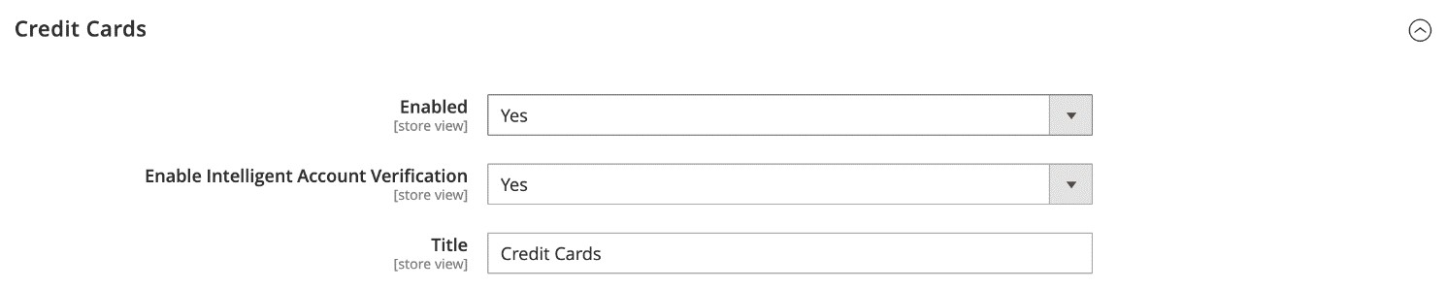

The shopper can save a new card through Intelligent Account Verification or through zero-authorization.

All form validations are handled through Custom labels and Custom Alert messages.

To configure alerts/show customized messages, do the following:

1. Go to Store/Settings/Configuration/Sales/Worldpay Exception Codes.
2. The default alert messages are under *Customize Account Level Messages*. You can customize these messages and the custom message box.

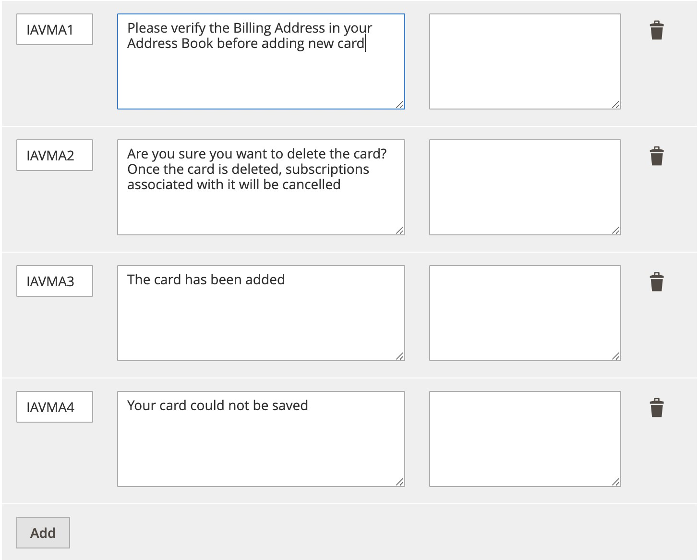

1. Click **Save Config** after updating the configurations.

Use the information in the table below to add the configurations above.

|  |  |  |
| --- | --- | --- |
| **Message Code** | **Actual Message** | **Custom Message** |
| **IAVMA1** | Please verify the Billing Address in your  Address Book before adding new card |  |
| **IAVMA2** | Are you sure you want to delete the card? Once the card is deleted, subscriptions associated with it will be cancelled |  |
| **IAVMA3** | The card has been added |  |
| **IAVMA4** | Your card could not be saved |  |

##### Manage/Customize labels

To manage/customize labels do the following:

1. Go to Store/Settings/Configuration/Sales/Worldpay Custom Labels.
2. The default labels are under *My Account Labels*, you can customize these labels as well as the custom message box.

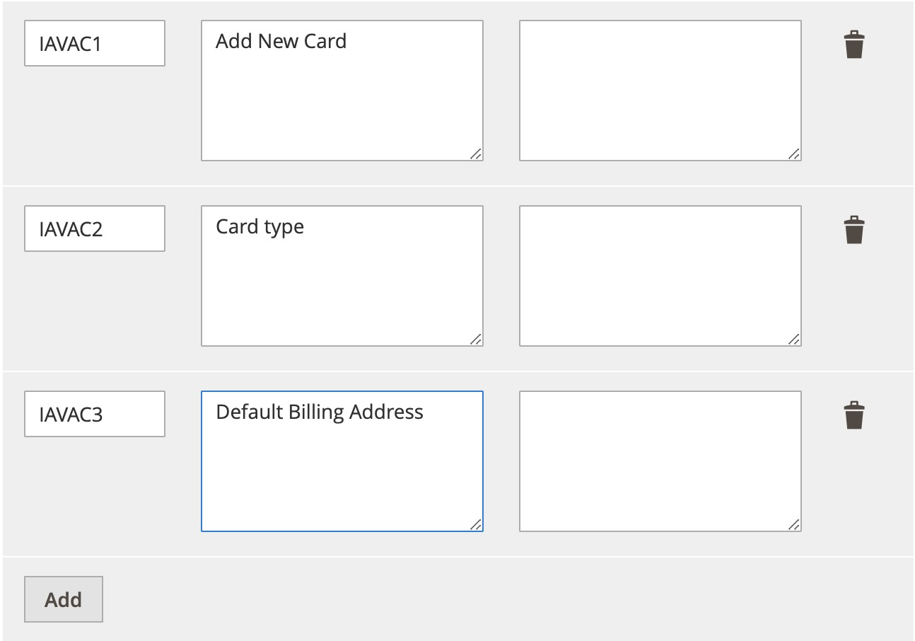

1. Click **Save Config** after updating the configurations.

Use the information in the table below to add or update the above configurations.

|  |  |  |
| --- | --- | --- |
| **Message Code** | **Actual Message** | **Custom Message** |
| **IAVAC1** | Add New Card |  |
| **IAVAC2** | Card type |  |
| **IAVAC3** | Default Billing Address |  |

##### Shopper experience

A new form is added for saving new credit cards under Login->My Account->Saved cards->Add new card. See the screenshot below.

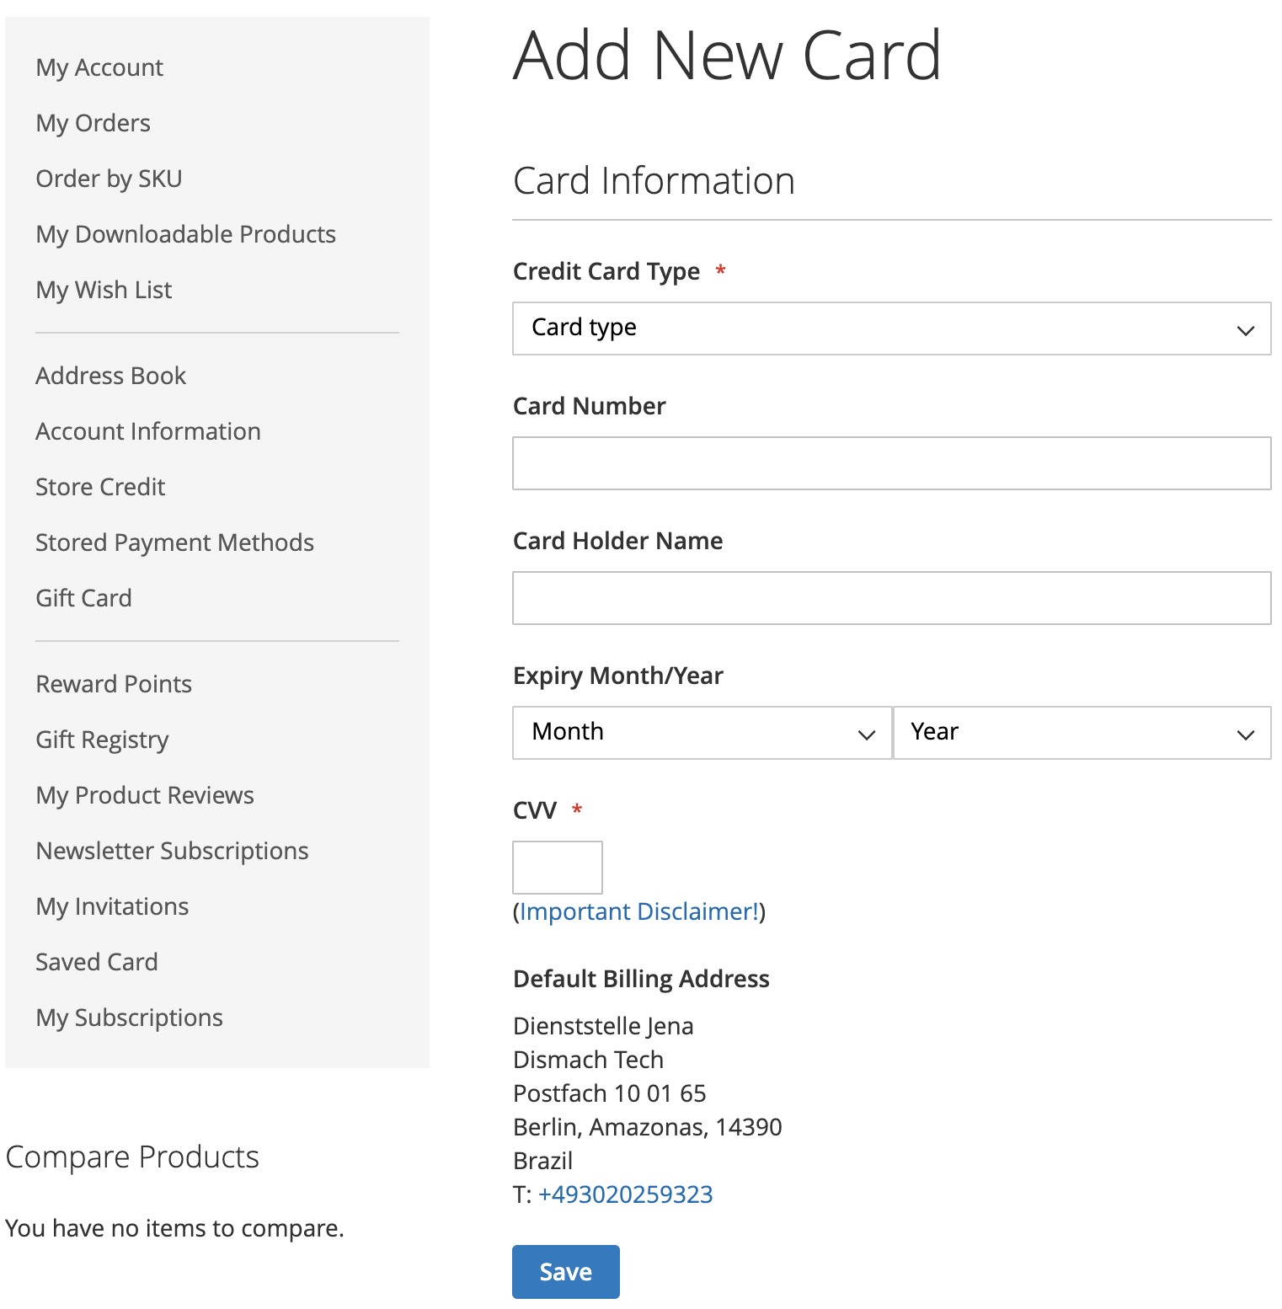

##### Key XML update

Worldpay IAV with zero authorisation amount for saving new card.

<paymentDetails action="ACCOUNTVERIFICATION">

<amount currencyCode="EUR" exponent="2" value="0"/>

The card is saved if ((lastEvent == 'AUTHORISED') || ((lastEvent == 'CANCELLED') &&

(riskScore[value] < 100 || riskScore[finalScore]< 100)) ) else, card is not saved in shoppers account.

Note: IAV works with AVS, CVC, 3DS, and checks made by a Worldpay fraud detection service, where available.

## How to configure 3DS

3DS Flex is the most advanced product on the market for 3-D Secure (3DS). It helps to increase issuer approvals for transactions affected by PSD2. For full details, and to download the user PDF, visit the [3DS Flex web page.](https://www.fisglobal.com/en-gb/merchant-solutions-worldpay/products/3ds-flex)

To use 3DS authentication, you must enable and configure 3DS at

Admin/Stores/Configuration/Sales/Worldpay

Under the Credit Card 3DS Authentication tab you will see the following 3DS configuration panel:

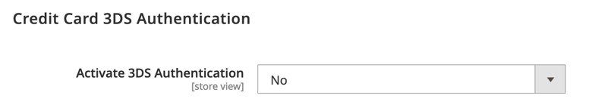

### Activate 3DS

1. Set **Activate 3DS Authentication** to **Yes** or **No.**

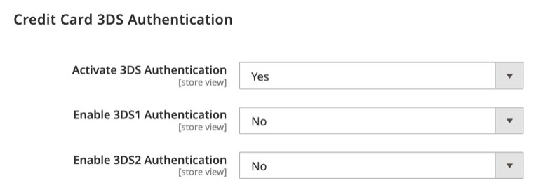

1. If **Activate 3DS Authentication** is set to **Yes**, then set **Enable 3DS1 Authentication** to **Yes** or **No.**

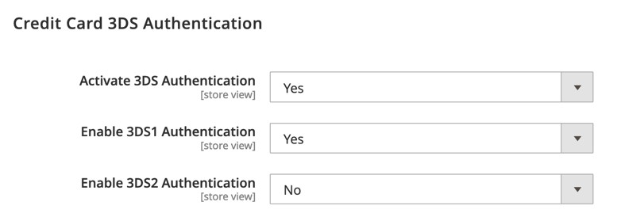

1. If **Activate 3DS Authentication** and **Enable 3DS1 Authentication** are both set to **Yes**, then set **Enable 3DS2 Authentication** to **Yes** or **No.**

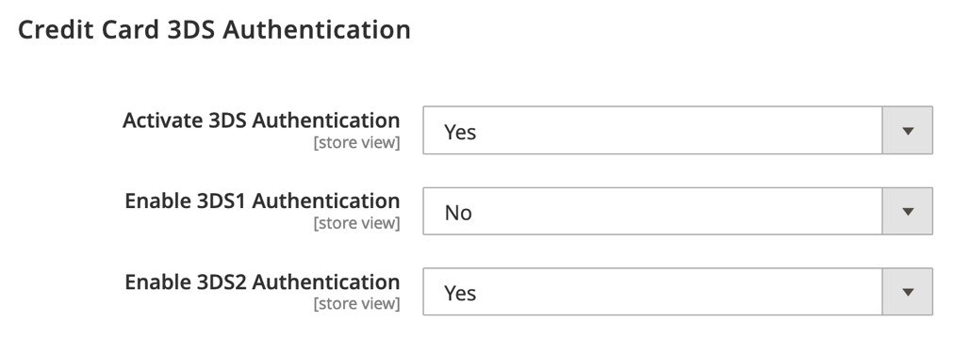

1. If Activate 3DS Authentication is set to Yes, Enable 3DS1 Authentication is set to No, and Enable 3DS2 Authentication is set to Yes, you can then configure 3DS2.

**Note**: If you enable both 3DS1 and 3DS2, the Worldpay gateway will detect the right authentication for the credit card.

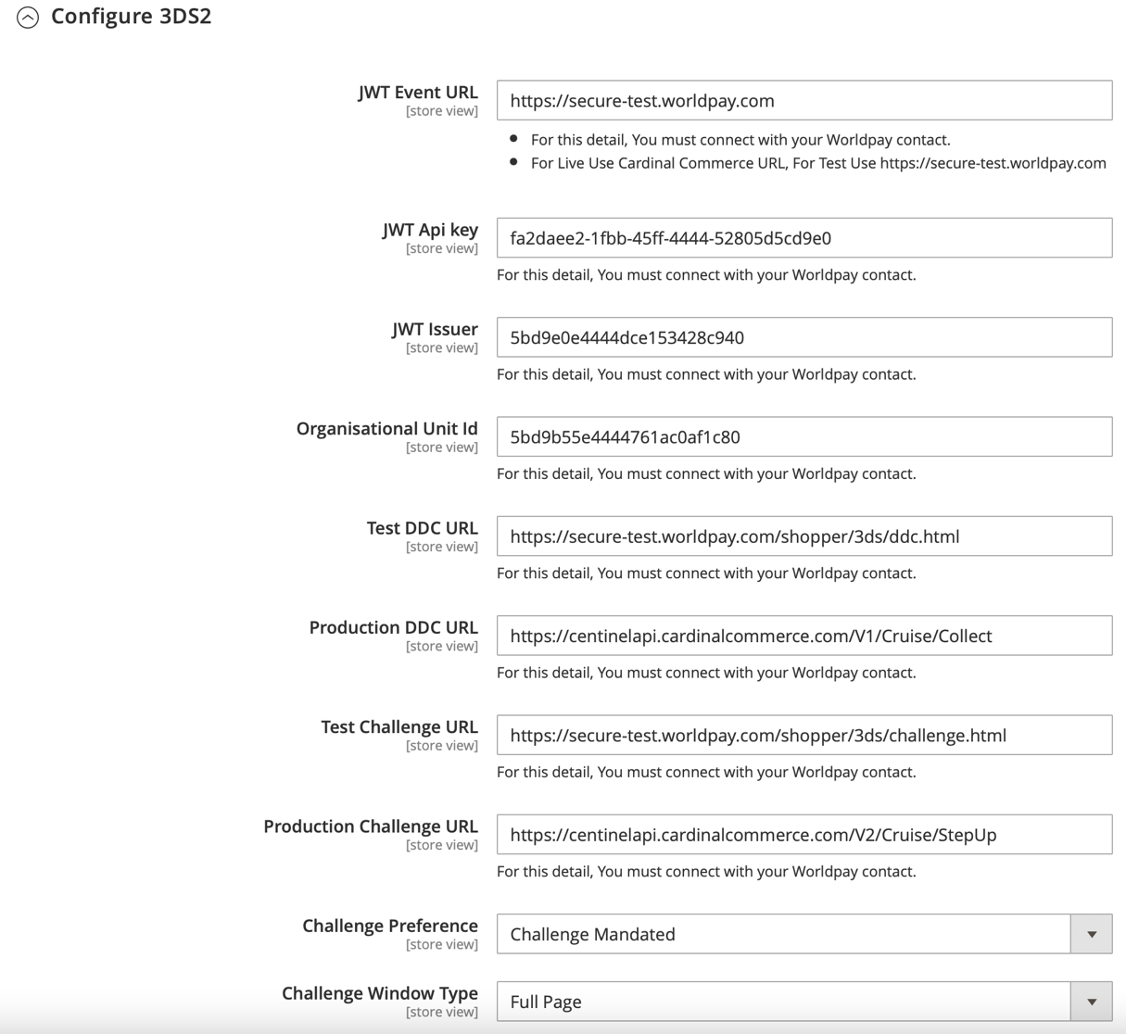

See the sample values in the image above to configure 3DS2. After configuration, you must clear the Magento cache: php bin/magento cache:clean

|  |  |
| --- | --- |
| **Configuration** | **Description** |
| **Enable 3DS2 Authentication** | This enables or disables the 3DS2 feature. If 3DS2 is disabled, orders will be placed by 3DS1 (if 3DS has been enabled). If both are disabled then the order will be placed by normal credit card authorisation. |
| **JWT Event URL** | This is for capturing the session ID from the domain.  For production mode, please use:  https://centinelapi.cardinalcommerce.com.  For test mode, please use: https://secure-test.worldpay.com |
| **JWT API Key, JWT Issuer and**  **Organisational Unit ID** | Worldpay supplies these values. You must contact your Worldpay representative to register you for 3DS2. |
| **Test DDC (Device Data**  **Collection) URL** | This is for creating the JWT session ID. For test mode, use:  https://secure-test.worldpay.com/shopper/3ds/ddc.html. |
| **Production DDC URL** | To create the JWT session ID in production mode, use:  https://centinelapi.cardinalcommerce.com/V1/Cruise/Collect |
| **Authentication Method** | This is added as risk data. It is a mechanism to authenticate shoppers:  guestCheckout: the shopper is not authenticated localAccount: you authenticate the shopper using your own systems  federatedAccount: you authenticate the shopper using a Federated ID  fidoAuthenticator: you authenticate the shopper using FIDO Authenticator issuerCredentials: you authenticate the shopper using issuer credentials  thirdPartyAuthentication: you authenticate the shopper using third-party authentication. |
| **Test Challenge URL** | This is the URL for the challenge page. For test mode, please use:  https://secure-test.worldpay.com/shopper/3ds/challenge.html |
| **Production Challenge URL** | This is the URL for the challenge page. For production mode, please use: https://centinelapi.cardinalcommerce.com/V2/Cruise/StepUp |
| **Challenge Preference** | noPreference: You have no preference about whether a challenge is performed.  noChallengeRequested: You prefer that no challenge is performed.  challengeRequested: You prefer a challenge to be performed. challengeMandated: There are local or regional mandates that mean that a challenge must be performed. This is an optional field. |
| **Challenge Window Type** | The 3DS2 challenge form redirects shoppers either to a full page or an iframe. The *Full Page* redirects them to either Worldpay or  Cardinal. The *Iframe* challenge form appears in the same page. |

**Note**: 3DS2 works with both Direct and Redirect modes. You can enable the integration mode at Stores/Configuration/Sales/Credit Cards. Please see Main configurations.

### Credit card configurations

For a detailed view of risk data, go to Sales/Orders/Order View/Information and look under Payment Information:

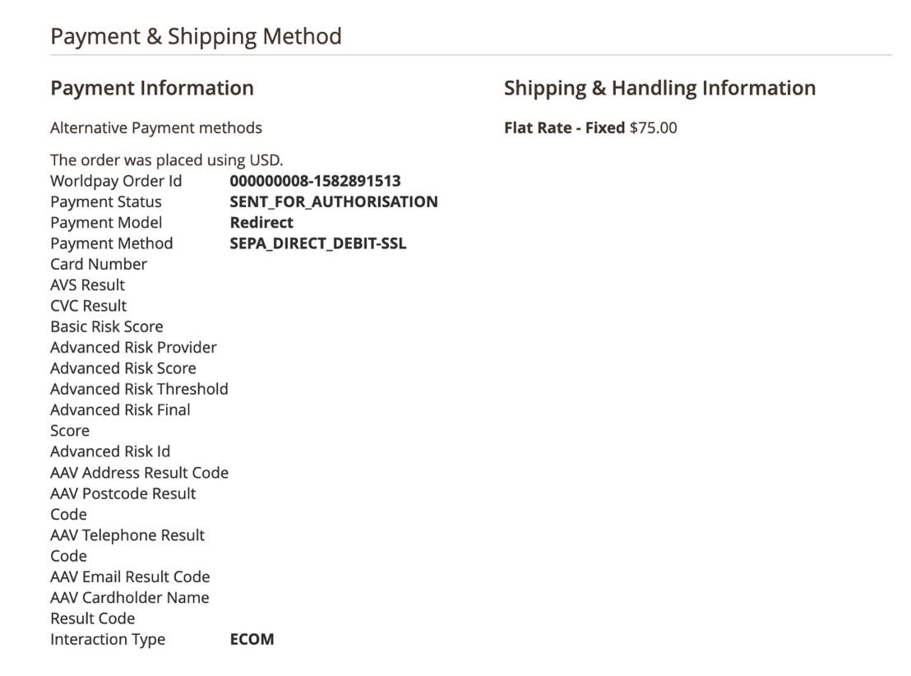

### Previously saved card not working after 3DS2 activation

If a shopper has saved their card before 3DS2 activation, they must update the card details in their My Account section. This is because the token created earlier may not work with 3DS2:

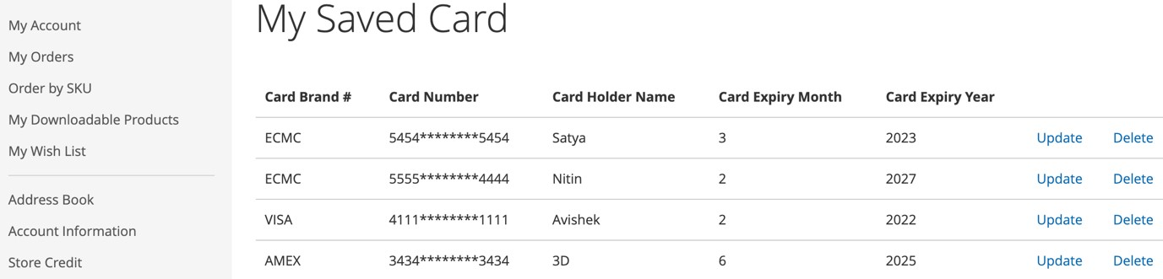

**Note**: Card details are not saved. Only the token is saved at the Magento level.

## US and Canadian domestic acquiring

This section covers features that only apply to merchants in the US and Canada.

### Issuer Insights

This section describes the additional data available once Issuer Insights is enabled by WorldPay.

To view Issuer Insights, do the following:

1. Go to Sales/Order, and click **View**.

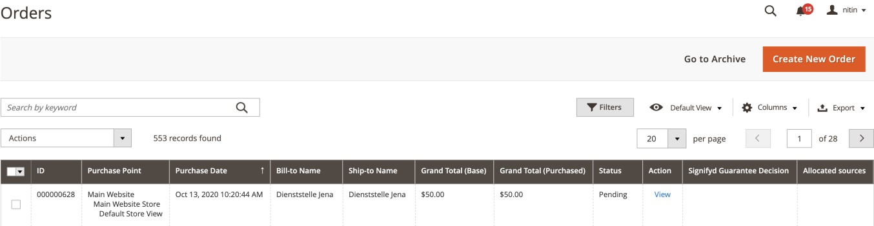

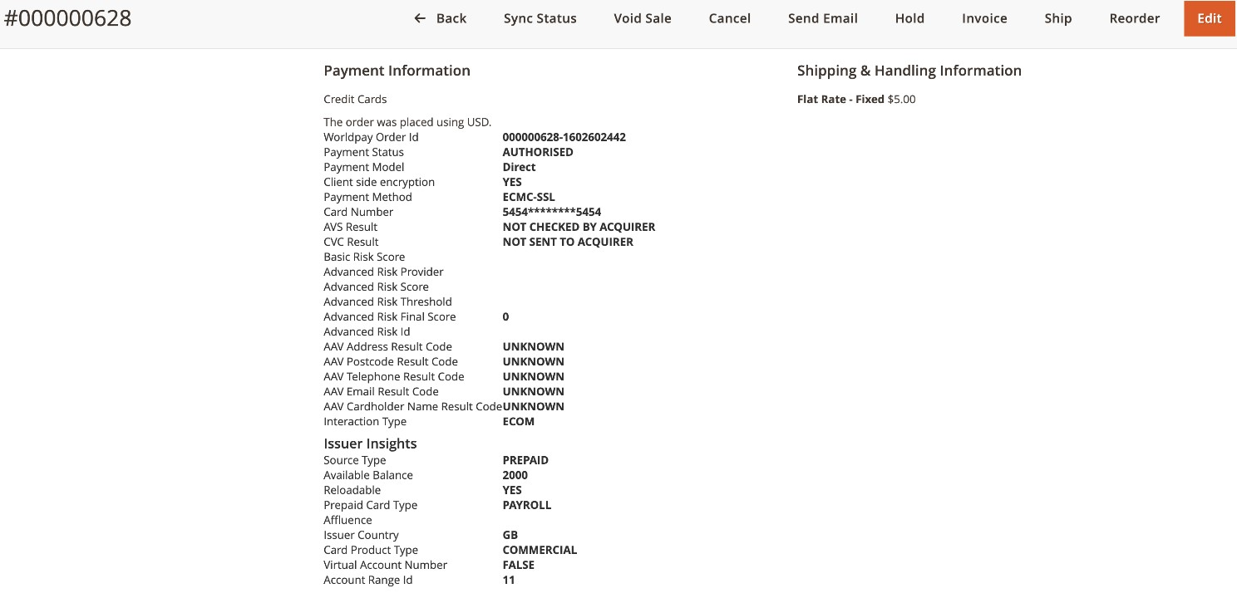

### ACH Direct Debit (USA Only)

This section describes how to configure ACH Direct Debit (USA domestic wire transfer) to your integrations.

**Note**: This is applicable only for the USA. You must have a US domestic bank account to use this feature.

To configure the system for ACH pay, do the following:

1. Go to Store/Settings/Configuration/Sales/Worldpay.

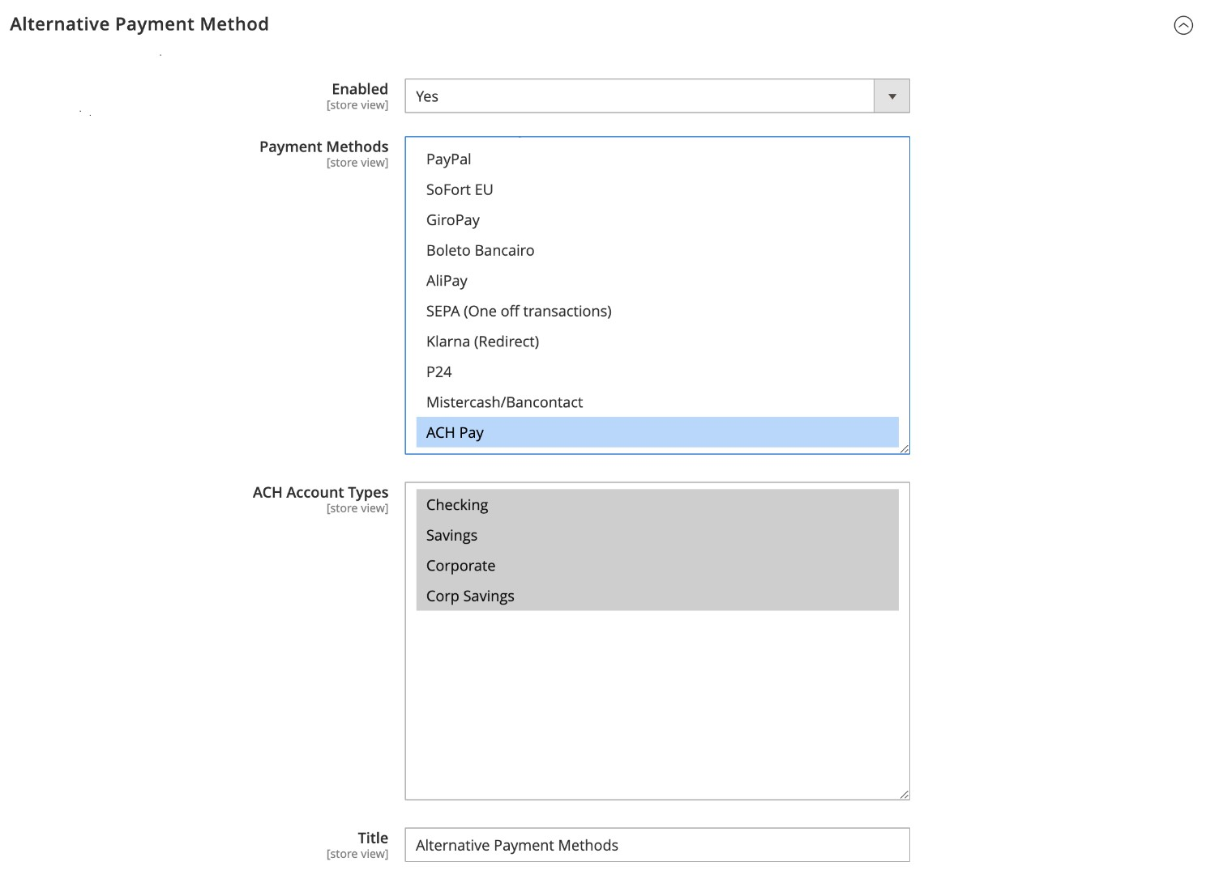

1. Use the information in the table below to complete the configuration.

|  |  |
| --- | --- |
| **Configuration** | **Description** |
| **Enabled** | Set to **Yes**, this will enable alternative payment method. |
| **Payment Methods** | Select **ACH Pay** from the options provided. This feature is only available for USA. |
| **ACH Account Types** | Configure the available bank account types. |

1. You can add the configuration to manage alerts/show customized messages by following below steps.
   1. Go to Store/Settings/Configuration/Sales/Worldpay Exception Codes
   2. Under *Customize Admin Worldpay Configuration Messages*, click the **Add** button and then add the below configurations.

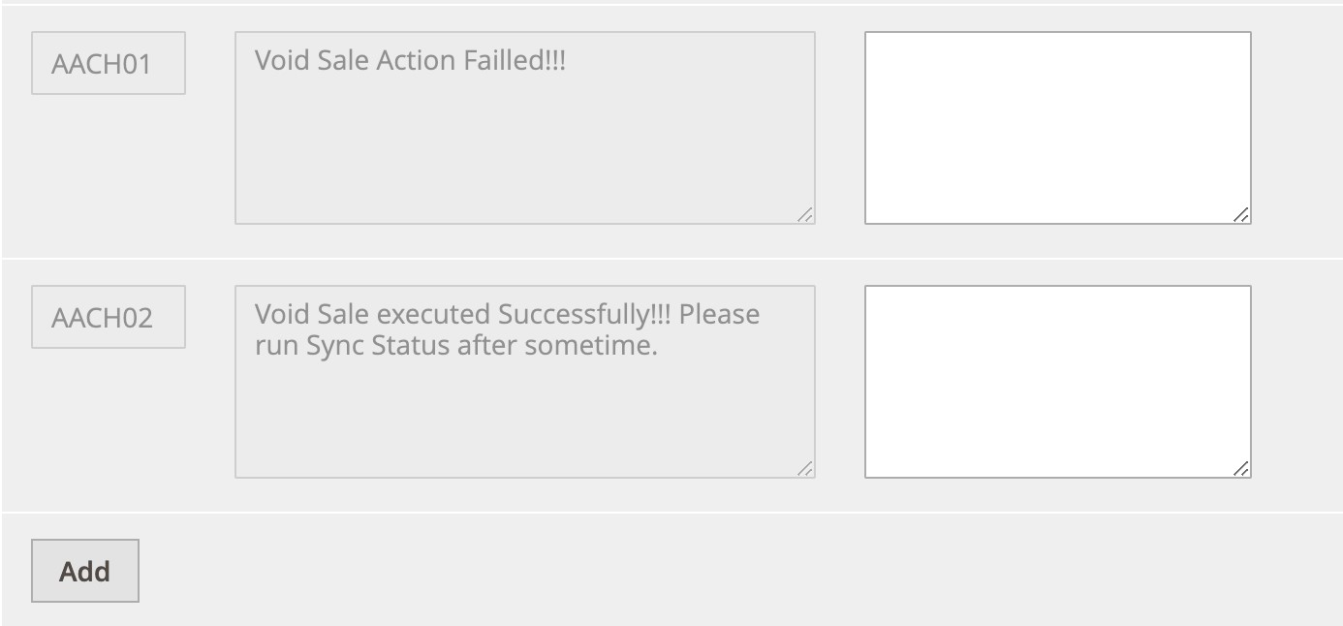

You must click **Add** after you add the configurations.

Use the table below to add the configurations in the screenshot above.

|  |  |  |
| --- | --- | --- |
| **Message code** | **Actual message** | **Custom message** |
| **AACH01** | Void Sale action failed |  |
| **AACH02** | Void Sale executed Successfully. Please run Sync Status after sometime. |  |

Under *Customize Checkout Messages*, you must click the **Add** button and then add the below configurations.

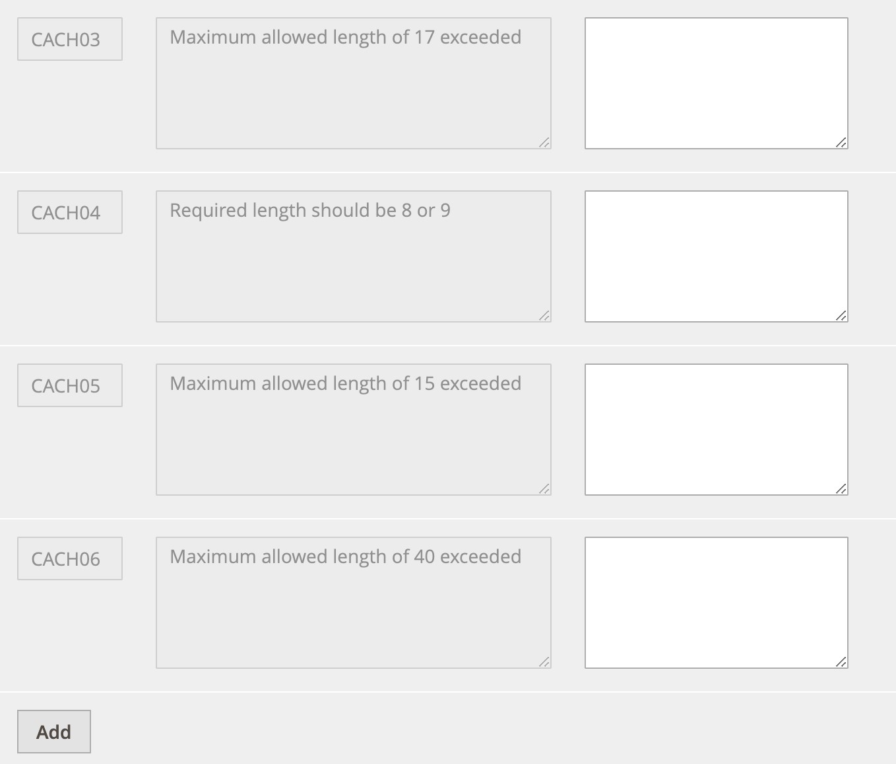

You must click **Add** after adding the configurations.

Use the information in the table below to add the above displayed configurations:

|  |  |  |
| --- | --- | --- |
| **Message code** | **Actual message** | **Custom message** |
| **CACH03** | Maximum allowed length of 17 exceeded |  |
| **CACH04** | Required length should be 8 or 9 |  |
| **CACH05** | Maximum allowed length of 15 exceeded |  |
| **CACH06** | Maximum allowed length of 40 exceeded |  |

1. In some cases, you may wish to void a sale request, this must be done within the same US business day as the sale request.
   1. To void a sale request, go to Sales/Orders
   2. Search for the order id shared by the shopper (For ex: 000000504.)

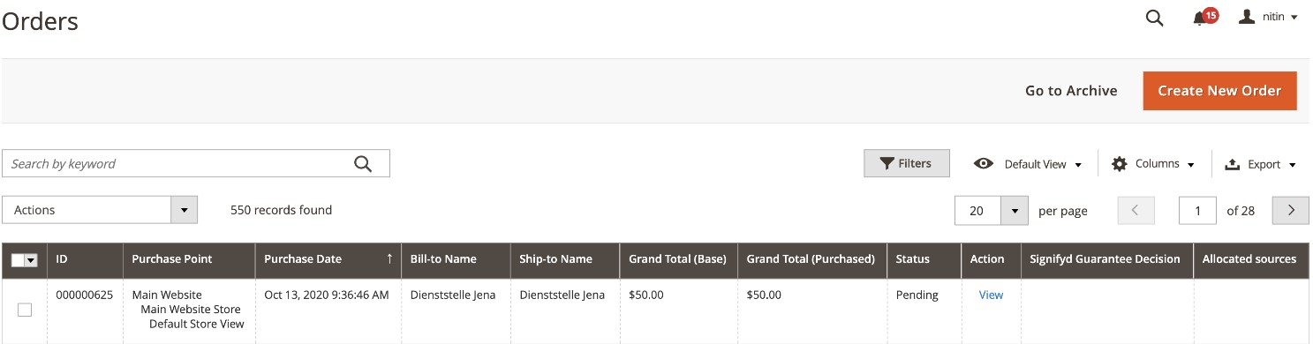

* 1. Click **View**, and the page below appears with option to void sale request.

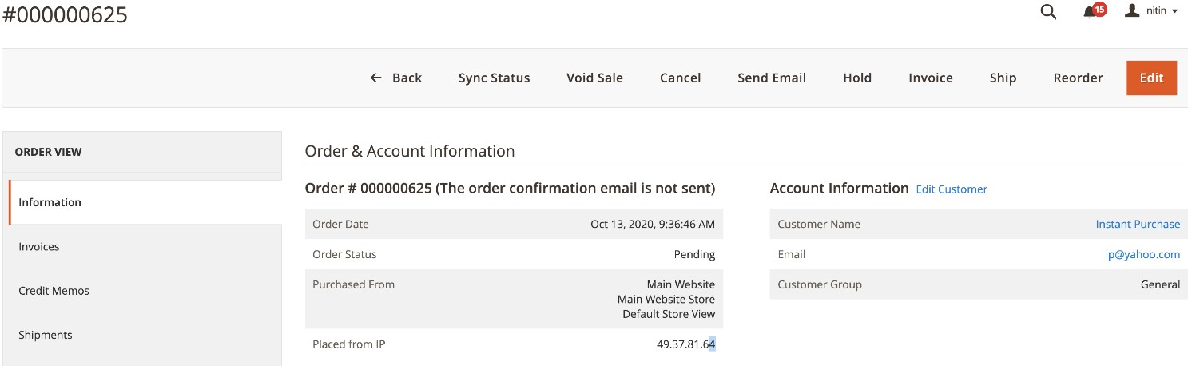

**Note**: The **Void Sale** button is visible within the same US business day as the sale request and only for ACH Pay orders.

If you choose to void the sale request, please do not send out a refund request from MAI site.

* 1. You must click the **Void Sale** button in order to void a particular sale request. You will receive below message on successful execution of void sale request.

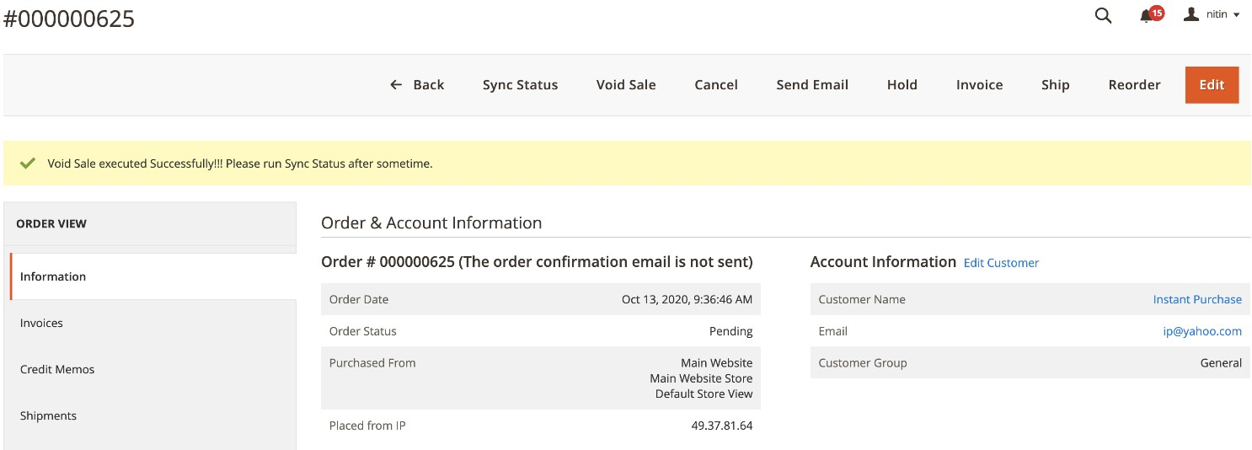

This indicates that the request was executed successfully, following which after some time you must run the sync status, which will reflect the current state of order status as well as payment status.

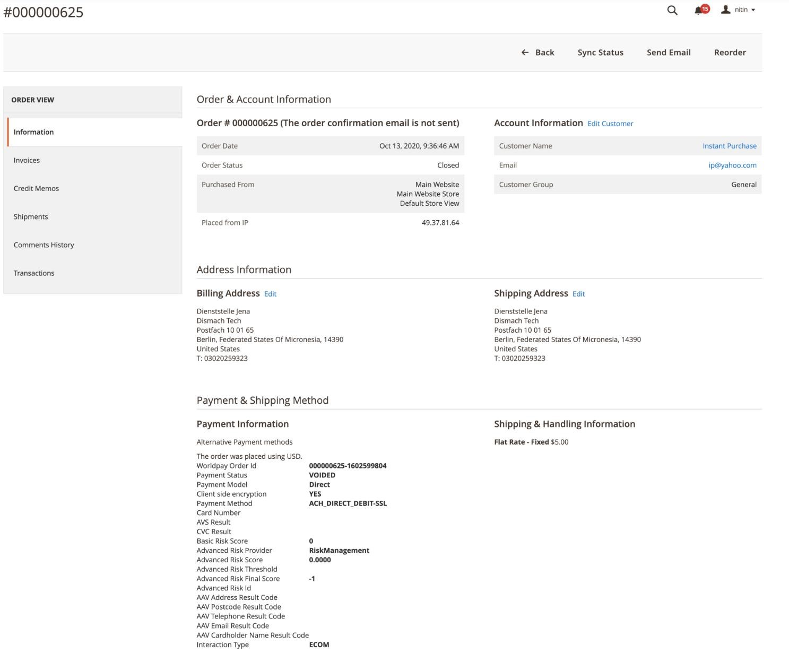

If you click the **Void Sale** button after the request has been voided, you get the error message below:

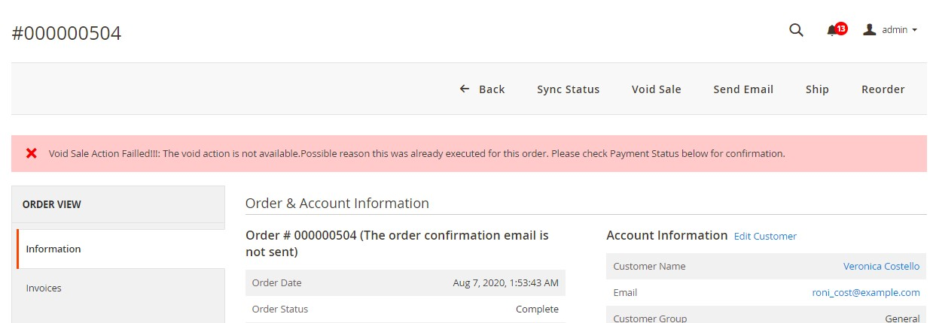

**Note**: The alert messages may vary depending on the availability of custom messages from the configuration.

If the **Void Sale** button is unavailable or if the request fails, you'll need to submit a refund request.

##### The shopper’s experience

Once you have configured your system, it has the following effects on your shoppers:

Shoppers see seven new fields in the alternative payment methods section on selecting ach pay:

* Bank Account Types
* Account Number
* Routing Number
* Check Number
* Company Name
* Email Address
* Purpose of transaction text box

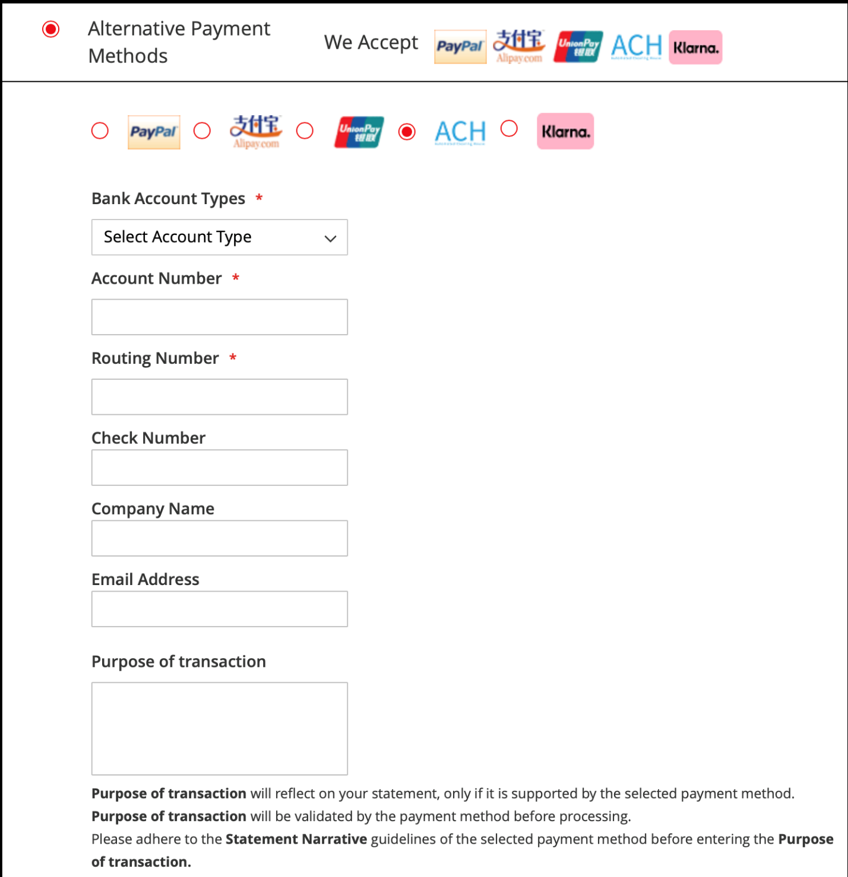

The ACH Pay-specific fields appear once the admin has enabled them, and if the billing address is US.

|  |  |
| --- | --- |
| **ACH Pay-specific field** | **Storefront validation** |
| **Bank Account Types** | Select box will appear. Values for selection will depend on account types configured by admin. |
| **Account Number** | Accepts only digits up to 17. |
| **Routing Number** | Accepts only digits with minimum length 8 and maximum length 9. |
| **Check Number** | Accepts only digits up to 15. |
| **Company Name** | Accepts string with maximum length of 40 characters. |
| **Email Address** | Accepts standard email validation. |
| **Purpose of transaction** | Accepts alphanumeric characters which will be truncated to 15 characters while sending the request. |

**Note**: ACH Pay is available only in direct integration mode.

### Prime Routing (USA Only)

This section describes how to configure Prime Routing to your integrations.

**Note**: This is applicable only for USA and works only in direct integration mode. Once Prime Routing is enabled, the request is treated as a Sales request.

To configure prime routing, do the following:

1. Go to Store/Settings/Configuration/Sales/Worldpay.

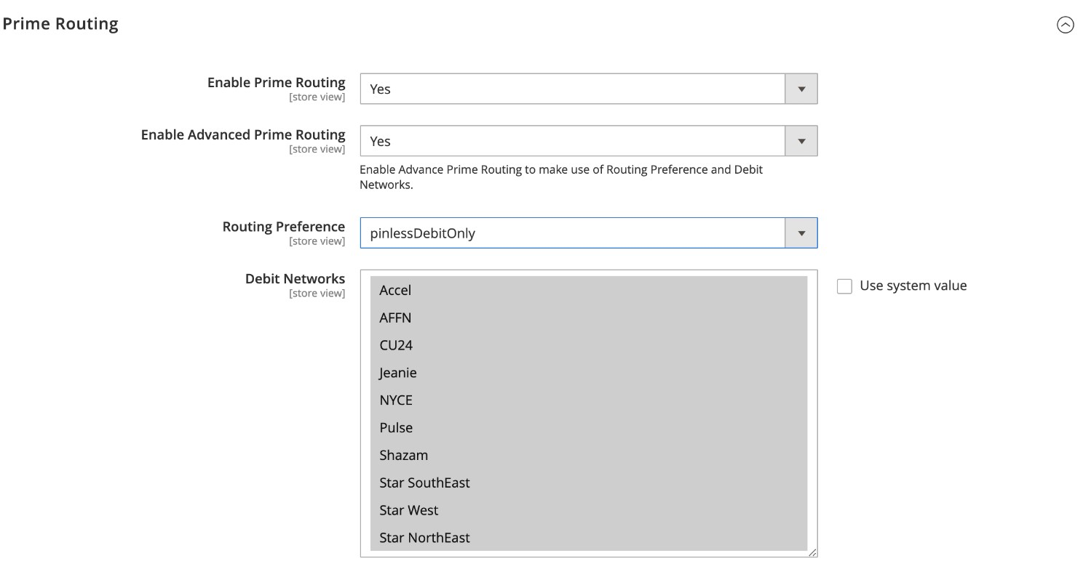

1. Use the information in the table below to complete the configuration:

|  |  |
| --- | --- |
| **Configuration** | **Description** |
| **Enable Prime Routing** | Set to **Yes**, this enables the prime routing feature. |
| **Enable Advanced Prime Routing** | Set to **Yes**, this allows you to configure the routing preference and debit networks. |
| **Routing Preference** | This lets you configure the routing preference to specify how a particular transaction should be routed. |
| **Debit Networks** | This lets you configure the debit networks to specify how a particular transaction should be routed. |

1. You can add the configuration to manage alerts/show customized messages by following below steps.
   1. Go to Store/Settings/Configuration/Sales/Worldpay Exception Codes.
   2. Under Customize Admin Worldpay Configuration Messages, you must click on the **Add** button and then add the below configurations.



You must click **Save Config** after adding the configurations.

Use the below table for adding the above displayed configurations.

|  |  |  |
| --- | --- | --- |
| **Message code** | **Actual message** | **Custom message** |
| **AACH01** | Void Sale action failed |  |
| **AACH02** | Void Sale executed Successfully Please run Sync Status after sometime. |  |

* 1. Under Customize Checkout Messages, you must click the **Add** button and then add the below configurations.

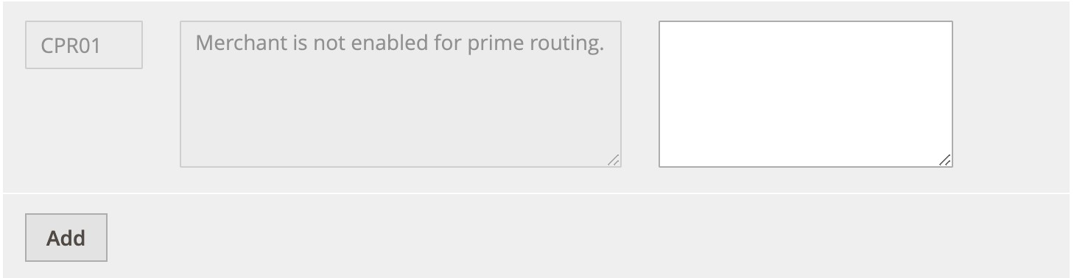

You must click **Save Config** after adding the configurations.

Use the below table for adding the above displayed configurations.

|  |  |  |
| --- | --- | --- |
| **Message code** | **Actual message** | **Custom message** |
| **CPR01** | Merchant is not enabled for prime routing. |  |

1. In some cases, you may wish to void a sale request, this must be done within the same US business day as the sale request.
   * 1. To void a sale request, go to Sales/Orders
     2. Search for the order ID shared by the shopper (e.g: 000000713.)

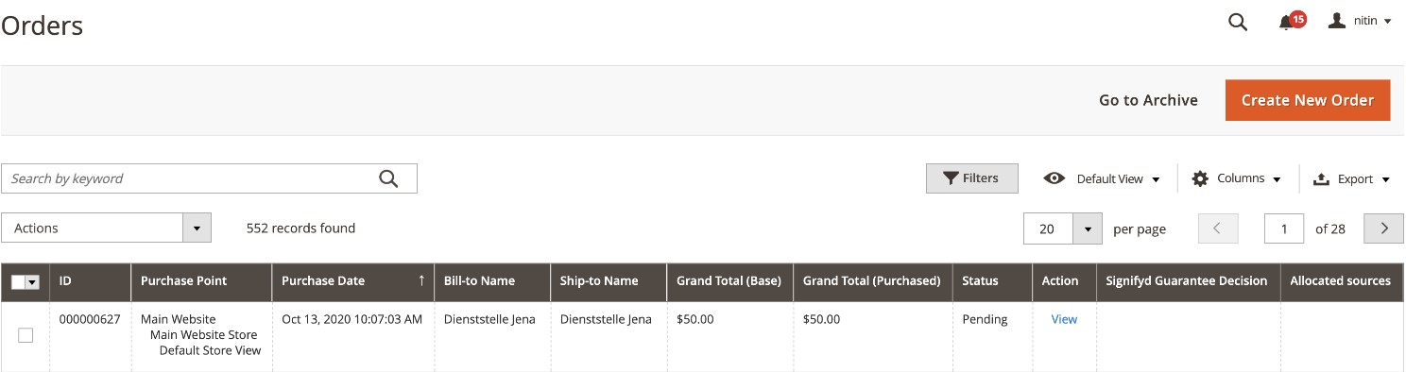

* + 1. Click on view, and you will be shown the below page with option to void sale request.

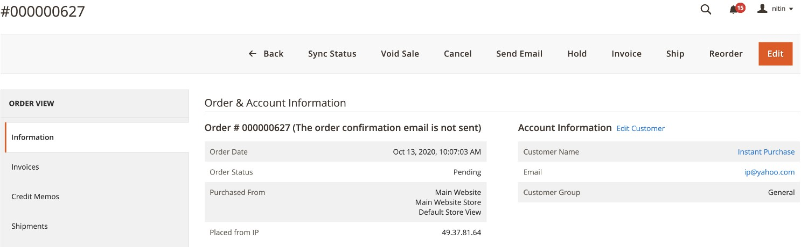

The **Void Sale** button is visible within the same US business day as the sale request and only for Sale Requests (Prime Routing requests) and ACH Pay orders.

If you want to void the sale request, please do not send out a refund request from the MAI site.

* + 1. You must click the **Void Sale** button to void a particular sale request. You will receive the message below when the void sale request process is successful.

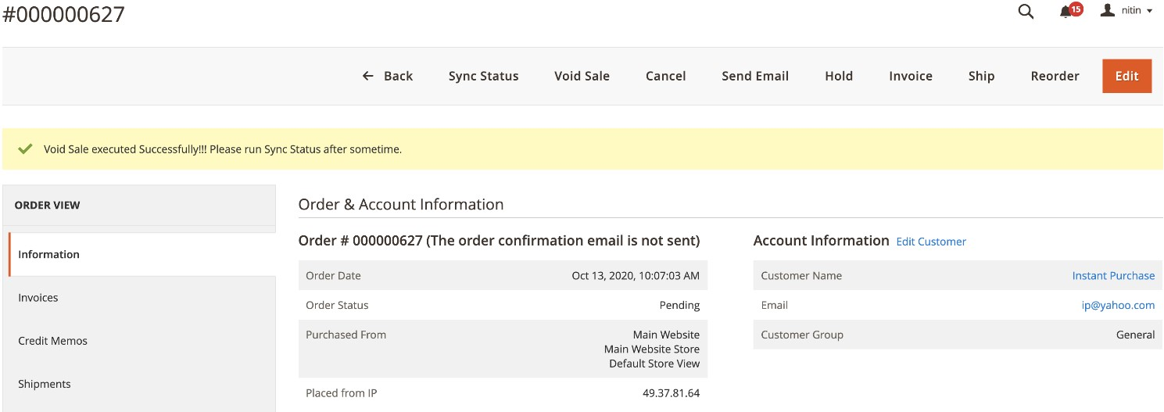

This indicates that the request was executed successfully. After some time run the sync status; this status shows the current state of the order status as well as the payment status.

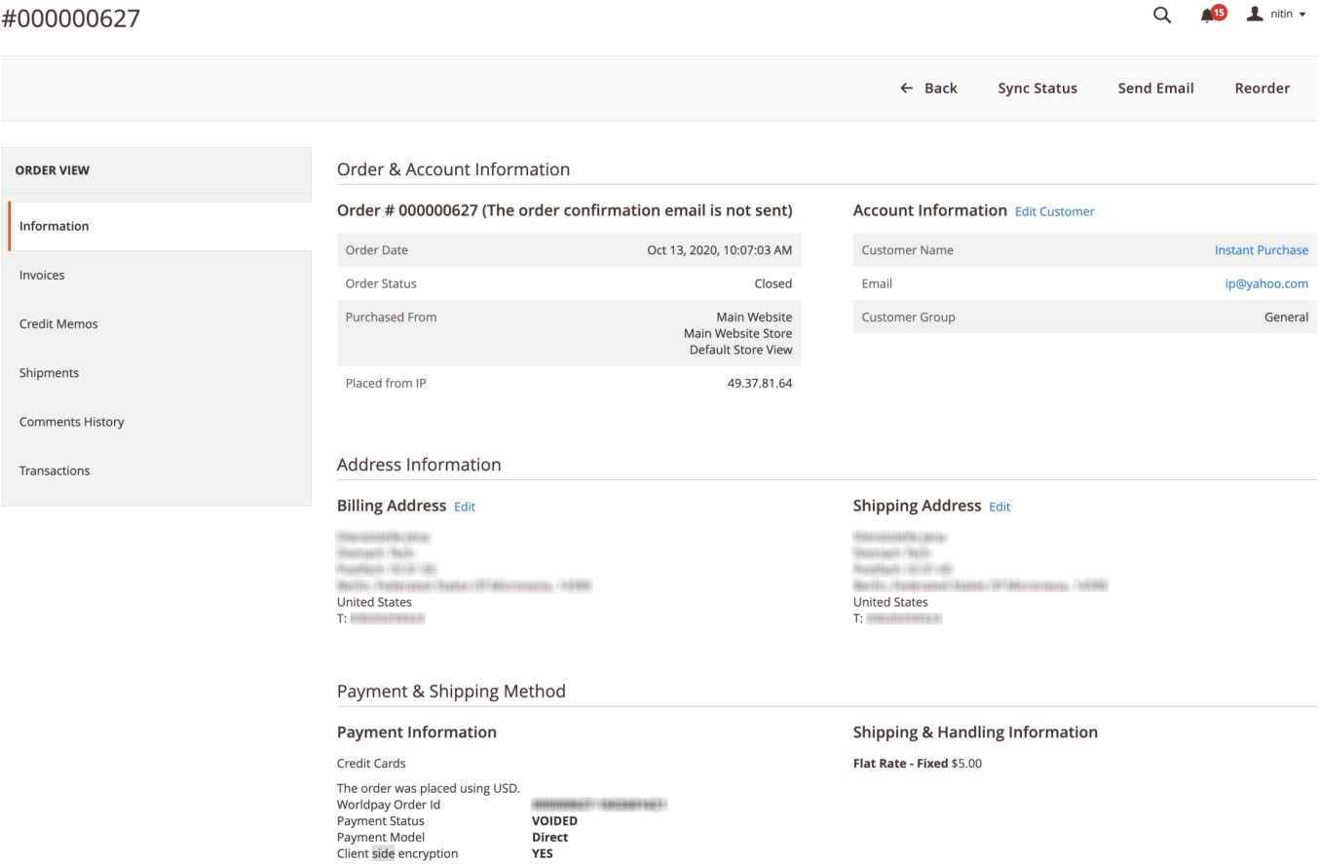

* + 1. If you click the **Void Sale** button after the request has been voided, you get the error message below.

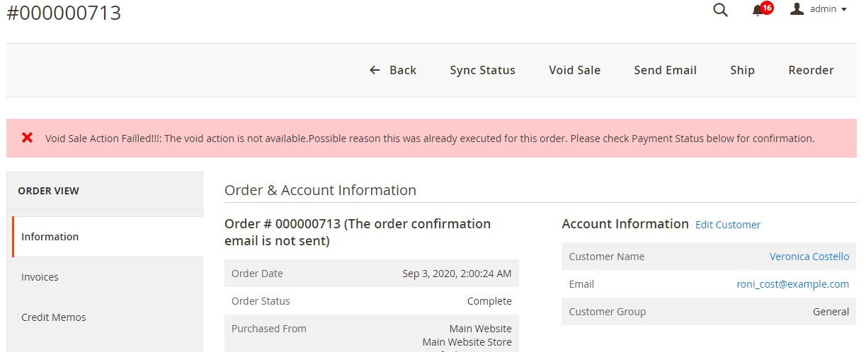

**Note**: The alert messages may vary depending on the availability of custom messages from the configuration.

If the **Void Sale** button is unavailable or if the request fails, must submit a Refund request.

**Note**: Prime Routing is available only in direct integration mode and if enabled the request is treated as a SALES request.

### Level 2/3 Data

Worldpay credit card processing data for VISA and MasterCard fall into two levels, when being passed by merchants: Level 1 and Level 2/3. Each level is defined by the amount of information that is required or passed as a set of additional data.

Level 1 processing has the lowest data requirements, but potentially the highest interchange fees. Level 2/3 processing demands card data that provides more information for business, commercial, corporate, purchasing, and government cardholders.

Credit card transactions submitted with Level2/3 card data can obtain lower interchange fees and provide merchants with a lower processing cost together with spending insights for shoppers. Naturally, it is in the best interest of merchants to submit Level 2/3 card data whenever possible.

You can supply Level 2 and Level 3 data through the following APIs:

* Direct XML (AUTHORISE and SALE)
* Redirect or HPP
* Capture or Refund batch request
* Capture or Refund order modification

##### Qualification criteria

**MasterCard**

* The transaction must be taxable
* Tax must be between 0.1% and 30% of the transaction amount
* For level 3 the transaction must use a corporate, business or purchasing card
* For level 3 at least one line item must be included

**Visa**

* The transaction must be taxable
* Tax must be between 0.1% and 22% of the transaction amount
* For level 3 the transaction must use a corporate or purchasing card • Tax must be between 0.1% and 22% of the transaction amount
* For level 3 the transaction must use a corporate or purchasing card

**Note:** Qualification criteria are validated by the Worldpay gateway and not by the Magento 2 plugin.

**How to setup Level 2/3 Data:**

Go to **Stores> Configuration> Sales> Worldpay**: **Level 2/3 Data for US and Canada Payments Configuring Level 2/3 Data:**

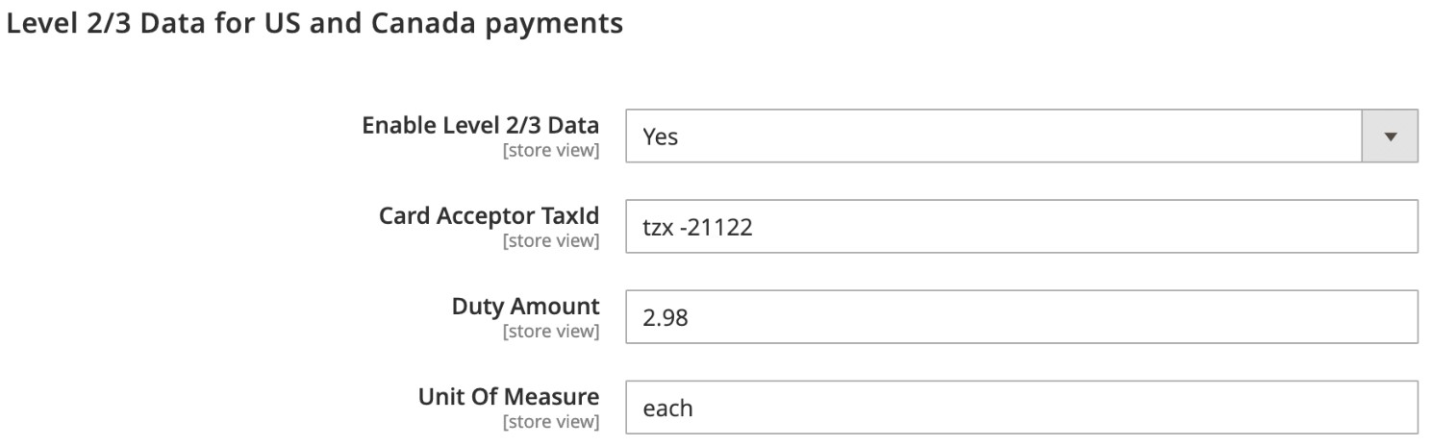

|  |  |
| --- | --- |
| **Configuration** | **Description** |
| **Enable Level 2/3 Data** | Field to enable/disable the level 2/3 data for US & Canada Payments. |
| **Card Acceptor TaxId** | Must be between 1-20 characters (9 digits for US domiciled merchants). |
| **Duty Amount** | Duty Amount manageable by merchant for international shipping which has duties tax. |
| **Unit Of Measure** | Merchant can configure product’s Unit of Measure, whose value is set as “**each**” by default. Unit of Measure will be passed on to Worldpay gateway. |

**Product attribute values:** Browse Catalog/Products – For any product type

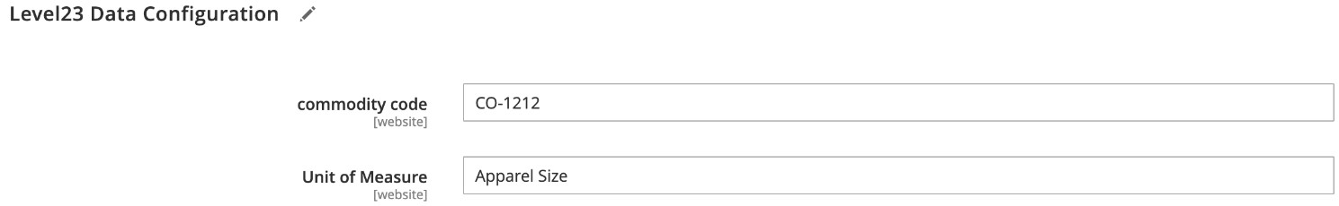

|  |  |
| --- | --- |
| **Configuration** | **Description** |
| **Commodity Code** | Commodity Code to be configured by merchant for each product. |
| **Unit of Measure** | Merchant configures product’s Unit of Measure and this value will overwrite the default value set under Stores/  Configuration/Sales/Worldpay: Level 2/3 Data for US and Canada Payments. |

**Note:** The Worldpay Magento 2 plugin adds two product attributes. These are *commodity code* and *Unit of measure* for all the product types to support level 2/3 data needs after installation.

##### Sample Payment Request

|  |
| --- |
| **Configuration** |
| <?xml version="1.0" encoding="UTF-8"?>  <!DOCTYPE paymentService PUBLIC "-//Worldpay//DTD Worldpay PaymentService v1//EN"  "http://dtd.worldpay.com/paymentService_v1.dtd" >  <paymentService version="1.4" merchantCode="YOUR_MERCHANT_CODE">  <submit>  <order orderCode="YOUR_ORDER_CODE">  <description>YOUR DESCRIPTION</description>  <amount value="100" currencyCode="EUR" exponent="2"/> <orderContent>  <![CDATA[]]>  </orderContent>  <paymentDetails>  <CARD-SSL>  <cardNumber>4444333322221111</cardNumber>  <expiryDate>  <date month="06" year="2019"/>  </expiryDate>  <cardHolderName>AUTHORISED</cardHolderName>  <cvc>666</cvc>  <cardAddress>  <address>  <firstName>Mr Bert</firstName>  <address1>Worldpay</address1>  <address2>270-289 The Science Park</address2>  <address3>Milton Road</address3>  <postalCode>CB4 0WE</postalCode>  <city>Cambridge</city>  <countryCode>GB</countryCode>  </address>  </cardAddress>  </CARD-SSL>  <session shopperIPAddress="127.0.0.1" id="ssn818495445"/> </paymentDetails>  <branchSpecificExtension> |
| <purchase>  <invoiceReferenceNumber>INV12233566</invoiceReferenceNumber>  <customerReference>CUST00000001</customerReference>  <cardAcceptorTaxId>VAT1999292</cardAcceptorTaxId>  <salesTax>  <amount value="2400" exponent="2" currencyCode="USD" /> </salesTax>  <discountAmount>  <amount value="0" exponent="2" currencyCode="USD" /> </discountAmount>  <shippingAmount>  <amount value="100" exponent="2" currencyCode="USD" /> </shippingAmount>  <dutyAmount>  <amount value="0" exponent="2" currencyCode="USD" /> </dutyAmount>  <shipFromPostalCode>CB40WD</shipFromPostalCode>  <destinationPostalCode>CB4OWD</destinationPostalCode>  <destinationCountryCode>GB</destinationCountryCode> <orderDate>  <date dayOfMonth="1" month="1" year="2018" /> </orderDate>  <taxExempt>false</taxExempt>  <item>  <description>Mobile phone</description>  <productCode>MOB1001</productCode>  <commodityCode>COM10022</commodityCode>  <quantity>1</quantity>  <unitCost>  <amount value="12000" exponent="2" currencyCode="USD" />  </unitCost>  <unitOfMeasure>each</unitOfMeasure>  <itemTotal>  <amount value="12000" exponent="2" currencyCode="USD" />  </itemTotal>  <itemTotalWithTax>  <amount value="14400" exponent="2" currencyCode="USD" />  </itemTotalWithTax>  <itemDiscountAmount>  <amount value="100" exponent="2" currencyCode="USD" /> </itemDiscountAmount>  <taxAmount>  <amount value="2400" exponent="2" currencyCode="USD" /> </taxAmount>  </item>  </purchase>  </branchSpecificExtension>  </order>  </submit>  </paymentService> |

**Note:** Level 2/3 data is highlighted with blue font-color.

## Latin American payments

This section describes how to add Latin American payments to your integrations, including payments by instalment.

**Prerequisite**: You must have a legal entity in each Latin American country that you want to trade in.

**Note**: Please contact your Worldpay representative to set up the appropriate routing for the countries you want to trade in.

List of countries:

The plugin supports payments from these countries:

* Argentina
* Bolivia
* Brazil
* Central America (Costa Rica, Nicaragua, El Salvador, Honduras, Panama, Guatemala)
* Chile
* Colombia
* Ecuador
* Mexico
* Peru
* Uruguay

### Latin America configurations

1. To begin the configuration: Go to Store/Settings/Configuration/Sales/Worldpay.

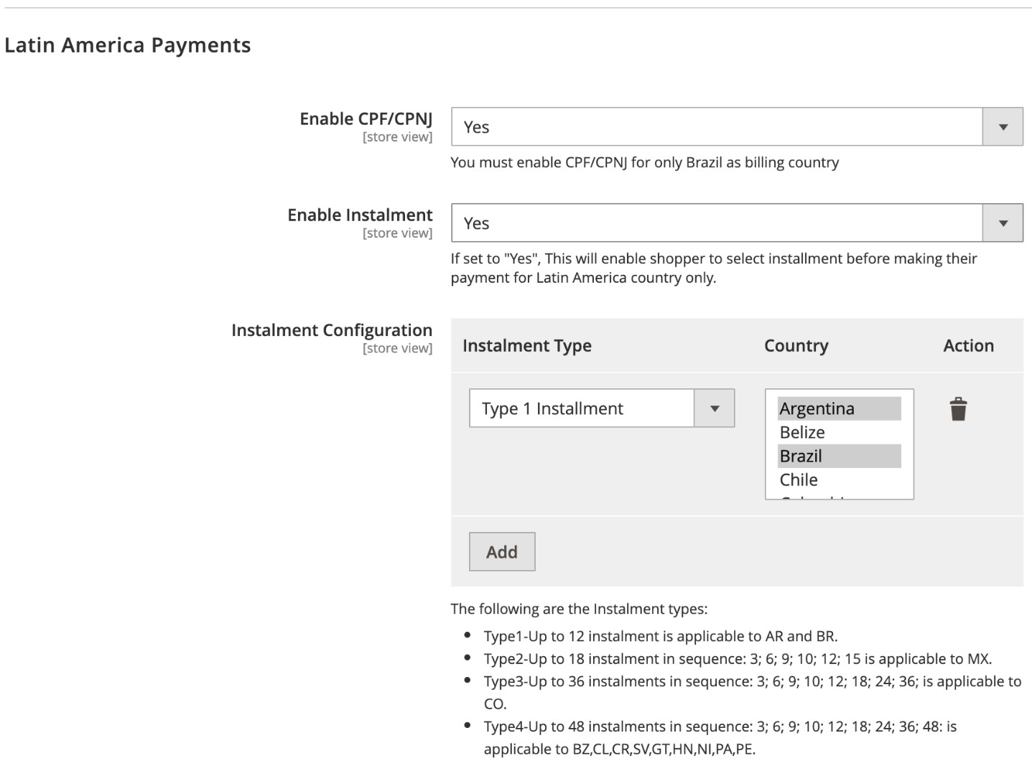

1. Use the information in the table below to complete the configuration.

|  |  |
| --- | --- |
| **Configuration** | **Description** |
| **Enable CPF/CNPJ** | Set to **Yes**, a shopper is only required to submit their CPF (Cadastro de Pessoas Físicas) and CNPJ (Cadastro Nacional da Pessoa Jurídica) ID number for payments originating in Brazil.* |
| **Enable Instalment** | Set to **Yes**, shoppers can pay in instalments. If set to **No**, instalments are not available. This feature is only available for Latin American countries. |
| **Instalment Configuration** | This enables you to do instalment-type mapping for Latin American countries. |
| **Instalment Type** | Type1 up to 12 instalments are applicable to Argentina and Brazil. Type2 up to 18 instalments (3, 6, 9, 10, 12, 15) are applicable to Mexico.  Type3 upt o 36 instalments (3, 6, 9, 10, 12, 18, 24, 36) are applicable to Colombia. |
|  | Type4 up to 48 instalments (3, 6, 9, 10, 12, 18; 24; 36; 48: are applicable to Brazil, Chile, Costa Rica, El Salvador, Guatemala, Honduras, Nicaragua, Panama and Peru. |

* You must only enable CPF for Brazilian payments.

3. Administrators can use the **Instalment** configuration to map countries with instalment types, and must apply the configurations in the table below:

|  |  |
| --- | --- |
| **Country** | **Permitted types of instalments** |
| **Brazil and Argentina** | Up to 12 instalments. |
| **Mexico** | Up to 18 sequential instalments: 3, 6, 9, 10, 12, 15, 18. |
| **Columbia** | Up to 12 instalments without interest. Up to 48 instalments with interest. Sequential instalments: 3, 6, 9, 10, 12, 18, 24, 36, 48. |
| **Peru and Central America** | Up to 48 sequential instalments: 3, 6, 9, 10, 12, 18, 24, 36, 48. |

### The shopper’s experience

Once you have configured your system, it has the following effects on your shoppers:

Shoppers see three new fields in the credit-card payment section:

* CPF/CNPJ text box (only for Brazil)
* Instalments-type dropdown (only for LatAm countries)
* Purpose of transaction text box

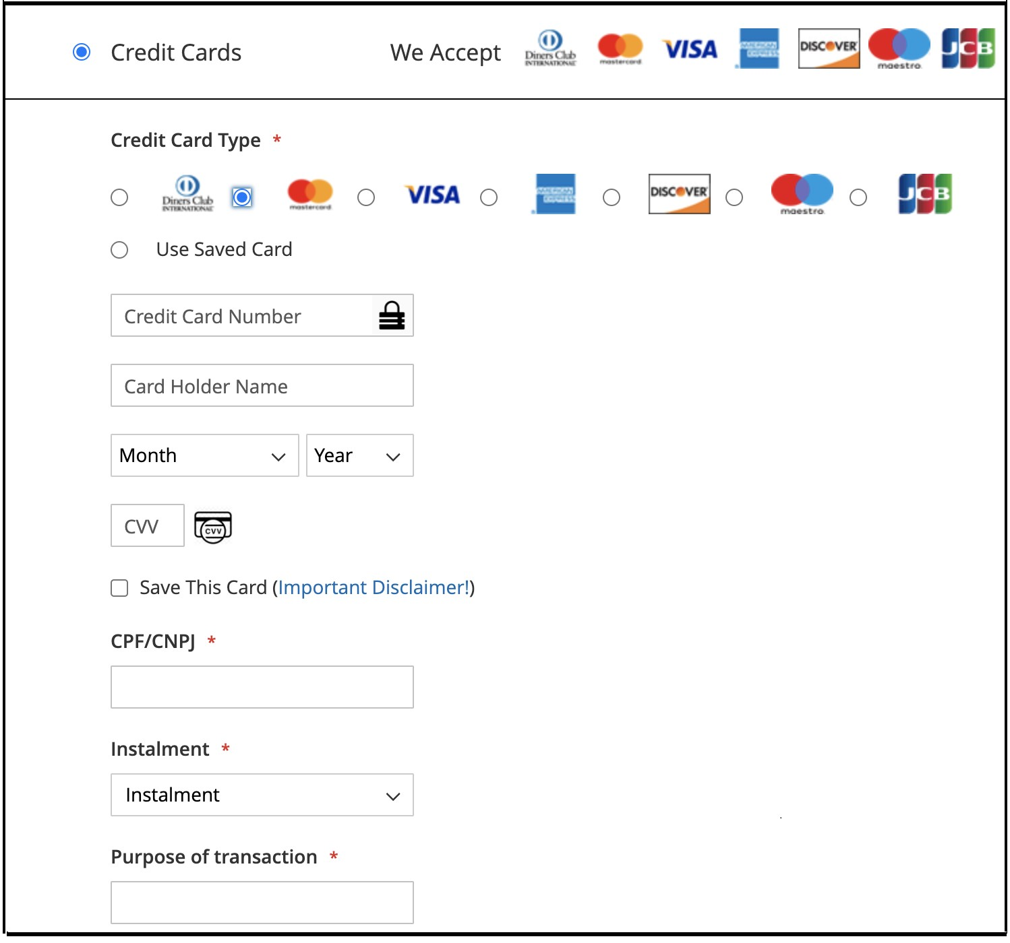

The Latin America-specific fields (**CPF/CPNJ, Instalment and Purpose of transaction**) appear once the admin has enabled them, and if the billing address is in one of the Latin American countries.

|  |  |
| --- | --- |
| **LatAm-specific field** | **Storefront validation** |
| **CPF** | Accepts only digits up to 11. |
| **CPNJ** | Accepts only digits up to 14. |
| **Instalment** | Select box will appear. Values for selection will depend on selected billing country. |
| **Purpose of transaction** | Accepts a maximum of 13 alphanumeric characters. |

### Recommendation for Brazil only

There are three variations of fields that should be visible for payments from Brazil:

1. Only CPF is enabled. (The **CPF** and **Purpose of Transaction** fields are visible.)
2. Only Instalments is enabled. (The **Instalment** and **Purpose of Transaction** fields are visible.)

Both CPF and Instalments are enabled. (The **CPF**, **Instalment** and **Purpose of Transaction** fields are

visible.)

## Exemption engine

The Exemption Engine enables frictionless checkout during 3DS2 using transactional data to predict issuer behavior. The engine requests real-time risk analysis of transactions to exempt as many as possible from SCA (strong customer authentication).

### How to configure the Exemption Engine

Go to Stores/Configuration/Sales/Worldpay/Exemption Engine:

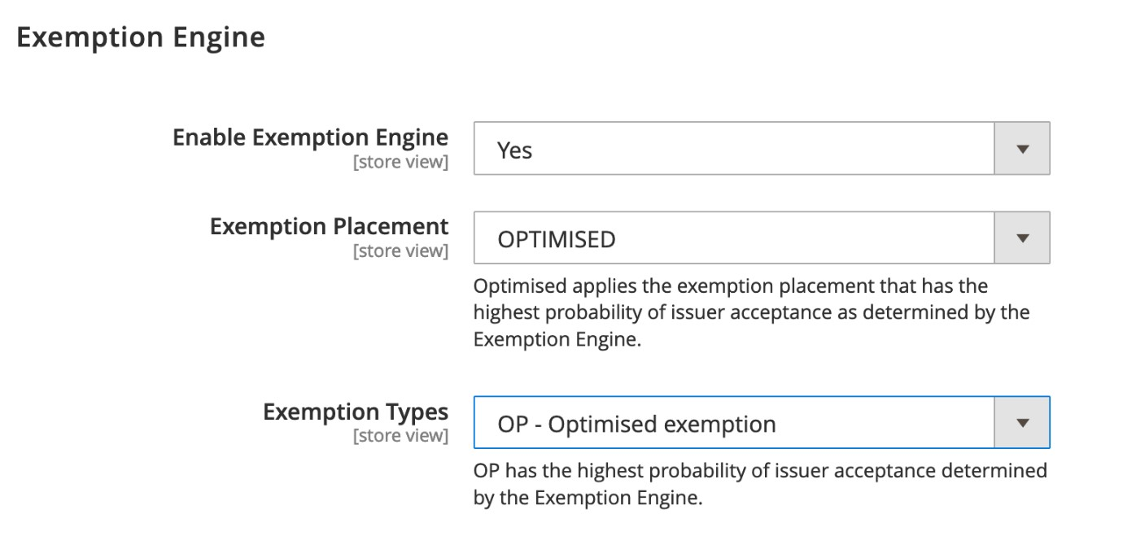

|  |  |
| --- | --- |
| **Configuration** | **Description** |
| **Enable Exemption Engine** | If set to **Yes**, transactions can be exempted from SCA, based on real-time risk analysis. |
| **Exemption Placement** | **AUTHORISATION**: Applies exemption in the authorization flow.  **AUTHENTICATION**: Applies exemption in the authentication flow. **OPTIMISED**: Applies the exemption placement that has the highest probability of issuer acceptance as determined by the Exemption Engine. |
| **Exemption Types** | **LV**: Low-value exemption (less than 30 EUR) **LR**: Low-risk exemption.  **OP**: Optimised exemption (highest probability of issuer acceptance determined by the Exemption Engine). |

Additional information:

* In some cases the exemption might not be accepted by the issuing bank. If this occurs the shopper is required to go through authentication
* If an exemption is allowed, the liability for the transaction rests with you and not the issuing bank

**Optimised** is the recommended *Placement and Types*

# FraudSight

Fraudsight combines unparalleled data insights, industry leading technology, and fraud prevention expertise. The result enables you to predict and prevent fraud.

Contact Worldpay Support to get FraudSight enabled on your system.

## Configure Fraudsight

Once FraudSight is enabled on your account it is automatically activated in your Magento plugin. To manage the Fraud related cases, the information in this section is important.

##### Manage alerts and messages

To manage alerts/show customized messages do the following:

1. Go to Store/Settings/Configuration/Sales/Worldpay Exception Codes.
2. Under Customize Admin Worldpay Configuration Messages, click the **Add** button and then add the configurations below.

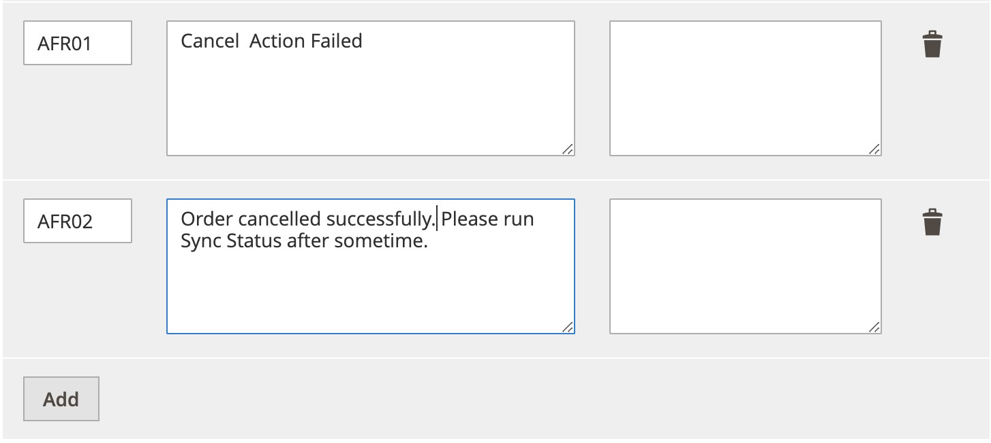

1. Click **Save Config** after you add the configurations.

Use the information in the table below to add to the above configurations.

|  |  |  |
| --- | --- | --- |
| **Message Code** | **Actual Message** | **Custom Message** |
| **AFR01** | Cancel Action Failed |  |
| **AFR02** | Order cancelled successfully  Please run Sync Status after some time. |  |

## FraudSight Response

Fraudsight response has one of the following messages:

* low-risk
* review
* high-risk

To see this message, go to Sales/Orders, and the message appears under *FraudSight Message*.

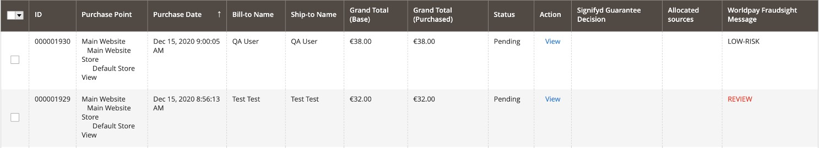

When the message is received it is “in review.” The message is highlighted in red, to show that you need to take action on this order. For more information, see Order Review.

You can also click **View** to see Fraudsight data. The Advance Risk Provider is FraudSight and under *Fraudsight Data*, you can see the message, score and reason codes if they are available.

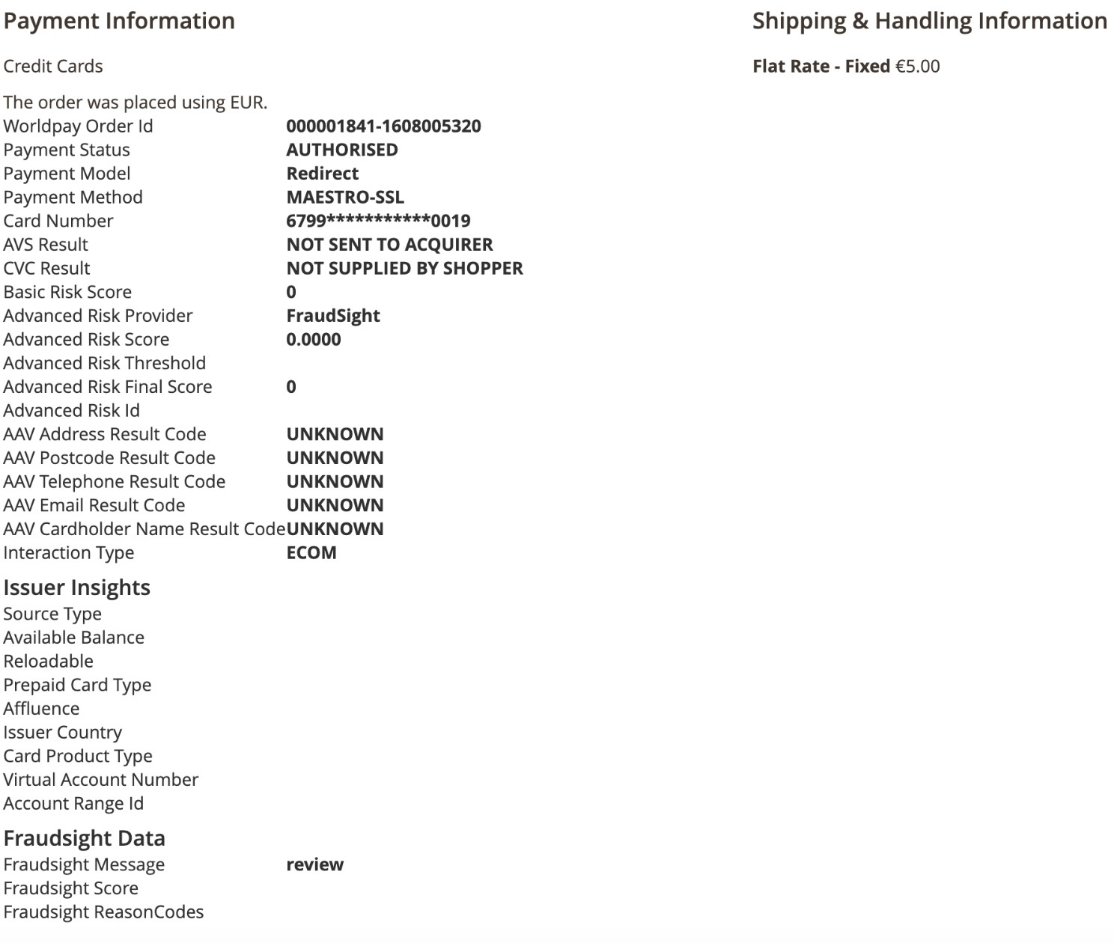

## Order Review

When the message received is “in review”, you may want to cancel the order or start a capture request.

##### Cancel an order

To cancel the order, do the following:

1. Go to Sales/Orders
2. Click the checkbox next to the order which has a message in review.

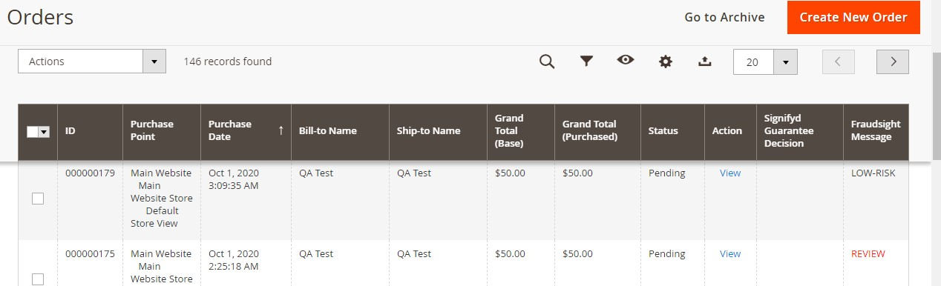

1. Click the **Cancel** button to send a cancel request to Worldpay. The screenshot below shows an example of the message you receive after a successful cancellation.

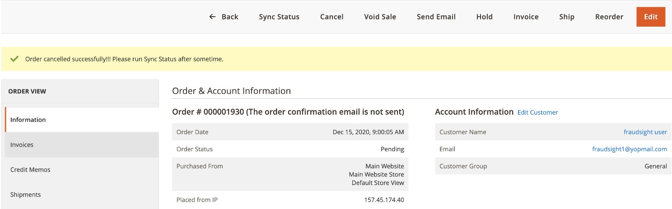

1. After some time run the sync status, this shows the current order status as well as payment status.

## Errors

If you click the Cancel button after the request has been cancelled, you get the error message in the screenshot below.

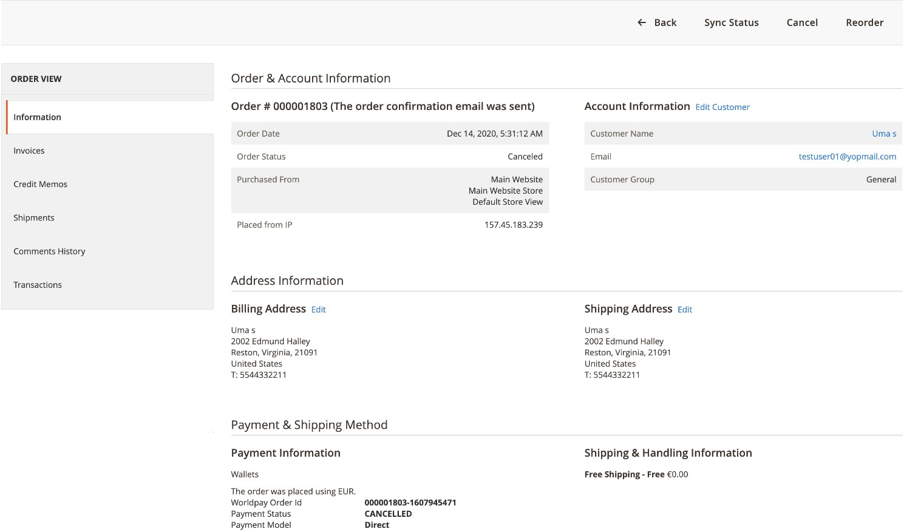

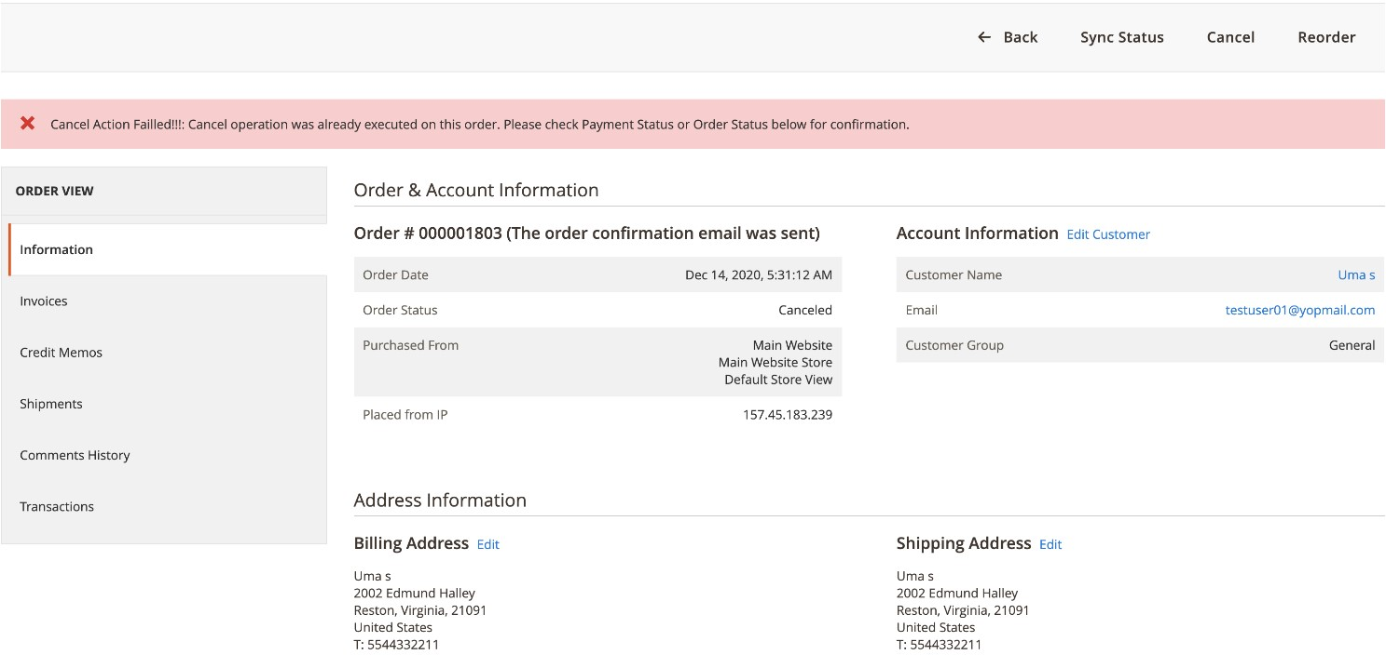

The alert messages may vary depending on the availability of custom messages from the configuration.

## Capture

To send a capture request:

1. Click *Invoice* and select *Capture Online* to send a capture request.

If you have a Redirect integration and FraudSight is enabled, use different methods to get FraudSight data. These methods are to use either order-notification, or to send order-inquiry requests. For order-inquiry requests run *Sync Status*.

# Tokenization and stored credentials

Magento does not save credit card details. Magento delegates the responsibility of securely storing credit card details to Worldpay by utilizing tokens. These tokens act as references to the actual credit card information stored on Worldpay's servers. Magento only stores and uses these tokens for future transactions, providing an added layer of security by reducing the exposure of sensitive credit card data within its system.

**1. Token Generation:**

- When a shopper makes a payment using a credit card and select “Save this card” on Magento Checkout, instead of Magento storing the credit card details, Worldpay generates a unique token for that credit card.

- This token generation process typically occurs on Worldpay's servers during the payment transaction.

**2. Token Initialization and Storage in Magento Database:**

- After Worldpay generates the token, it sends it back to Magento.

- Magento then stores this token in its database, associating it with the customer's account or payment method.

- This token acts as a reference to the credit card details stored securely on Worldpay's servers.

**3. Token Usage for Future Authorizations:**

- When the shopper returns to the website and initiates a new transaction, Magento retrieves the token associated with their saved payment method and show it to the user on checkout page under “Use Saved Card” option.

- When Shopper Select any card from the list and click Place order then Magento sends this token to Worldpay during the checkout process instead of sending the actual credit card details.

- Worldpay then references its database to retrieve the corresponding credit card details linked to that token.

- The payment authorization process proceeds using the retrieved credit card details, and if successful, the transaction is completed.

**4. Token Expiration :**

- In production, tokens are created with an initial life of 4 years. In Sandbox, tokens are created with an initial life of 7 days. More details can be found [here](https://developerengine.fisglobal.com/apis/wpg/tokenisation)

## How to configure tokenization and stored credentials

You can enable tokenization at Stores -> Configuration -> Sales -> Worldpay ->Tokenization:

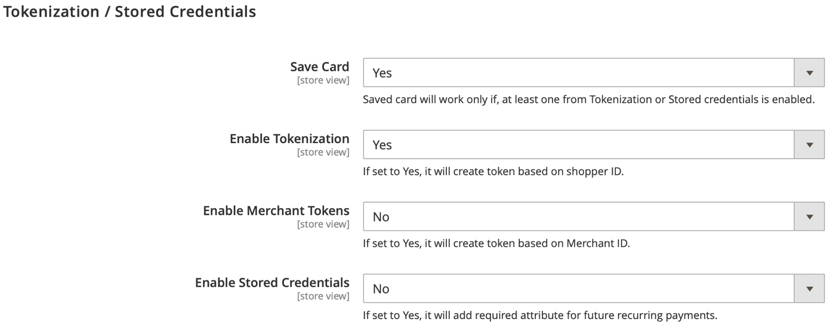

Do the following:

1. Set *Save Card* to **Yes** or **No**. -Card-saving will work only if either *Tokenization* or *Stored Credentials* is enabled. Set *Enable Tokenization* to **Yes** or **No**.

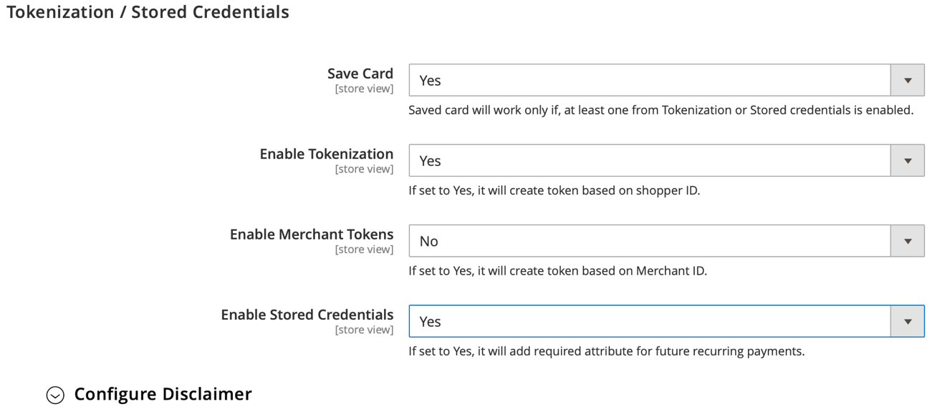

1. Set *Enable Stored Credentials* to **Yes** or **No**. If *Stored Credentials* is enabled, the required *usage* attribute is added, with values like FIRST and USED. This will also add the transactionIdentifier value of the FIRST response as schemeTransactionIdentifier in the USED request.

Read the [Worldpay online documentation](https://developer.worldpay.com/docs/wpg/industryschemeextras/storedcredentials) for more details about stored credentials.

|  |  |
| --- | --- |
| **Configuration** | **Description** |
| **Save Card** | If set to **Yes**, the save card function is enabled so long as either Tokenization or Stored credentials is enabled. |
| **Enable Tokenization** | Write the message that shoppers see. |
| **Enable Merchant Tokens** | If set to Yes, it will create token based on Merchant ID. |
| **Enable Stored Credentials** | If set to **Yes**, stored credentials are enabled and a token with long expiry time is created. |

Additional information:

* A maximum of 16 cards can be saved under each authenticated shopper ID
* Tokenization/stored credentials must be enabled to ensure compliance when storing card details You can configure a disclaimer that shoppers must accept during checkout to save their card:

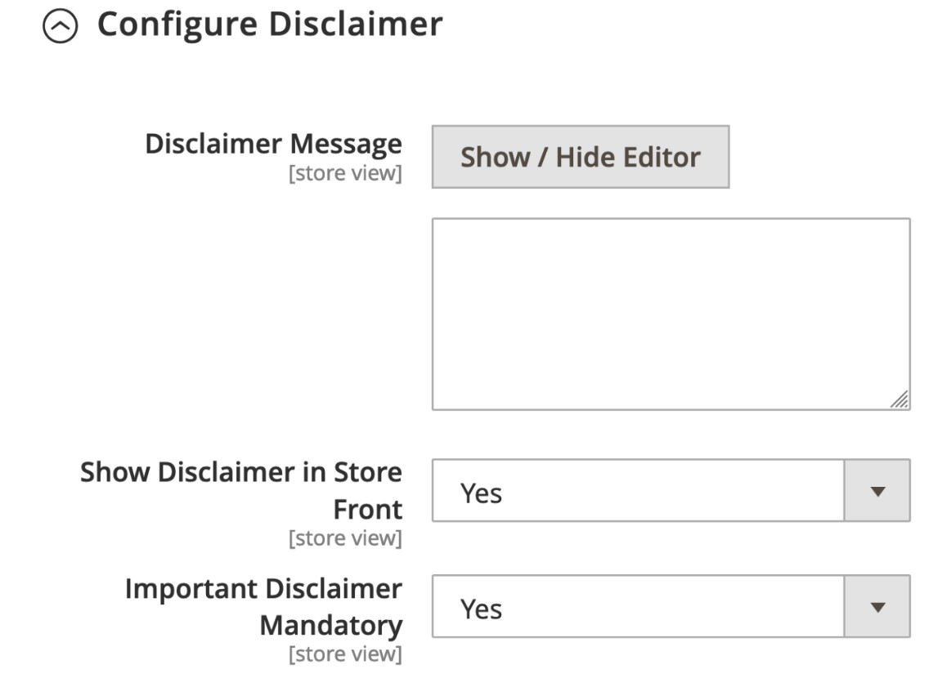

|  |  |
| --- | --- |
| **Configuration** | **Description** |
| **Enable Stored Credentials** | If set to Yes, stored credentials is enabled. |
| **Disclaimer Message** | Write the message that shoppers see. |
| **Show Disclaimer In Store Front** | If set to Yes, a pop-up link to the disclaimer message appears on the checkout page. |
| **Important Disclaimer Mandatory** | If set to Yes, the shopper must agree the disclaimer before they can save their card details. |

**Note**: See the [Worldpay support centre](http://support.worldpay.com/support/kb/gg/stored-credentials-overview/) for more details about disclaimers.

## The shopper’s experience with stored credentials enabled

Once stored credentials are enabled and a disclaimer are configured, the shopper enters a flow in which they can save the card after verifying the disclaimer.

This process typically involves the Magento merchant configuring a disclaimer message to inform users that their card details will be tokenized if they choose to save their card for future use.

The disclaimer provides transparency to the user about how their payment information will be securely stored and used for future transactions.

It outlines the tokenization process, assuring the user of the security measures in place to safeguard their sensitive data.

By presenting this disclaimer, Magento merchants ensure that users can make informed decisions about saving their payment methods, fostering trust and confidence in the e-commerce platform.

Reference Screenshots:

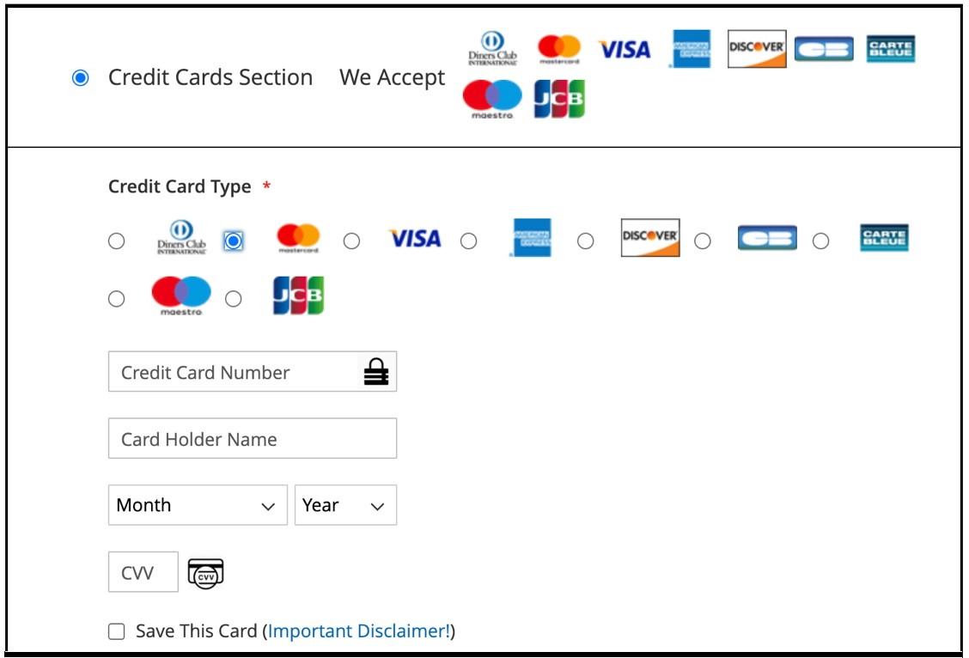

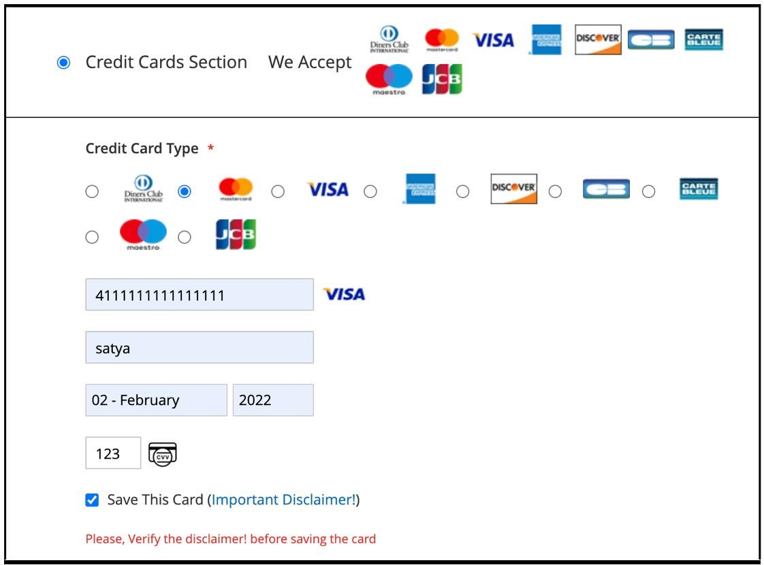

If a shopper attempts to place an order without verifying the disclaimer, they will be prompted to review and accept it before proceeding. This ensures that their card details can be saved securely. Additionally, if the disclaimer is not accepted, a token should not be created for future use, thereby preserving the user's choice and privacy.

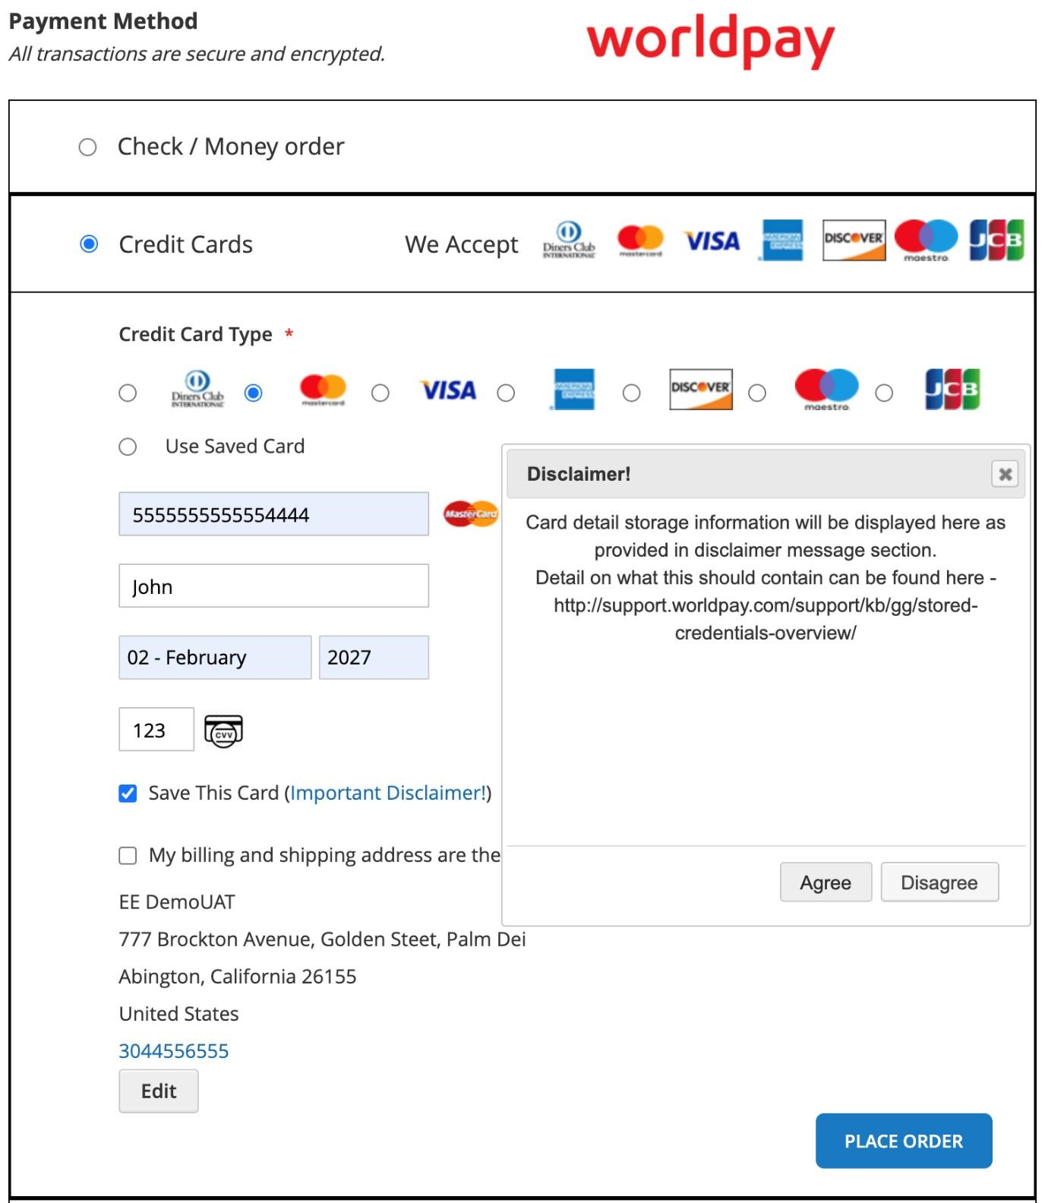

When the shopper clicks the "Important Disclaimer" link, they are presented with the option to either agree or disagree with the disclaimer. In order to both place the order and save the card, the shopper must agree to the disclaimer.

If the shopper chooses to disagree with the disclaimer, the "Save This Card" option will remain unchecked, and the order will proceed without any saved card details.

**The Shopper's Experience when they already have card tokens stored within their account.**

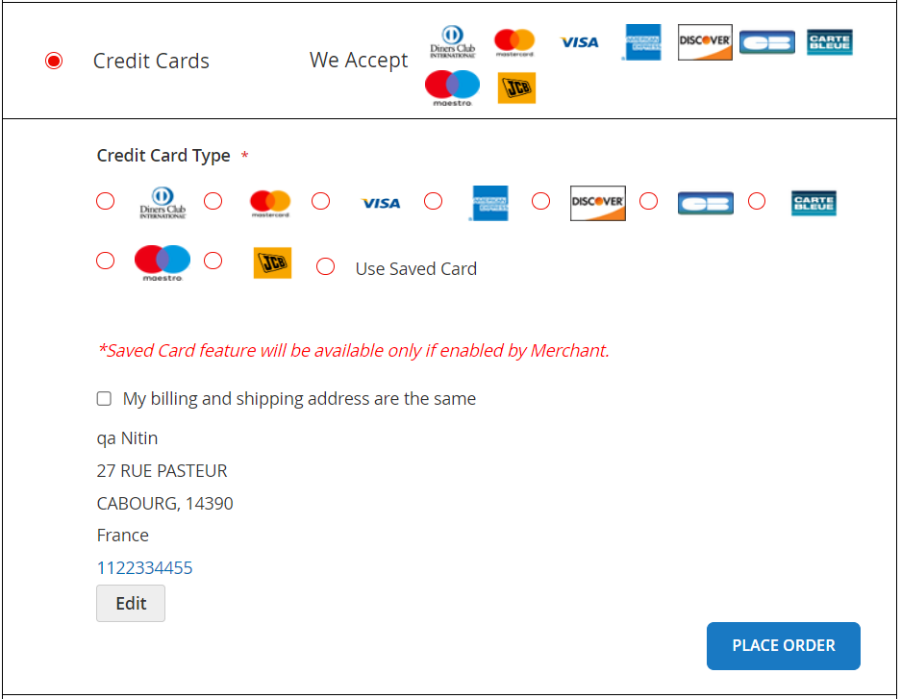

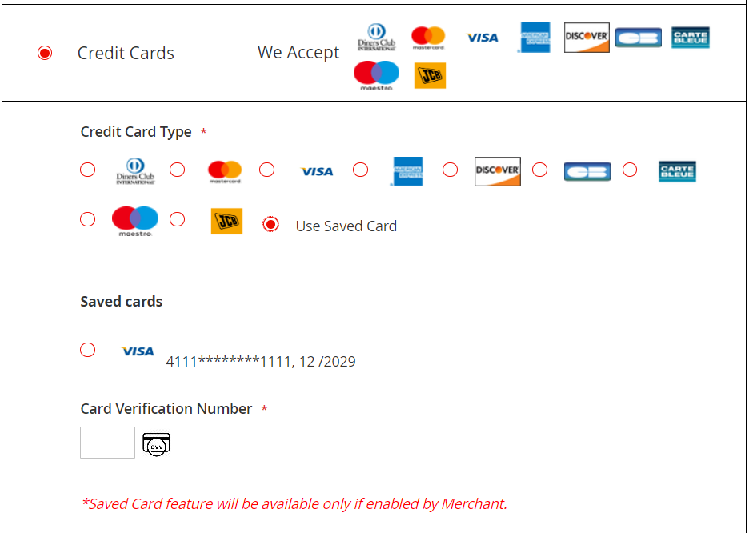

When the shopper clicks on 'Use Saved Card,' they will be presented with all previously tokenized cards. The shopper can then select any one of the cards for payment.

Shoppers can view all their saved cards on the 'My Account -> Saved Cards page.

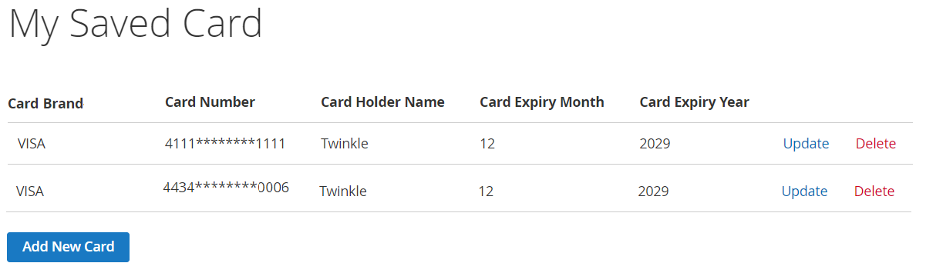

# Hosted payment page

Shoppers can be redirected to a payment page hosted by Worldpay. To enable this, follow these steps:

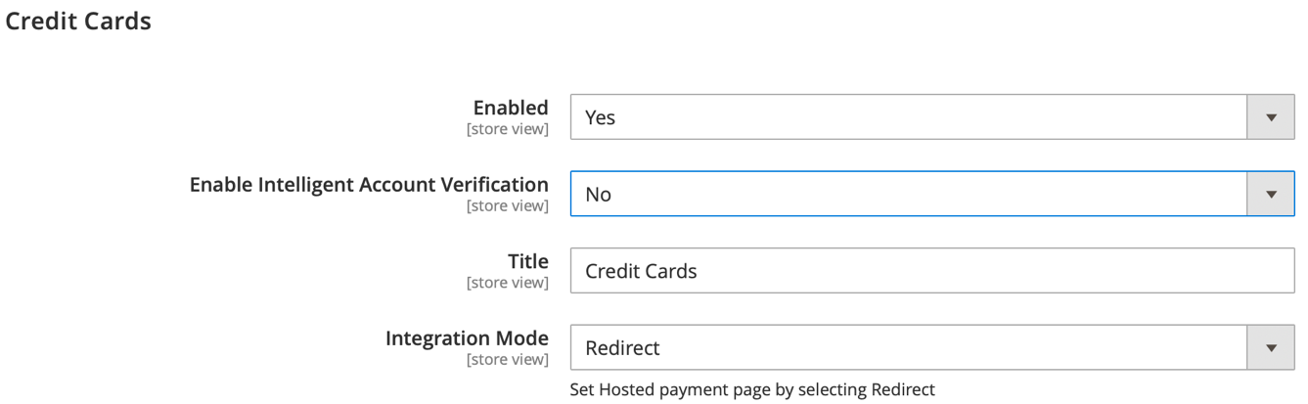

1. Go to Stores/Configuration/Sales/Worldpay/Credit Cards. Set Enabled to Yes and Integration Mode to Redirect.

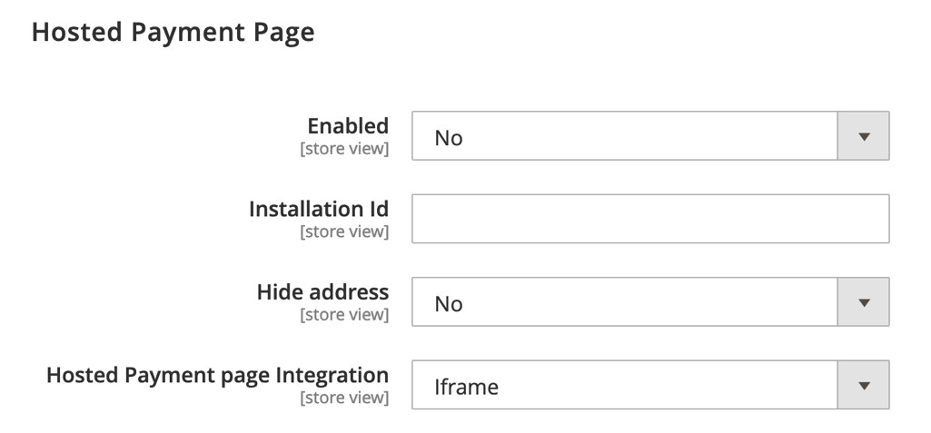

1. Go to Stores/Configuration/Sales/Worldpay/Hosted Payment Page. Set *Enabled* to **Yes** and enter your Worldpay Installation ID.

|  |  |
| --- | --- |
| **Configuration** | **Description** |
| **Enabled** | When set to Yes, a redirection to the hosted payment page is available at checkout. |
| **Installation Id** | Enter the installation ID you should have received from Worldpay and that looks like: 1111111. |
| **Hide address** | Choose whether to hide the billing address of the shopper on the hosted payment page. |
| **Hosted payment page integration** | Choose whether the hosted payment page appears as an iframe or a complete page. |

Once the hosted payment page is configured, shoppers can use this method as described below.

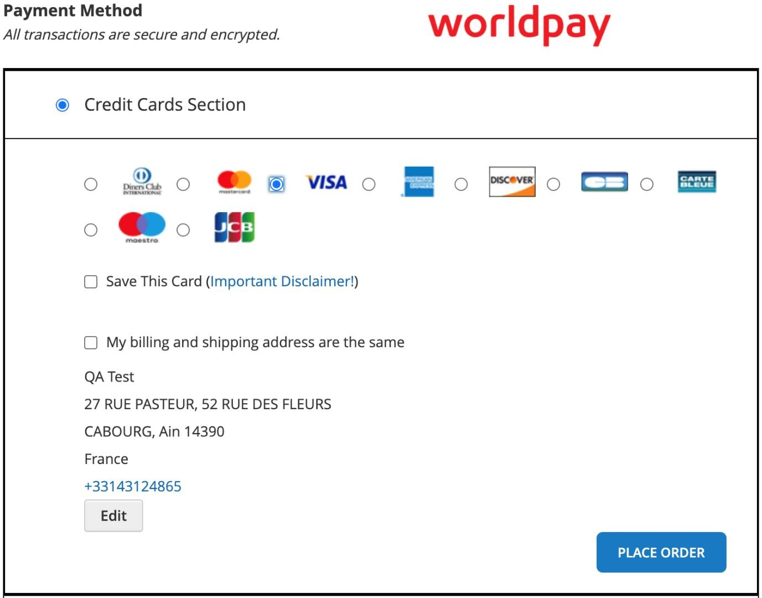

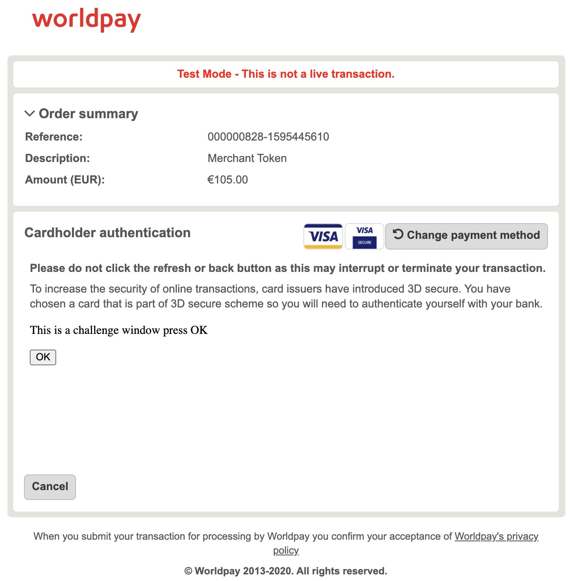

1. The shopper selects their card type and continues to the Worldpay hosted payment page.
2. The hosted payment page appears in an iframe within the Magento application and requests payment details. The shopper completes the details and makes the payment.

## Hosted payment page with 3D Secure

The shopper can complete the 3D Secure authentication on the hosted payment page as shown below:

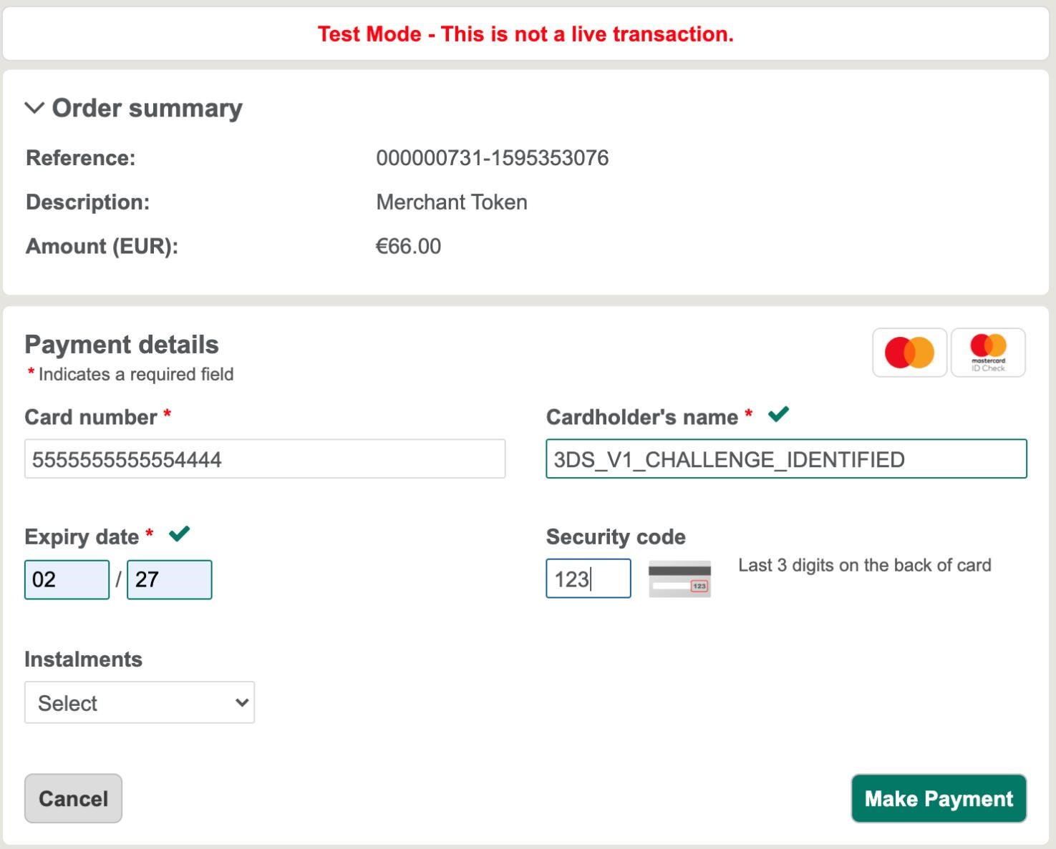

1. The hosted payment page opens in an iframe within the Magento application. The shopper can complete the details of 3D secure authentication and make the payment. This screenshot shows the magic value used to simulate 3D secure authentication.



As the shopper has chosen a card that is part of 3D Secure scheme, they must authenticate it with the bank using the challenge window.

# Mobile Wallets

## Apple Pay

The Apple Pay mobile payment and digital wallet service enables customers to make payments in person, in iOS apps, and on the web. It is supported on the iPhone, Apple Watch, iPad and Mac.

##### Prerequisites

To enable Apple Pay for your customers, you’ll need an Apple Developer account that is associated either with the Apple Developer Program or the Apple Developer Enterprise Program.

Your shoppers can only see Apple Pay as a payment option if they:

* Use an Apple Pay-compatible device
* Use Safari if they are paying on the web
* Are located in a country or region where Apple Pay is available

##### How it works

You can see the transactional flow in the diagram below:

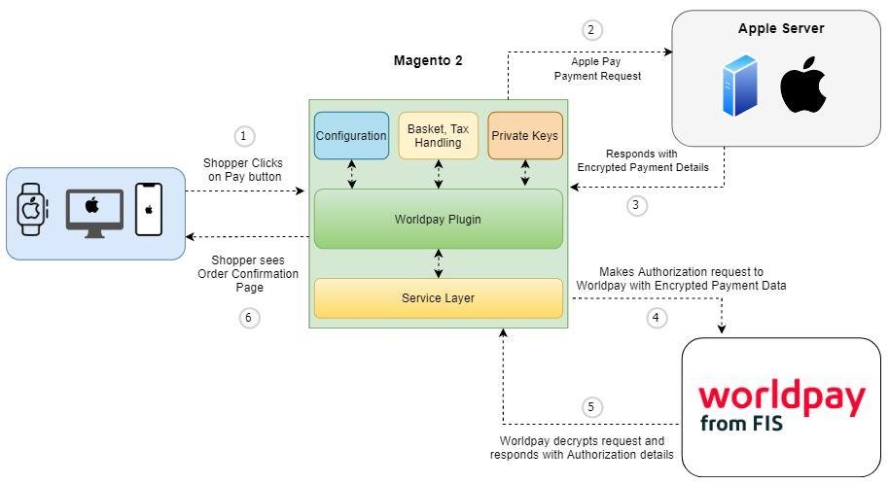

1. The shopper places the order.
2. Magento requests the encrypted payload from Apple Pay.
3. Apple Pay returns the encrypted payload after authentication.
4. Magento sends an XML Direct request for authorization to Worldpay, containing the encrypted Apple Pay data.
5. Worldpay sends the payment response to Magento.
6. The Magento plugin informs the shopper of the outcome.

##### Implementation steps

1. [Create your merchant ID](https://help.apple.com/developer-account/?sub=dev103e030bb#/devb2e62b839) (eg, *merchant.com.worldpay.merchantAccount*) then log in to your Worldpay merchant account.
2. Switch to the mode you’ll be using (test or production), select **Integration** from the left-hand menu and **Apple Pay** in the top menu. You can see these details in the screenshot below:

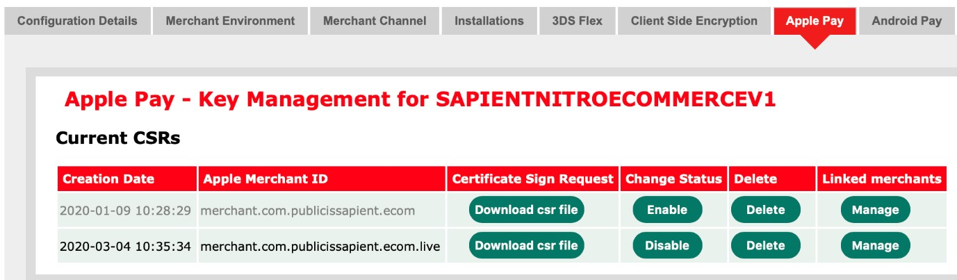

1. Enter your Apple merchant ID and click the **Generate** button (if not generated already). Now you can see the certificate signing request (CSR) that you generated. Download that file so you can create your payment-processing certificate.
2. [Enable Apple Pay](https://help.apple.com/developer-account/?sub=dev3f2891710#/dev4cb6dfbdb) on the Apple developer website.
3. [Create a payment processing certificate](https://help.apple.com/developer-account/?sub=dev103e030bb#/devb2e62b839) on the Apple developer website, but please note the following:

− Make sure you enter the Apple merchant ID you created in step 1

− Skip the step in which you create an Apple-generated CSR

− Instead, select the Worldpay CSR you generated step 1

− Download and save the payment processing certificate you generated (.cer file)

1. When you have completed the steps on the Apple developer website, send the payment processing certificate you downloaded to Worldpay. You’ll then need to wait until Worldpay confirms that the certificate is activated.
2. Register and validate your merchant domain with Apple – For this, you can Contact Worldpay Relationship Manager or Support Team to register the domain for Apple pay.  
   Before you register your domains with Apple you must add [this](https://payments.worldpay.com/.well-known/apple-developer-merchantid-domain-association) file to each domain. Put the file on your domain at this path: /.well-known/apple-developer-merchantid-domain-association.
3. [Create a merchant identity certificate](https://help.apple.com/developer-account/#/dev1731126fb)

For each transaction you must request a session from Apple using your merchant identity certificate. Please note the following when you create your Apply merchant identity certificate:

* When asked for your merchant ID, make sure you enter the Apple merchant ID you created in step 1
* Follow the instructions from Apple for creating a CS R yourself

**Note**: The CSR you generated from Worldpay can't be used for creating a merchant ID certificate. So generate a CSR of your own and use that to generate the merchant ID certificate:

* 1. Download and save the generated merchant ID certificate (.cer file).
  2. When you have completed the instructions from Apple, add the merchant ID certificate to your keychain.
  3. When you create your own CSR, you might also get a private key. Add that file too in your keychain app.
  4. Export the merchant ID certificate from your keychain as a p12 file (see screenshot below).

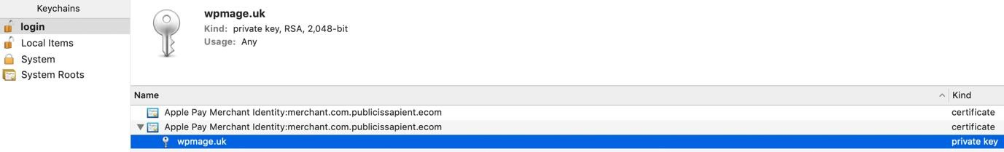

* 1. Make a note of the password you entered in the field shown below

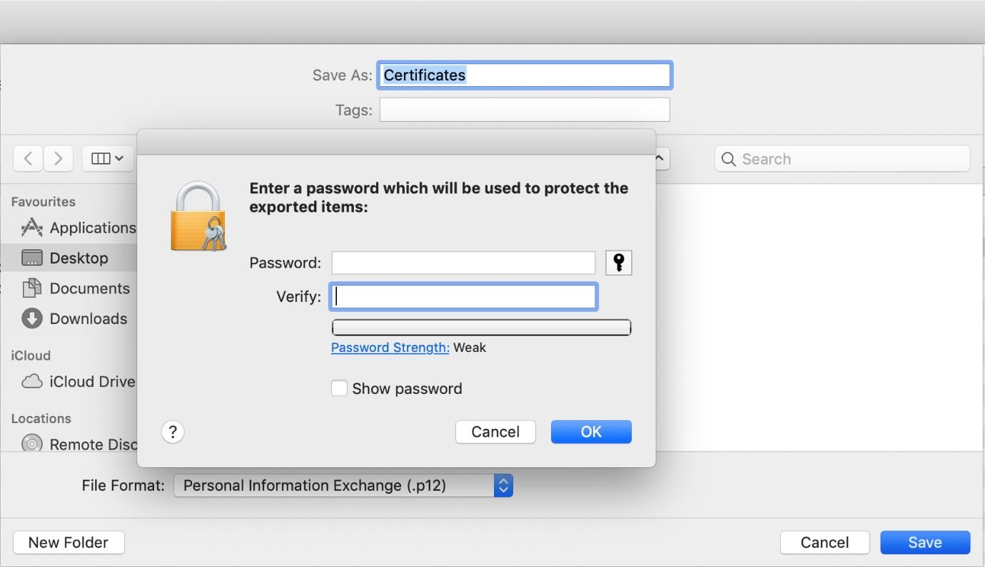

* 1. You must now convert your p12 file to a PEM file using the following command:

openssl pkcs12 -in ApplePayMerchantIdentity_and_privatekey.p12 -out ApplePay.crt.pem -clcerts -nokeys

openssl pkcs12 -in ApplePayMerchantIdentity_and_privatekey.p12 -out

ApplePay.key.pem -nocerts

* 1. When you generate these files you may be asked for your password. If so, use the password you used in step 5. Upload both files to your server: eg, /var/www/html/apple-certs/
  2. Use the following commands to verify the files:

openssl x509 -noout -modulus -in ApplePay.crt.pem | openssl md5 openssl rsa -noout -modulus -in ApplePay.key.pem | openssl md5

* 1. The output of both commands should be the same. You can check this in the section below.
  2. If the output of both commands is not the same, please double-check that you have followed all the previous steps accurately. If both outputs are the same, then you have enabled Apple Pay successfully.

##### How to configure Apple Pay

Go to Magento Admin/Stores/Configurations/Sales/Worldpay

You should see the Apple Pay configuration in the Wallets section. Complete and save these configurations, as shown below, and customers will now be able to use Apple Pay at checkout.

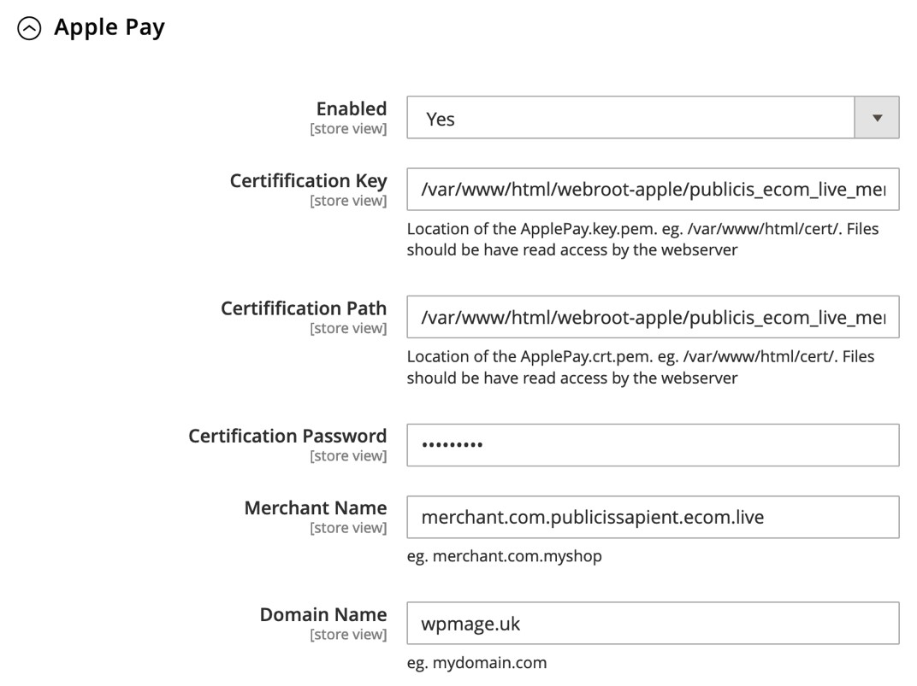

|  |  |
| --- | --- |
| **Configuration** | **Description** |
| **Wallet Enabled and Title** | If set to **Yes**, the wallet section is available at checkout to enable payment by Apple Pay, Google Pay, etc.  The shopper sees the title you enter as the heading for the Mobile Wallet section. |
| **Enabled** | When set to **Yes**, Apple Pay is available at checkout. |
| **Certification Key** | The path of the certification key (pem) file in the server. |
| **Certification Path** | The path of the certification CRT (pem) file in the server. |
| **Certification Password** | Your certificates password. |
| **Merchant Name** | Your Apple merchant ID. |
| **Domain Name** | The domain name you registered with Apple. |

**Note**: CSR keys are unique for test and production environments, and for each Merchant ID.

At checkout, customers see the Apple Pay option in the format in the screenshot below:

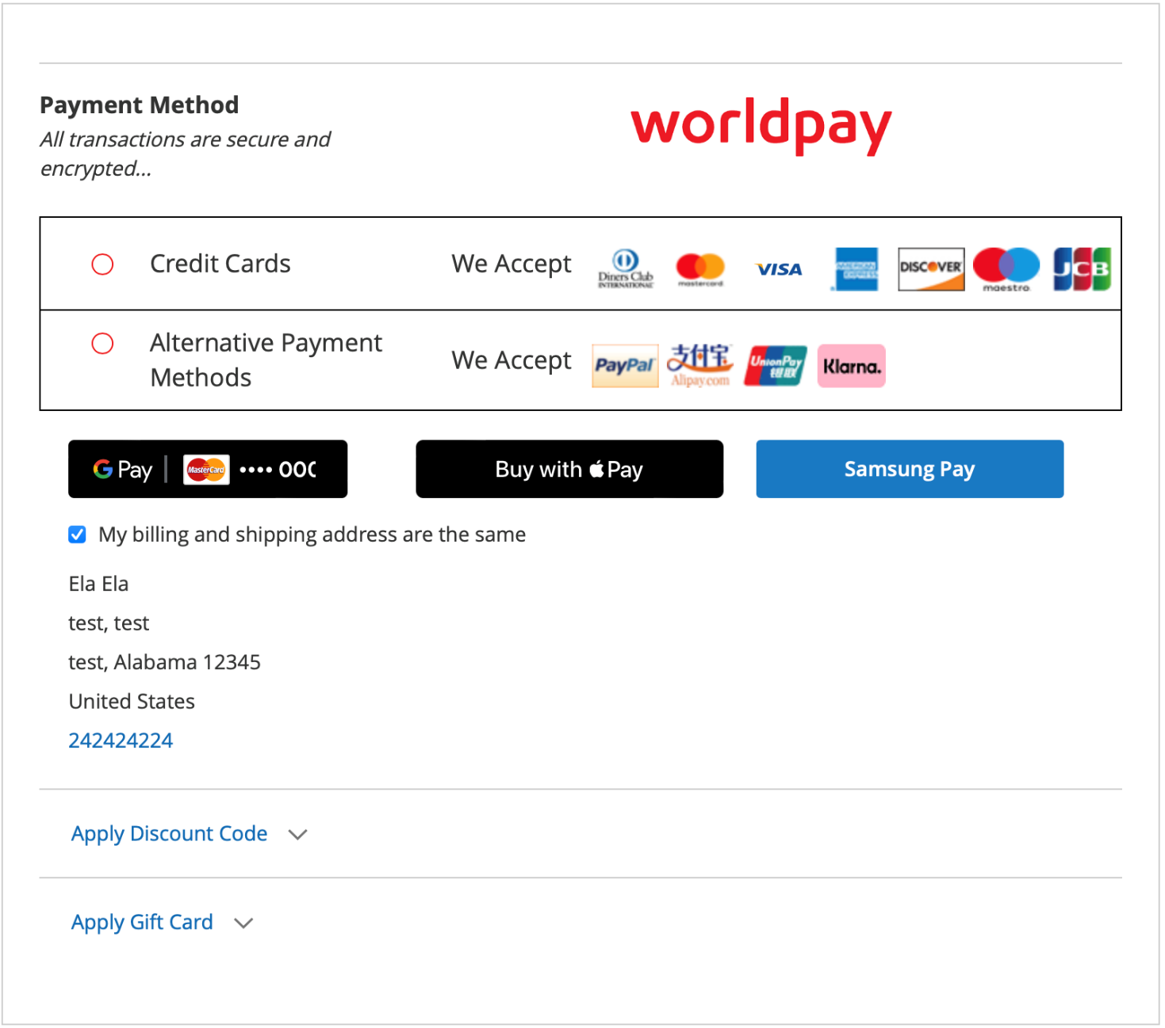

##### Apple Pay in PDP

You should enable admin configuration to display Apple Pay in PDP,

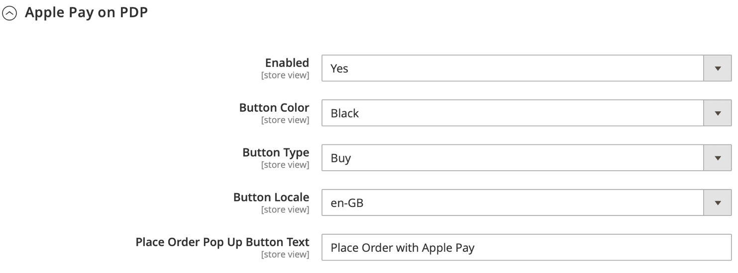

##### The shopper’s experience

Once Apple Pay on PDP is enabled, shoppers see Apple Pay button

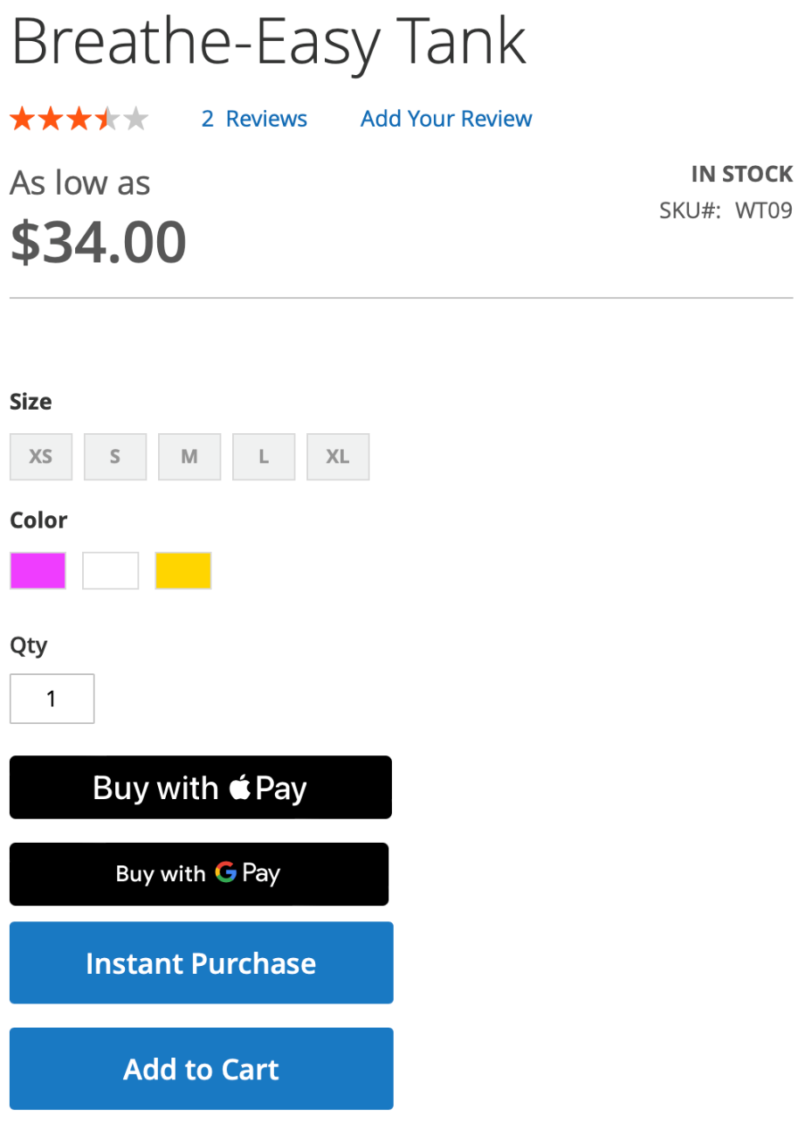

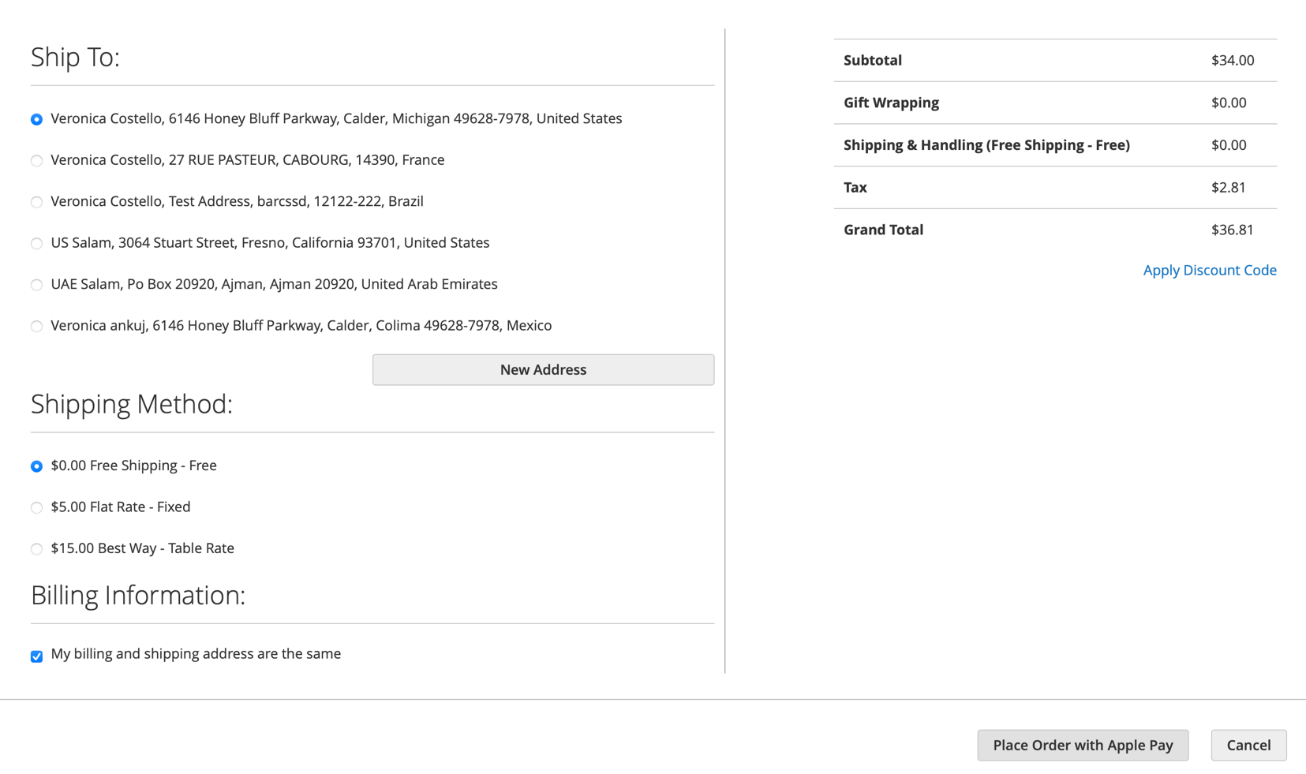

## Apple Pay HPP

##### The Apple Pay HPP integration enables your customers to make payments using Apple Pay directly within WorldPay's hosted payment page.

This guide assumes you have a Hosted Payment Page integration with Worldpay. If you do not, talk to your Worldpay Relationship Manager or Support Team before you proceed.

##### Prerequisites

Before you begin, you must:

1. Have a HPP integration with Worldpay
2. Verify your domain (Iframe/Lightbox only) with Apple Pay
3. Have a Worldpay merchant code

There are two configuration available for Apple pay HPP

1. Full Page Redirect
2. Lightbox/Iframe Integration

Full Page Redirect:

There are no integration requirements for Apple Pay with Worldpay Hosted Payment Pages (HPP), but you must complete the registration process:

Register full Re-direct for use in Production.

1. Login to the Production MAI, go to the Apple Pay tab and scroll down to Hosted Payment Pages
2. Contact Worldpay Relationship Manager or Support Team to register the domain for Apple pay HPP
3. Review the Apple Pay terms and conditions.
4. Tick the box to confirm acceptance of the Apple Pay Terms and Conditions

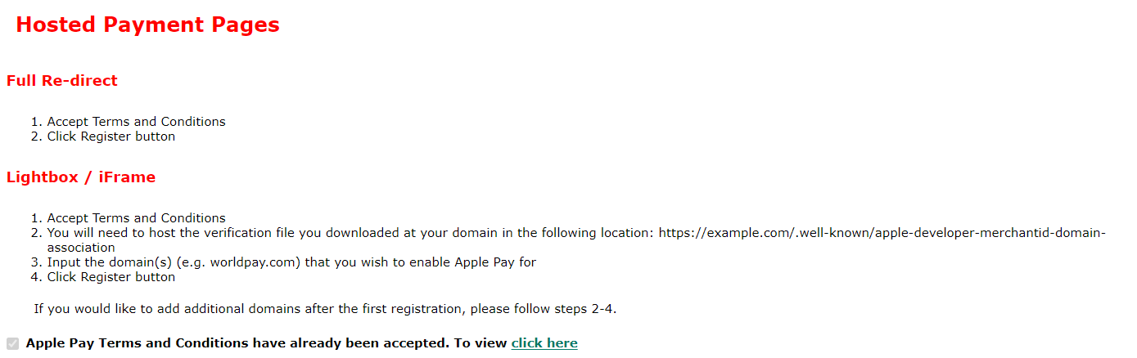

1. In the Production MAI you can enable/disable Secure Test and Production environments for this merchant code. The registration with Apple Pay applies to all your merchant codes but you must enable each code for Production individually.

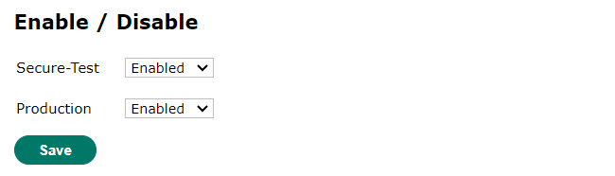

LightBox / Iframe:

The process to enable apple pay HPP in lightbox / Iframe is similar to Full Page redirect except one difference:

Before you register your domains with Apple you must add [this](https://payments.worldpay.com/.well-known/apple-developer-merchantid-domain-association) file to each domain. Put the file on your domain at this path: /.well-known/apple-developer-merchantid-domain-association.

##### The shopper’s experience

Once the Apple Pay HPP configuration done, The shopper will see Apple pay Express Checkout button on HPP Page.

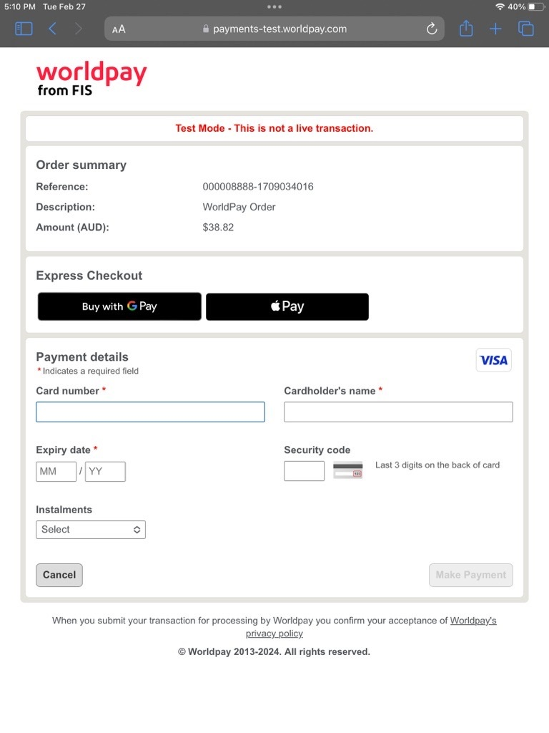

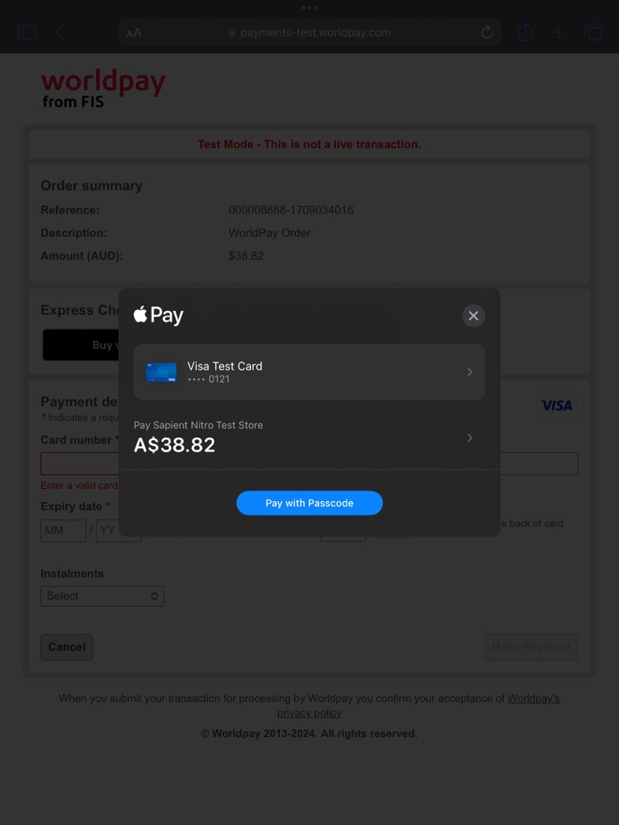

## Google Pay

Google Pay lets your customers pay with a single click, using payment methods saved in their Google account.

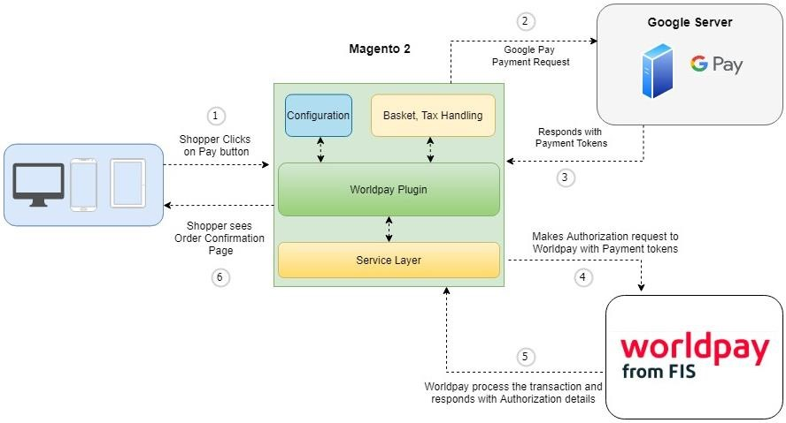

1. The shopper places the order.
2. Magento requests the payment token from Google Pay.
3. Google Pay returns the payment token.
4. Magento sends an XML Direct request for authorization to Worldpay, containing the payment token.
5. Worldpay sends the payment response to Magento.
6. The Magento plugin informs the shopper of the outcome.

You can enable Google Pay payments, as seen in the screenshot below, at

Admin/Stores/Configuration/Sales/Worldpay/Mobile Wallets

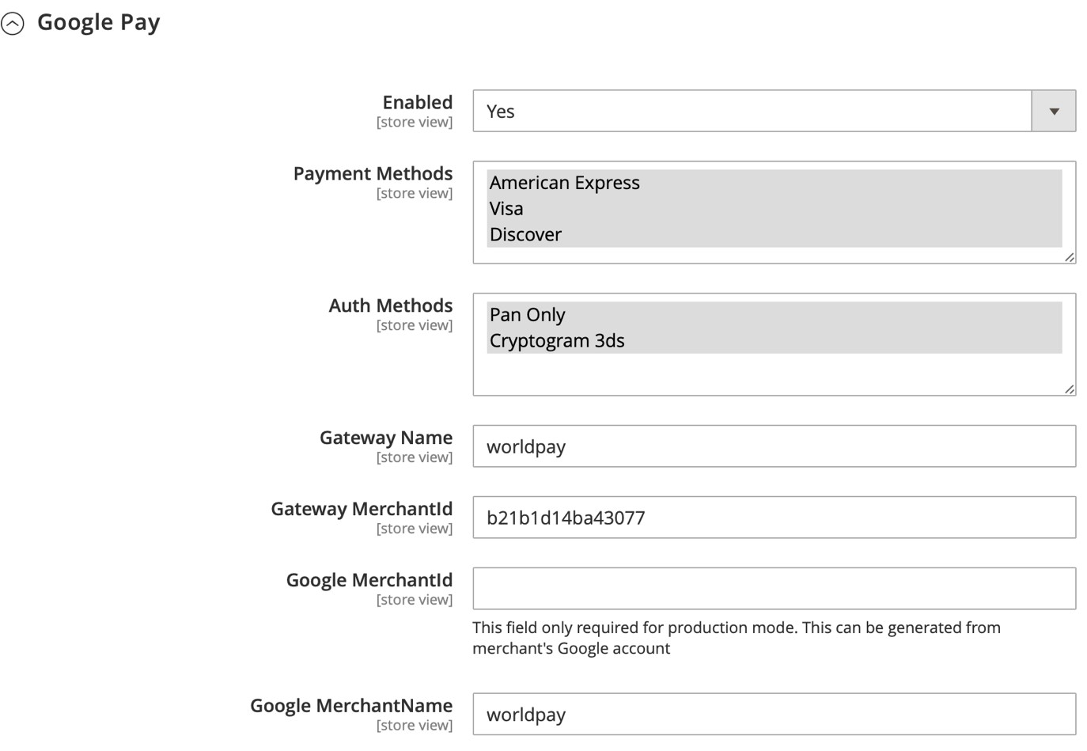

The highlighted fields indicate that you can select multiple items.

**Note**: In order to use production mode, you must first submit a request to Google to have your account activated.

You will also need to set the configurations shown in the screenshot above:

|  |  |
| --- | --- |
| **Configuration** | **Description** |
| **Enabled** | When set to Yes, Google Pay is available at checkout. |
| **Payment Methods** | Supported credit cards. |
| **Authentication Methods** | PAN_ONLY: Personal account number.  CYRPTOGRAM_3DS:3D Secure authentication. |
| **Gateway Name** | Set this to worldpay |
| **Gateway MerchantId** | Your Worldpay merchant ID. |
| **Google MerchantId** | Your Google merchant ID. |
| **Google MerchantName** | You can configure this in your Google merchant account. |

To change between test and production environments, go to the General Configuration section:

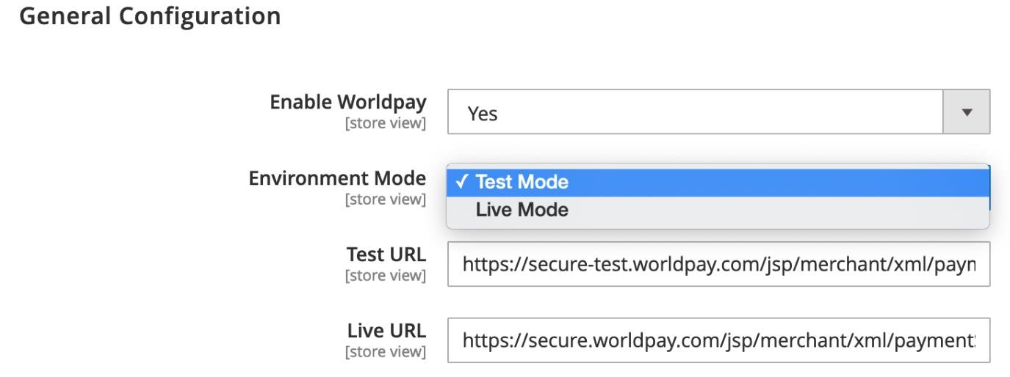

##### The shopper’s experience

Once Google Pay is enabled, shoppers see it as an option at checkout:

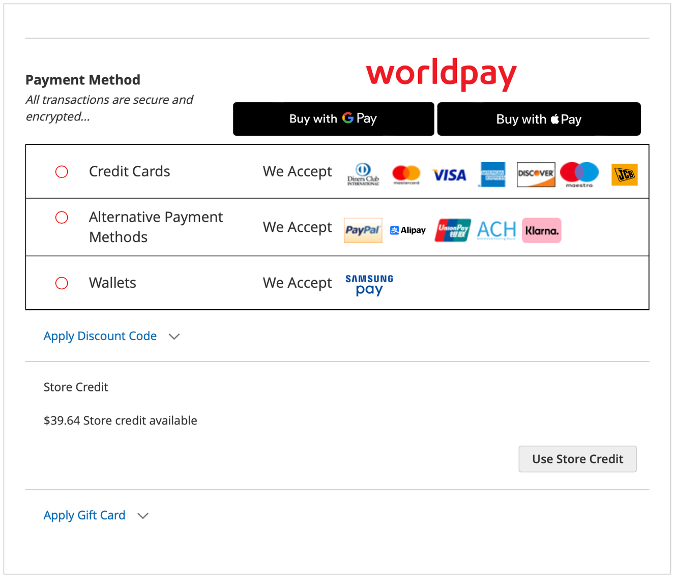

After clicking the **Place Order** button, the shopper sees their saved card details in their Google account, if they have already signed in to their Google account. If they haven’t signed in, Google asks them to.

If the shopper doesn’t have a saved card in their Google account, they are asked to enter their card details.

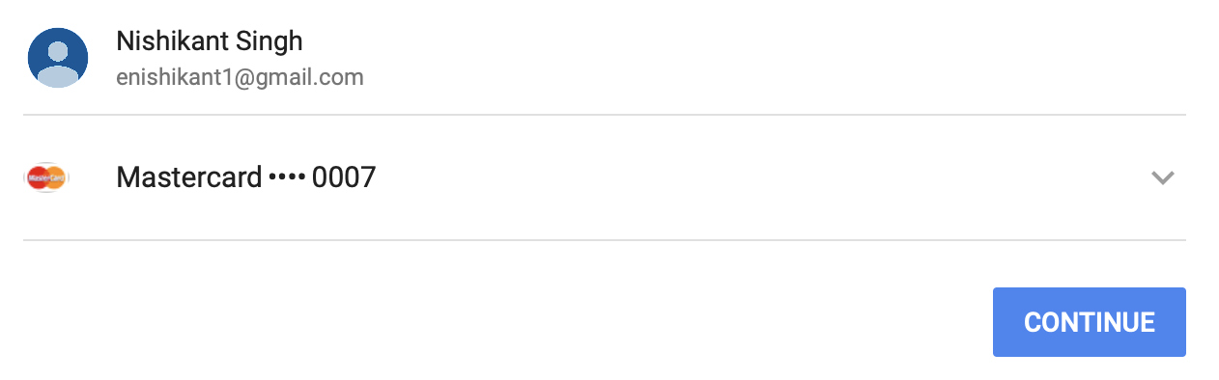

If the payment is approved by Google and Worldpay, the customer sees a success page:

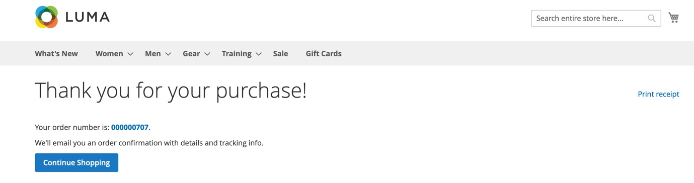

Google Pay supports Strong Customer Authentication 3DS2.

##### Google Pay – HPP

##### The Google Pay HPP integration enables your customers to make payments using Google Pay directly within WorldPay's hosted payment page.

##### Prerequisites

This guide assumes you have a Hosted Payment Page integration with Worldpay. If you do not, talk to your Worldpay Relationship Manager or Support Team before you proceed.

##### How to enable Google Pay HPP button on HPP Page

Note: You must have an Admin user account to change the Google Pay settings in the MAI. Your Admin user account must also have the permissions for Google Pay management ticked in the user settings.

1. Use your Admin user account to log into the MAI.
2. Make sure you are in the Production environment of the MAI. This environment has a grey background color, and the toggle switch at the bottom of the column on the left says Production Mode. If you are in the Test environment, the background color is purple, and the toggle switch says Test Mode. Click the purple button to change from Test mode to Production mode.
3. Click INTEGRATION from the menu on the left, the integration screen appears.
4. Click the Google Pay tab.
5. Tick the checkbox to Accept the Google’s Terms & Condition.

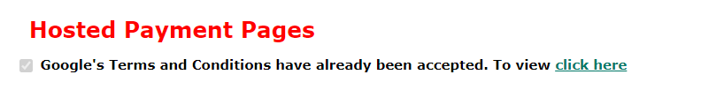

1. Change the Secure-Test switch to Enabled, and the Production switch to Enabled.

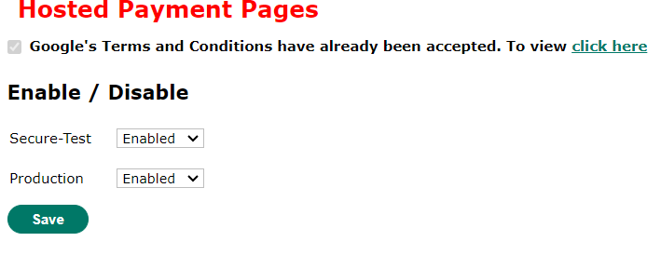

1. Click Save

##### The shopper’s experience

Once GooglePay Express Checkout Button is enabled then shopper will see Googlepay Express Checkout button on HPP Page.

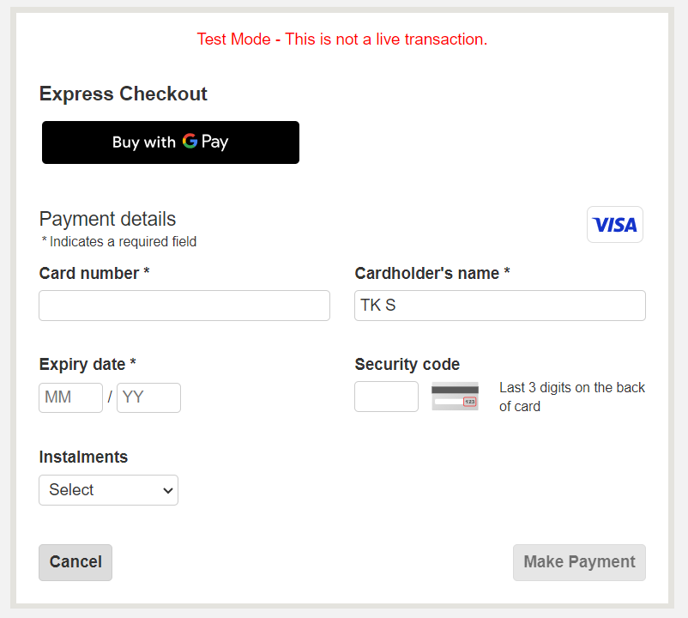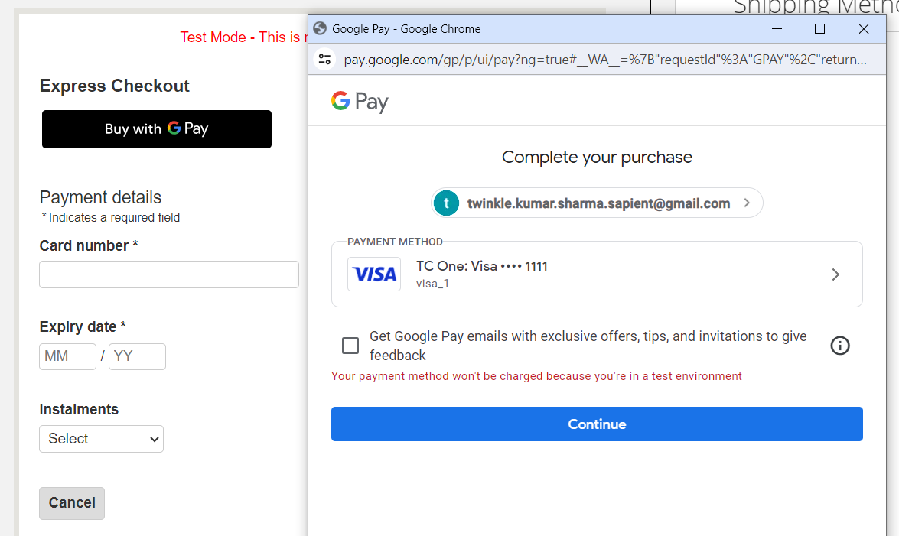

##### Google Pay in PDP

You should enable admin configuration to display Google Pay in PDP,

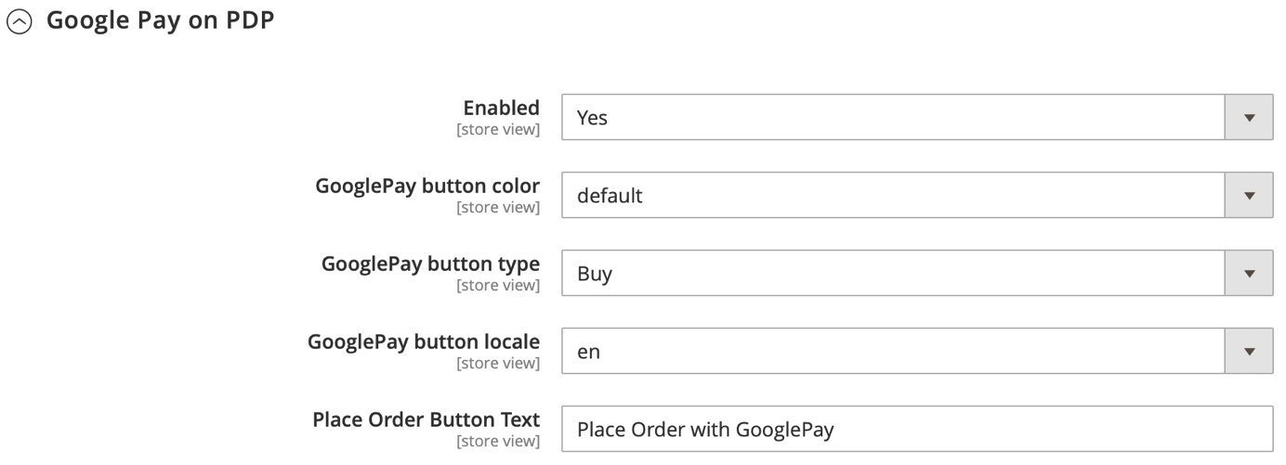

##### The shopper’s experience

Once Google Pay on PDP is enabled, shoppers see Google Pay button in PDP

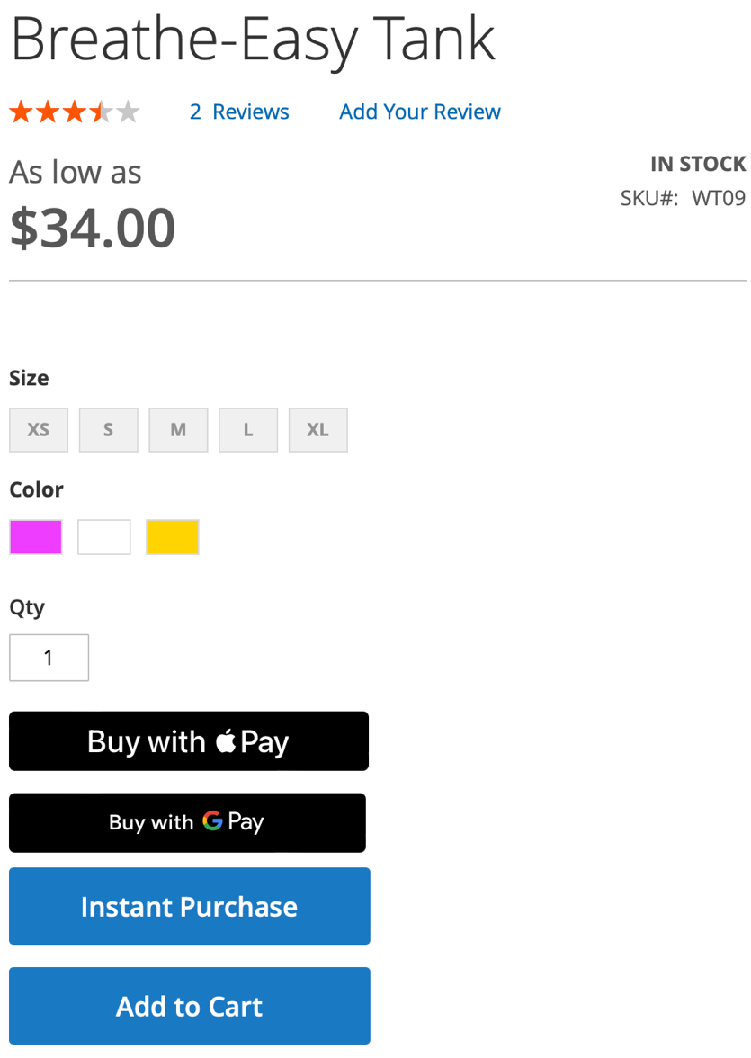

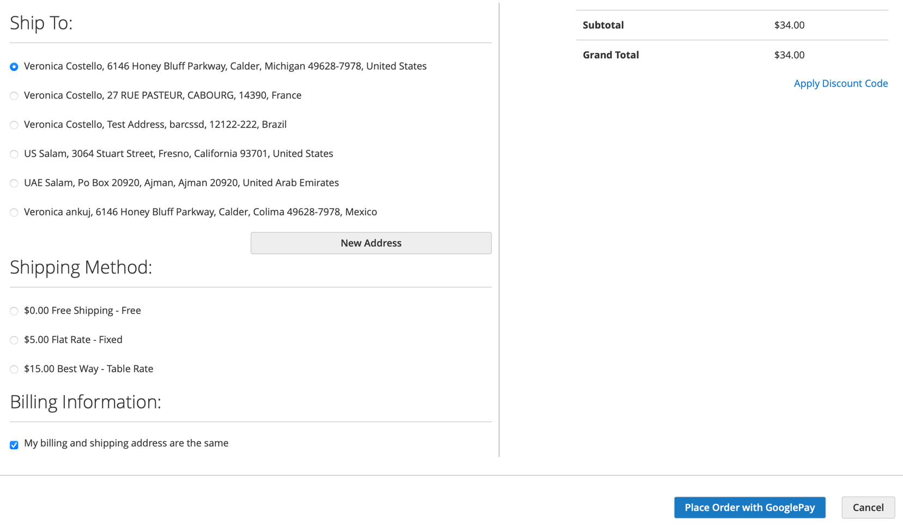

## Samsung Pay

**Introduction:**

Samsung Pay is distinguished both by cutting edge technology as well as backward compatibility that makes acceptance easy for everyone. Apple Pay, Google Pay and Samsung Pay are all digital wallets that use NFC, which stands for near-field communications. NFC makes secure data transmission from a mobile device to a point of sale (POS) system possible.

##### Pre-requisites

* User should have Samsung Pay enabled mobile device, even for PC payments
* Acquirer/Issuer must support tokenized transactions for In-App as per card network specifications
* The domain name and development IP address should be whitelisted from the Samsung server
* Worldpay to enable Samsung Pay on your account

##### Facts

• Support for PC and mobile browser-based payments, using cards tokenized on mobile device user identification and device binding. This is based on Samsung account ID (email ID) • Require server-to-server integration between Samsung and the partner’s backend server • User authentication and payment credential generation occurs in the user device

##### Payment through PC Web

You can provide a *Samsung pay* option for payment on your web site. The user selects *Samsung pay* option to pay. The payment requesting push message arrives in the user’s device and the payment can be confirmed by user authentication. The generated payment cryptogram and data is passed to your system. Then it is passed to the PG (Payment Gateway) and card network side for transaction approval.

##### Integration preparation

For onboarding as a new partner of the Samsung Pay web checkout service, give the information below to the Samsung Pay team so that they can register it at the admin portal. After registration, the Samsung Pay team will give you your “service ID.” Use the service ID to integrate with the Samsung Pay web checkout APIs and web checkout UI.

**Service Name:**

Give PG or Merchant service name.

**Domains:**

This is used for verifying the server-to-server API call. The Samsung web checkout API server uses this field to compare the domain or IP that calls the API. If they do not match, the transaction creation fails.

**CSR:**

Give the CSR (Public) file to the Samsung Pay team. If you have separate files for both the development and production environment, give these two files together. The Samsung Pay team use the admin portal to register it. Payment credential data is encrypted using this CSR.

**Development server Ips:**

Give your development server IPs – this is to register them in the firewall exception list in the Samsung dev.

environment. Once registered, the Web UI and web checkout API server in the Samsung development environment are opened for these IP addresses.

**Production server Ips:**

Give your production server IPs – this is to register them in the firewall exception list in the Samsung production environment for server-to-server connection. Once registered, the Web checkout API server is opened for these IP addresses.

**Developer Ips:**

For testing, developers must manually call web checkout APIs. To support this, Samsung need the developers’ IP addresses from your side. These should be external IP addresses such as proxy server IP. Then Samsung team will also register them.

After doing this registration task, the Samsung team will give you your **service ID** for the web checkout service. Service ID is very important because it is used for the whole flow of web checkout service. The Samsung team will give two service IDs, one is for development environment and the other one is for production environment.

**Service ID:**

Unique identifier for identifying your system in Samsung web checkout service. It is used for the whole flow of the web checkout service. Read this document for information and keep it for reference.

**Architectural Diagram:**

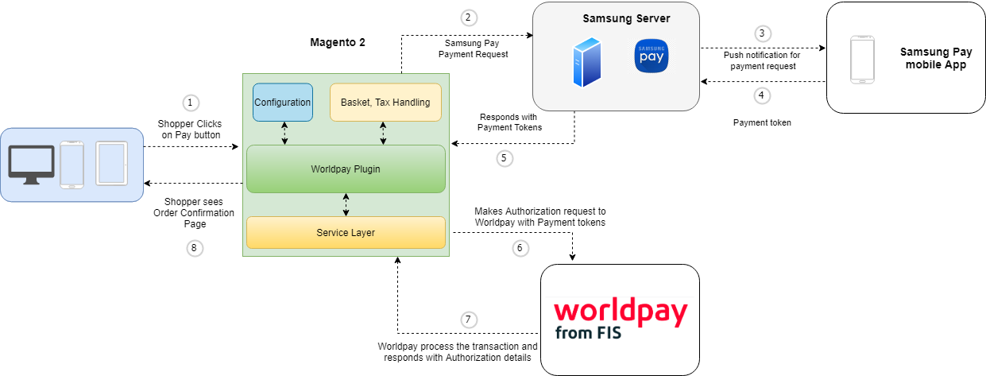

1. Web checkout initiates the Samsung Pay wallet.
2. Samsung Pay returns the encrypted payload following shopper authentication.

1. The plugin sends the encrypted payload to your server.
2. The plugin sends an XML Direct request to Worldpay containing the encrypted Samsung Pay data.
3. Worldpay sends the Authorization response.
4. The plugin informs the shopper of the outcome (order success / failure).

**Admin Configuration:**

You can find the Samsung Pay admin configuration under mobile wallets in

Admin/Store/Configuration/Sales/Worldpay/Mobile Wallet/Samsung Pay

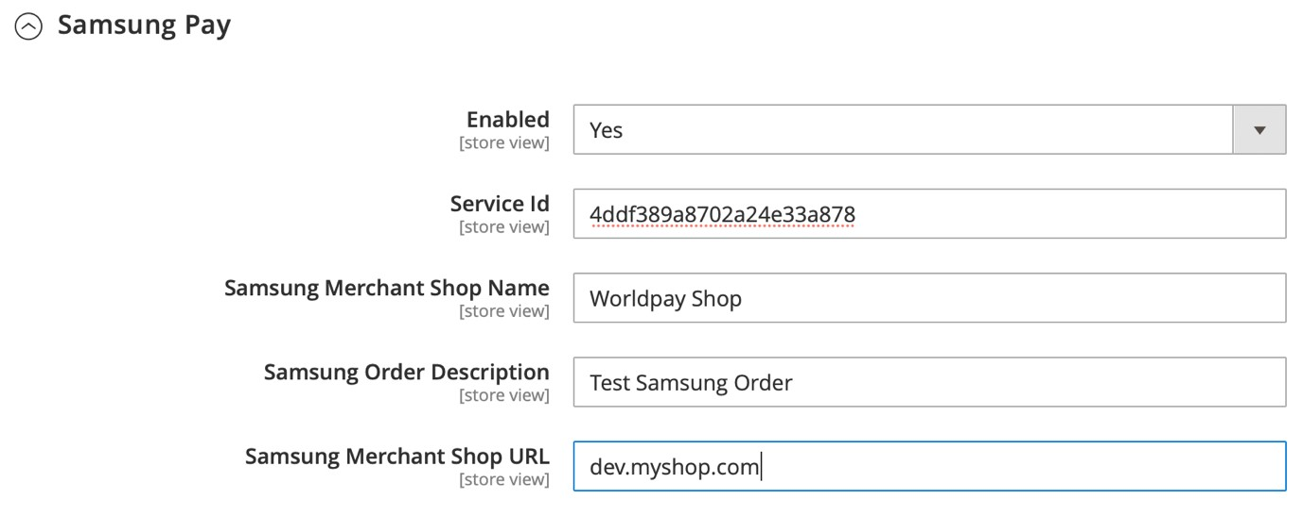

You can enable/disable from the above configuration

Note: Limited Card Brands (Visa and MasterCard) supported by Worldpay plugin currently.

**Test / Live mode:**

You can change the environment in General Configuration section,

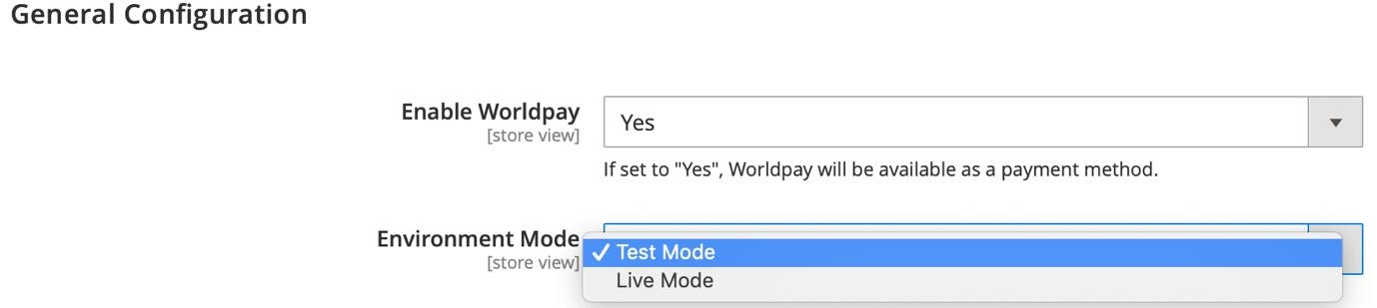

You don’t need to change the API URL, it will be changed based on this selection.

##### The Shopper experience

1. Place order using Samsung Pay from the Magento checkout page.

1. Once authentication is successful, the shopper is redirected to Samsung Pay page.

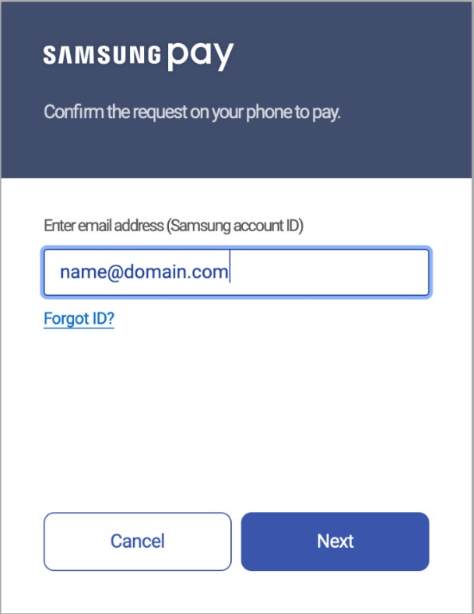

1. After submitting Samsung account ID, Samsung checks for the registered device under that account ID and triggers a push notification to that device. The User has to accept/reject the payment in 5 minutes before this expires.

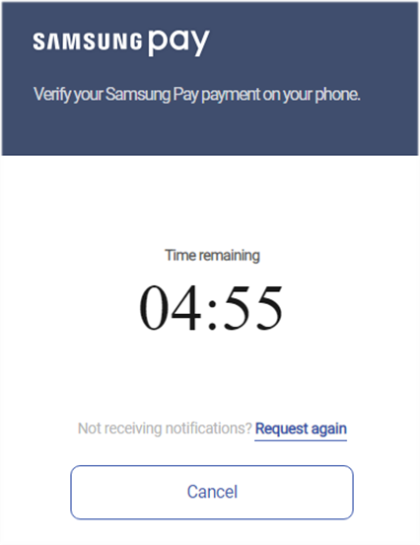

1. a: Push notification triggered to Samsung phone.

b: Need to authorize the device on Samsung phone.

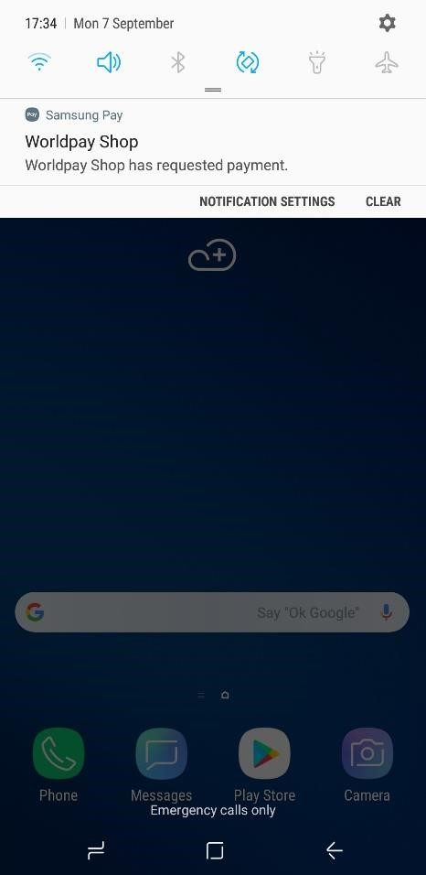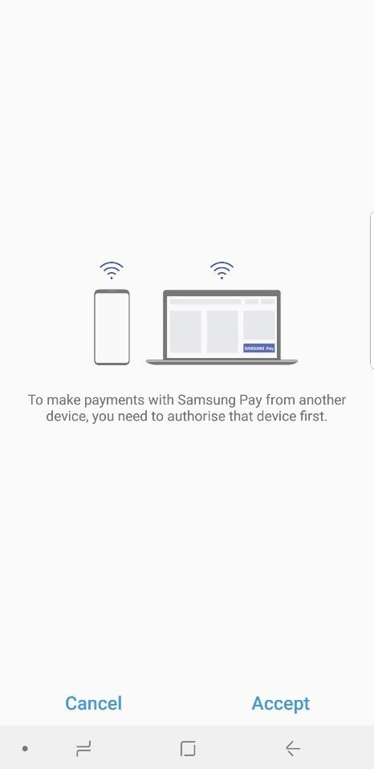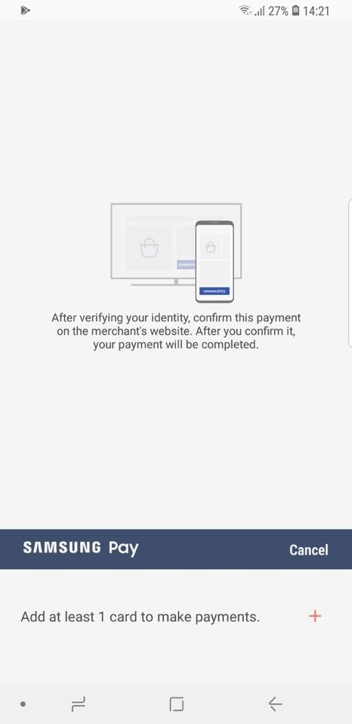

1. Add a card to make the payment and if a card is already available please continue with the payment using Samsung Pay PIN. Supported card brands are Visa and MasterCard.
2. Payment can be accepted and verified or it can be rejected.

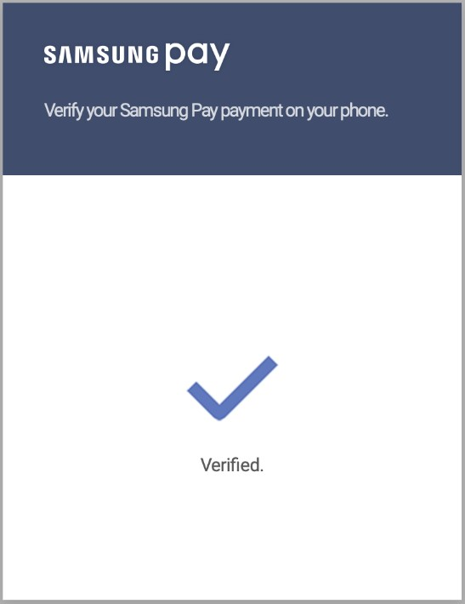 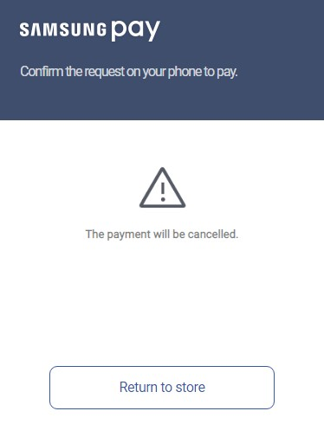

1. The payment is verified now so the user is redirected to the shop page with a success message,

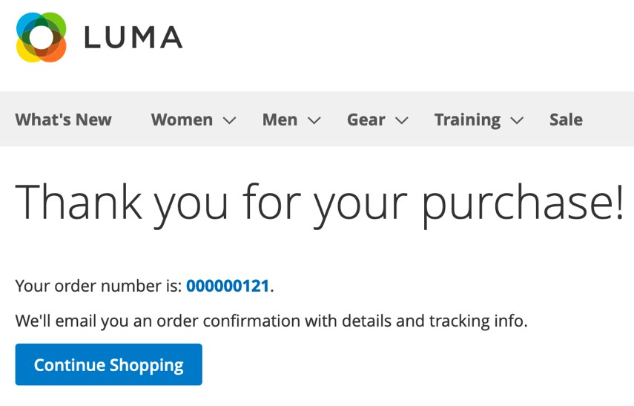

1. You can see the order in Magento admin in Sales/order,

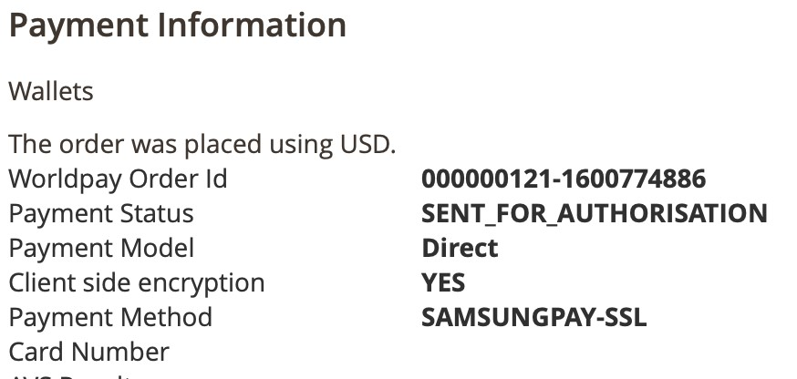

1. For any reasons the payment is not done due to authentication failed/if user clicked cancel order button/if user clicked Return to Store button, from Samsung Payment page, then user is redirected to the shop cart page URL and that order will be cancelled, and the same cart is restored.

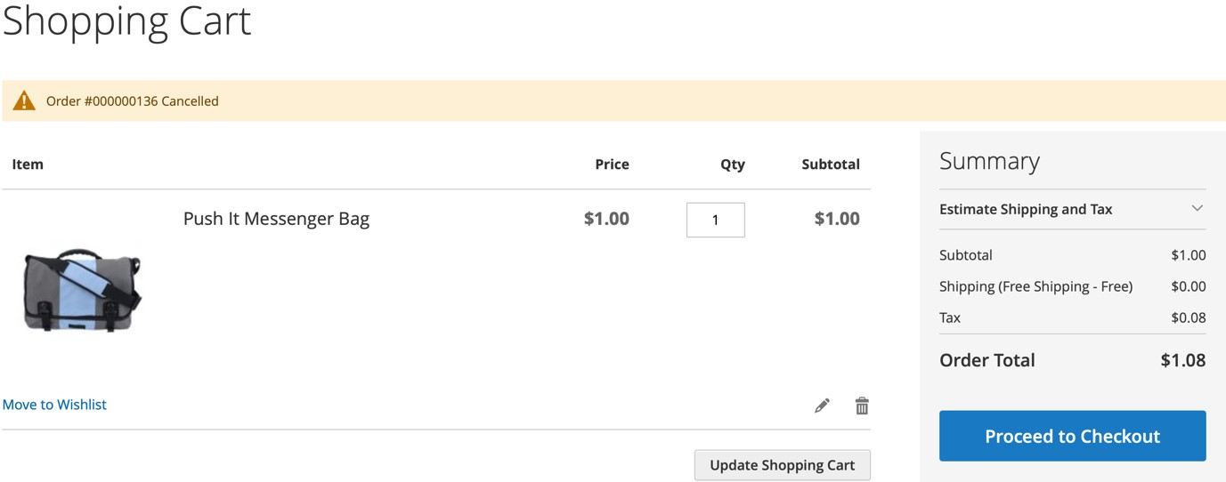

**Reference:**

1. <https://pay.samsung.com/developers/resource/guide>
2. <https://developer.worldpay.com/docs/wpg/mobilewallets/samsungpay>

# Chrome Pay: payment request API

This feature is experiencing issues with Chrome version 100 and above. We will release the patch for the same later.

To speed up the checkout process, Chrome Pay collects saved data from the Google Chrome browser and displays that data within checkout forms.

Shoppers see a single pop-up window that they use to confirm or change their details (billing and shipping address, and their choice of saved credit cards).

To configure Chrome Pay, go to Store/Configuration/Sales/Worldpay/Google Chrome Payment Request API.

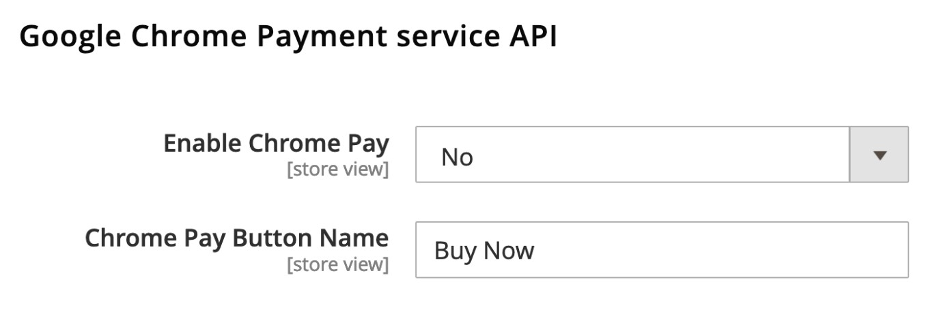

|  |  |
| --- | --- |
| **Configuration** | **Description** |
| **Enable Chrome Pay** | If set to **Yes**, Chrome Pay is available in the shopper’s cart. |
| **Chrome Pay Button Name** | Customize the **Button** label to access Chrome Pay. |

**Note**: The Chrome Payment Request API only works if the integration mode is set to Direct at Store/Configuration/Sales/Worldpay/Credit Cards

Once Chrome Pay is enabled, shoppers see a **Buy Now** button in their cart, as shown below:

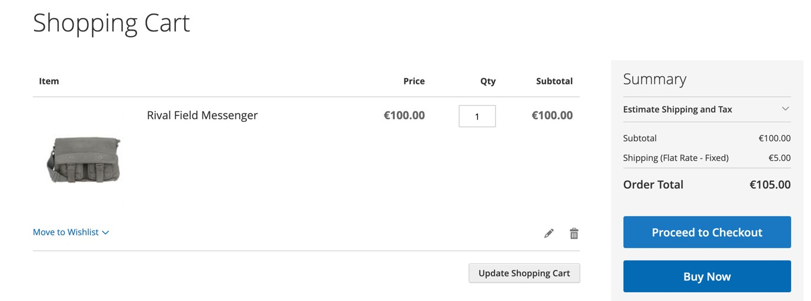

When the shopper clicks **Buy Now,** the Chrome payment request API displays the pop-ups shown below:

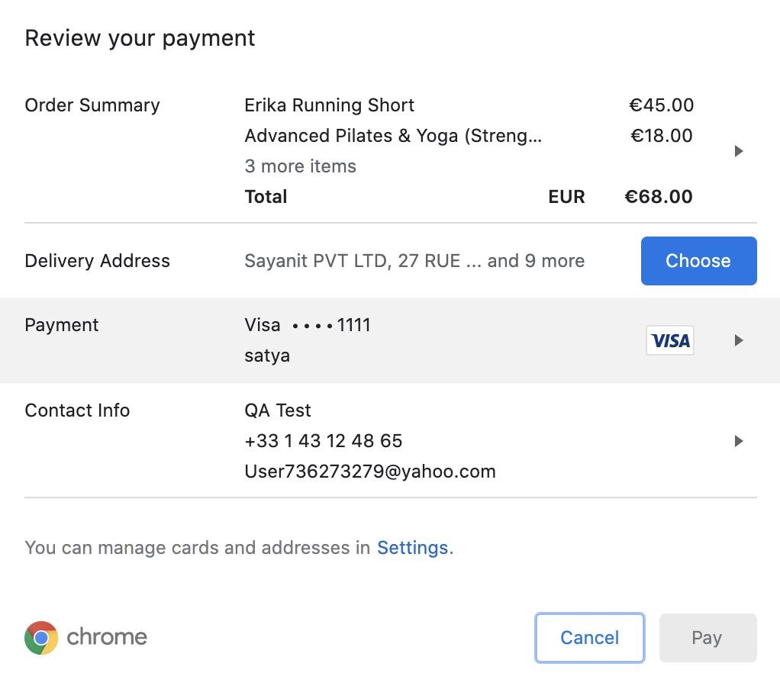

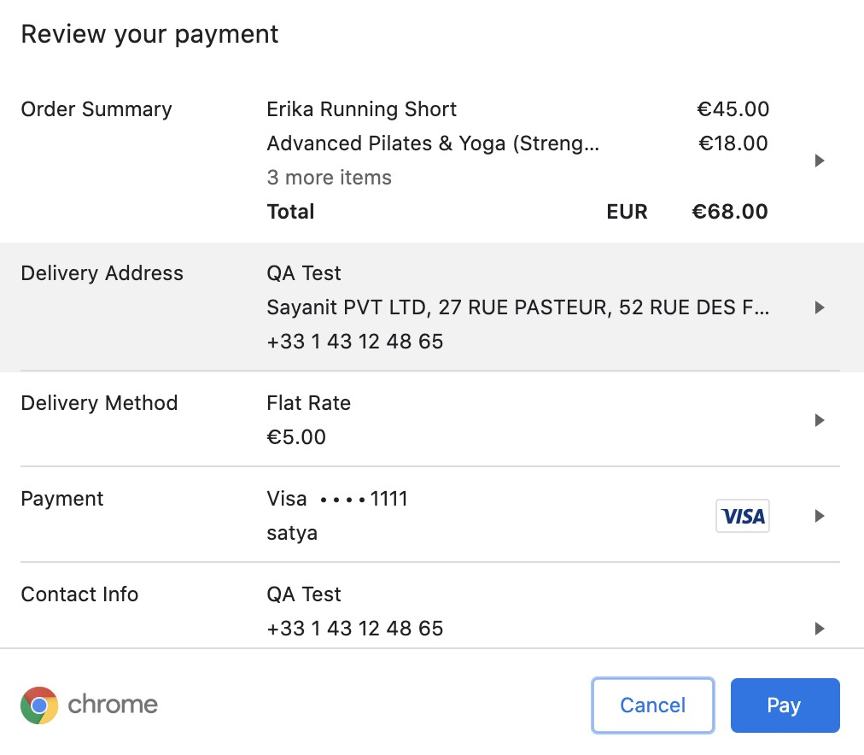

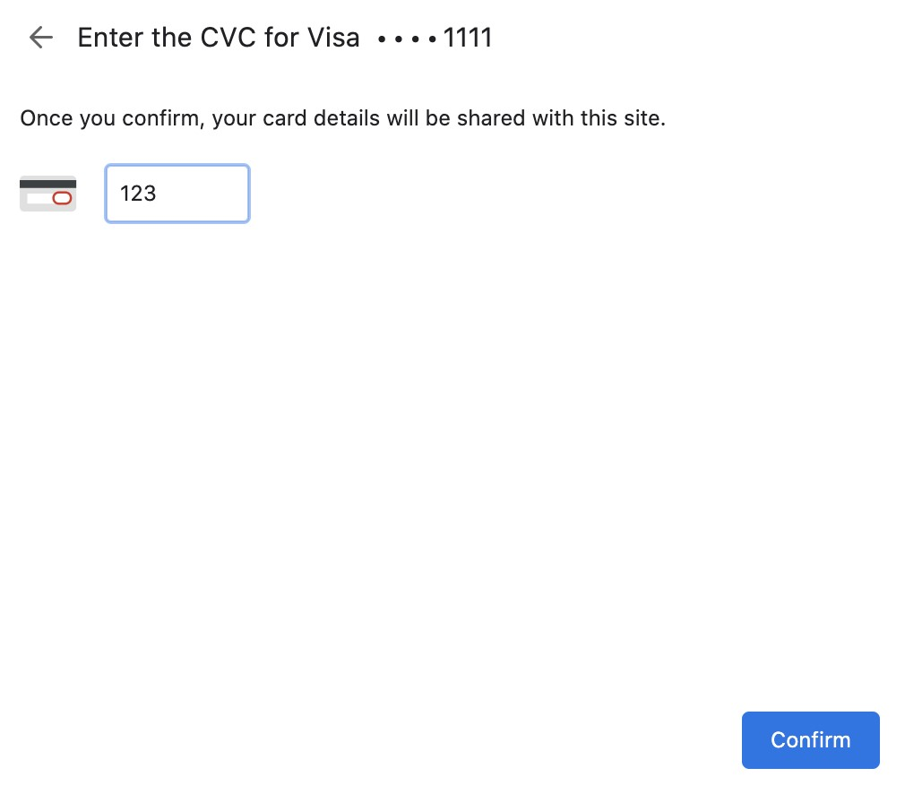

Shoppers must:

1. Choose their shipping address and shipping method, then choose the payment method.
2. Click the **Pay** button to complete the order.
3. Enter their CVC details to confirm the payment.

**Chrome Pay 3DS-2**

The Chrome Payment services API supports strong customer authentication 3DS2.

### MOTO payments

This feature enables call center staff to place mail-order and telephone orders on behalf of shoppers. It only supports direct credit card integration, with no 3D secure authentication.

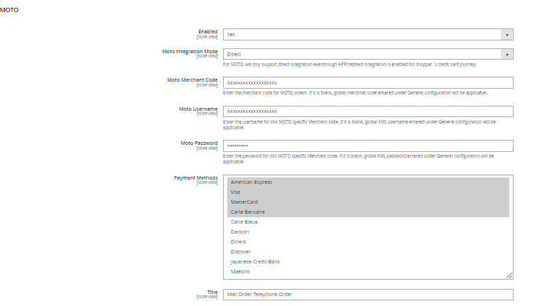

**Note**: MOTO payments support hosted payment pages, which have a high level of PCI DSS compliance. However, the current version does not support client-side encryption or 3DS for direct integration, which have a low level of PCI DSS compliance.

|  |  |
| --- | --- |
| **Configuration** | **Description** |
| **Enabled** | If set to Yes, MOTO payments are available for order processing in the Magento admin area. |
| **Moto Integration Mode** | We only support direct integration even though HPP/redirect integration is enabled for shopper`s credit card journey. |
| **Moto Merchant Code** | Enter the merchant code for MOTO orders. If it is blank, global merchnat code entered under General configuration will be applicable. |
| **Moto Username** | Enter the username for this MOTO specific Merchant code. If it is blank, global XML username entered under General configuration will be applicable. |
| **Moto Password** | Enter the password for this MOTO specific Merchant code. If it is blank, global XML password entered under General configuration will be applicable. |
| **Payment Methods** | Select the credit cards that are available to admin users in a dropdown. |
| **Title** | Write the title that admin users see in the admin panel. |

**Note:** To process a non-3DS payment, add Moto merchant code, username, and password details. You can reach out to Worldpay and request a separate merchant code to process a non-3DS payment..

#### The shopper’s experience

In the Magento admin area, in-store staff can generate MOTO payments as follows.

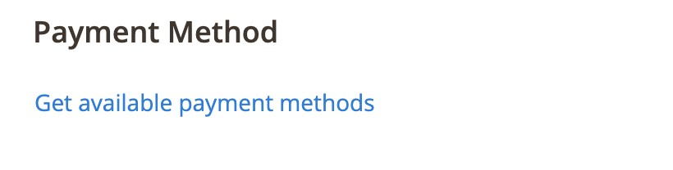

1. When you select the billing country in the billing address, click **Get available payment methods**.

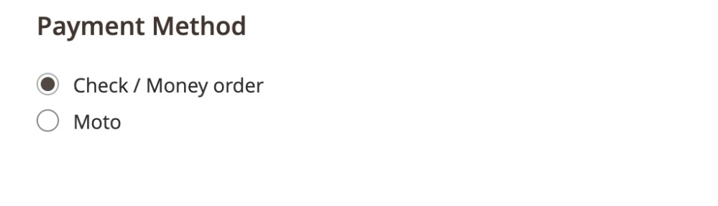

1. You can then select *MOTO* from the available payment methods.

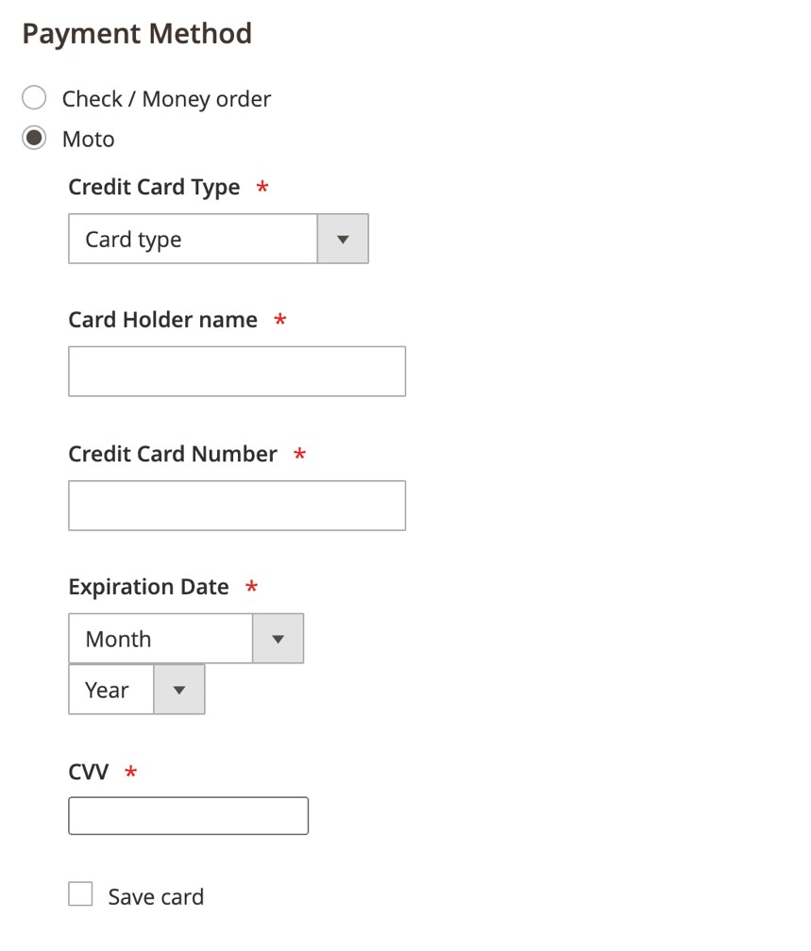

After you select **Moto,** the credit card payment processing form opens and the staff member can place the order.

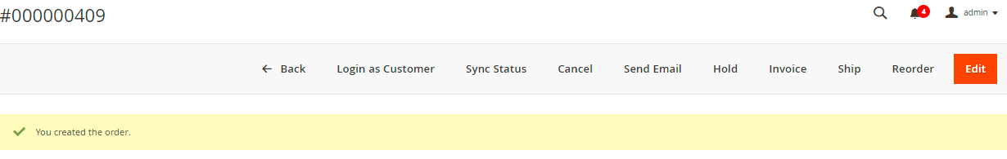

# Alternative payment methods

This section shows you how to configure alternative payment methods.

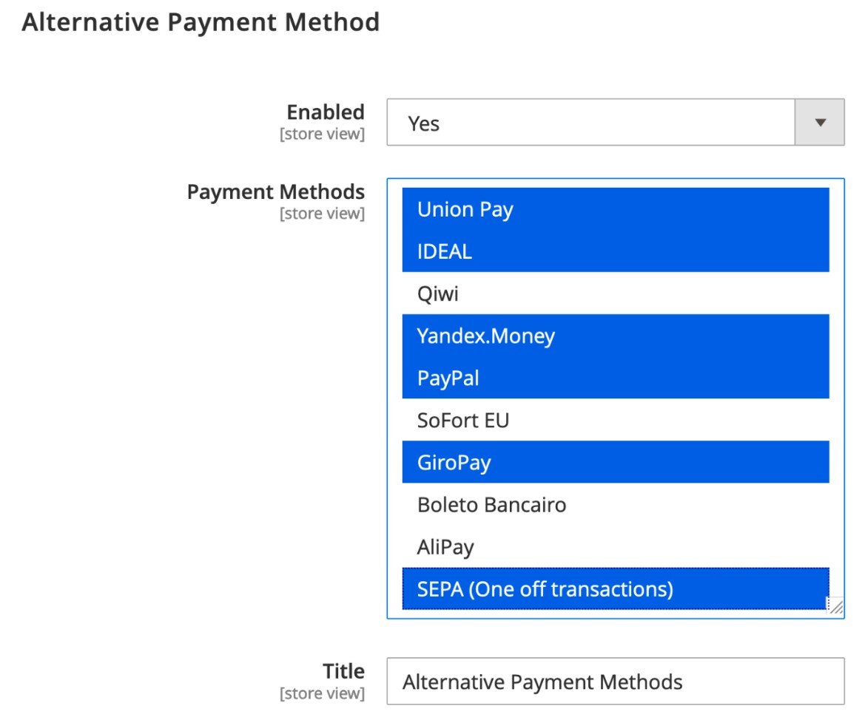

**Note**: The blue highlighted payment methods in the screenshot above show that you can select multiple payment methods.

|  |  |
| --- | --- |
| **Configuration** | **Description** |
| **Enabled** | If set to **Yes**, shopper can use alternative payment methods at checkout. |
| **Payment Methods** | The alternative payment methods you select are available for payment processing during checkout. |

## Dynamic narratives

Statement narrative is added to all the APMs that Worldpay supports. It is the narrative that appears on the shopper's statement, as well as the web page of some banks.

## The shopper’s experience

There is a new text area where the shopper can add a narrative (max 255 characters) under the label *Purpose of transaction*:

To enable **Dynamic Narrative**, go to Store/Configuration/Sales/Worldpay/Alternative Payment Methods/ Enable Statement Narrative

|  |  |
| --- | --- |
| **Configuration** | **Description** |
| **Enable Statement Narrative** | If set to **Yes**, shopper can use purpose of transaction box for alternative payment methods at checkout. |

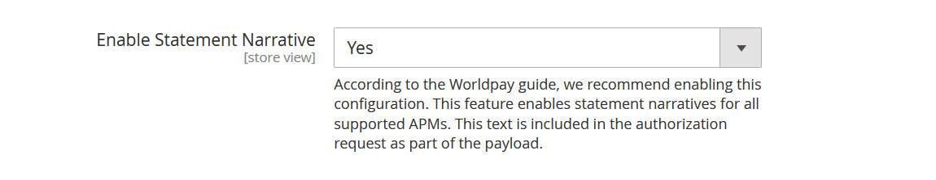

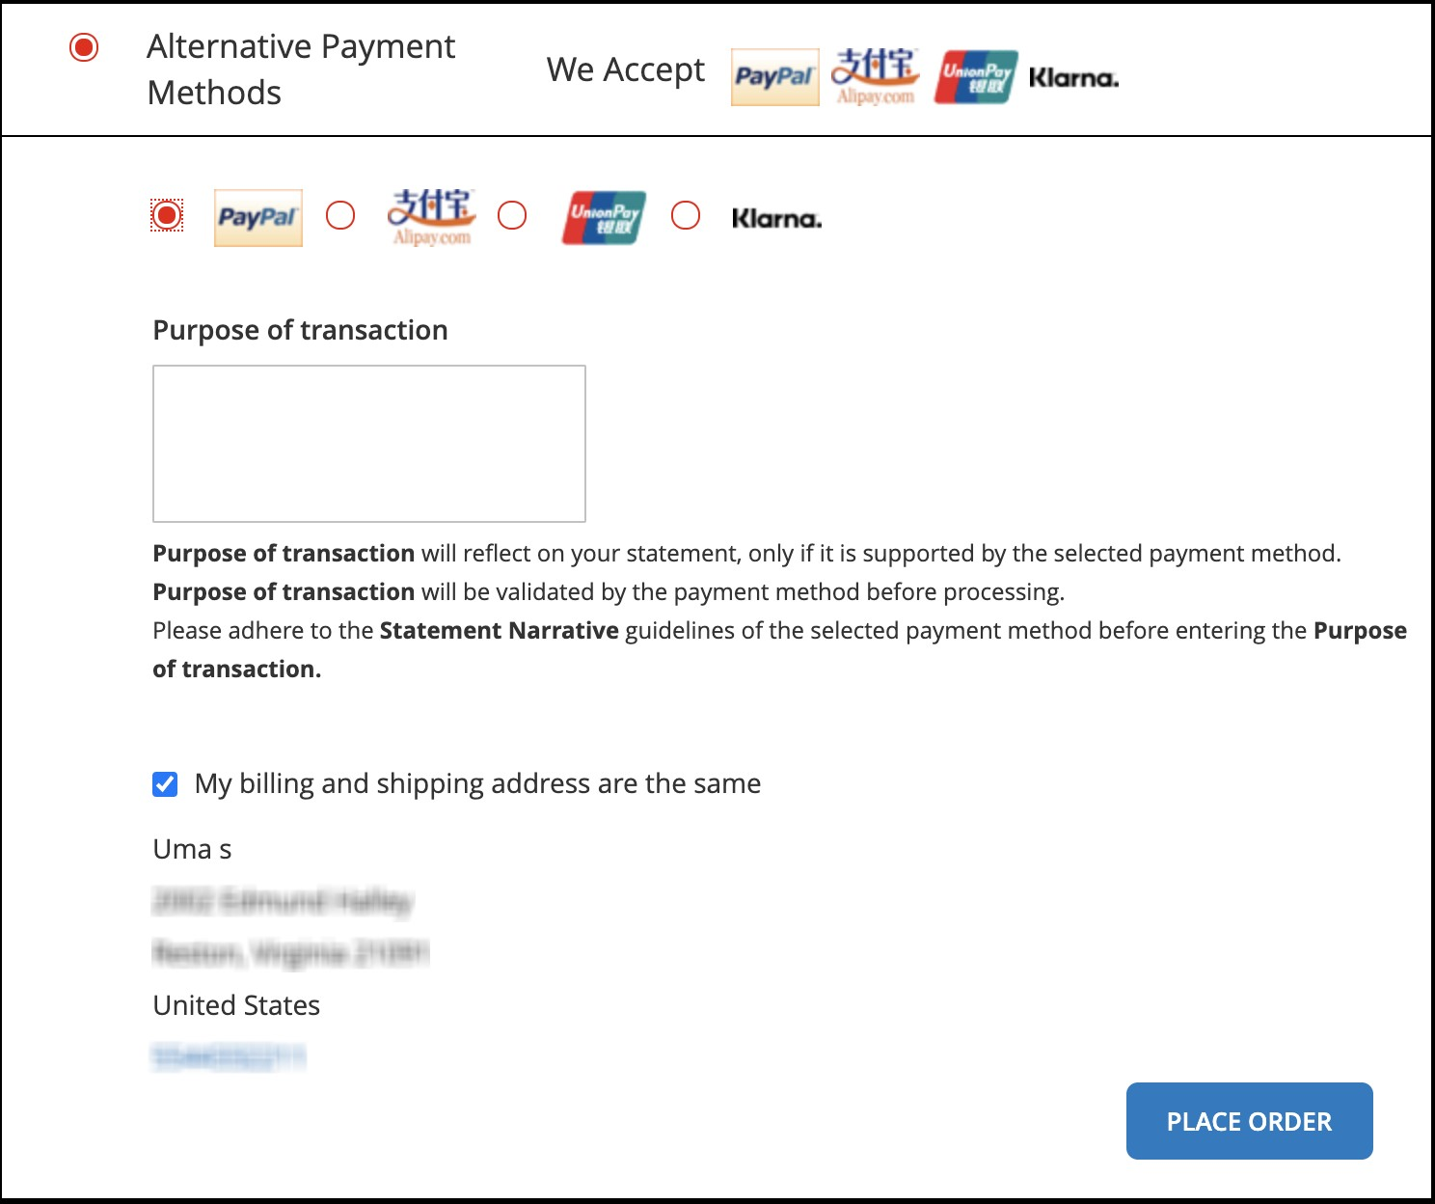

## Payment XML changes

Worldpay supports 13 APMs:

PayPal, IDEAL, Klarna, Mistercash/Bancontact, Union Pay, P24, Yandex.Money, AliPay, SoFort EU, GiroPay, Boleto Bancairo, SEPA (one-off transactions), and Qiwi.

They all have the following element added to the order node in the payment service request xml:

<statementNarrative>MERCHANT STATEMENT NARRATIVE</statementNarrative>

The *Ideal* APM expects the narrative to be passed in the description node within the order node, limited to a maximum of 35 characters.

## PAYPAL

## There is a new PayPal API available, please contact your Implementation Manager for more information. It will then be possible to switch to the new API, as well as add the PayPal SmartButton in HPP.

## KLARNA

Klarna is a buy now, pay later payment method that provides a fast checkout process.

KLARNA payment method is a redirect payment flow and shopper will be redirected to the hosted payment page.

There are three different product types that define when and how your shopper pays.

|  |  |  |
| --- | --- | --- |
| **Value** | **Description** | **Countries**  **Available in** |
| **KLARNA_SLICEIT-**  **SSL** | The shopper pays in instalments. During boarding, you agree with Klarna the terms of the instalment timeframes. | SE, NO, FI, DE, AT,  UK, DK, US |
| **KLARNA_PAYLATER-**  **SSL** | The shopper pays within a specified timeframe. This timeframe is 30 days for UK/ US and 14 days for Europe. | SE, NO, FI, DE, NL,  AT, CH, UK, DK, US |
| **KLARNA_PAYNOW-**  **SSL** | The shopper pays the full amount immediately by bank transfer. | SE, DE, NL, AT |

**NOTE:** Shoppers can only see the available Klarna payment methods in their respective countries (see the above table). This is when the shopper’s billing country matches the site locale. See the portal [documentation](https://developer.worldpay.com/docs/wpg/apms/klarnakp) for the latest information on the countries available.

### Klarna configurations

To configure Klarna, do the following:

1. Go to: Stores> Configuration> Sales> Worldpay> Klarna

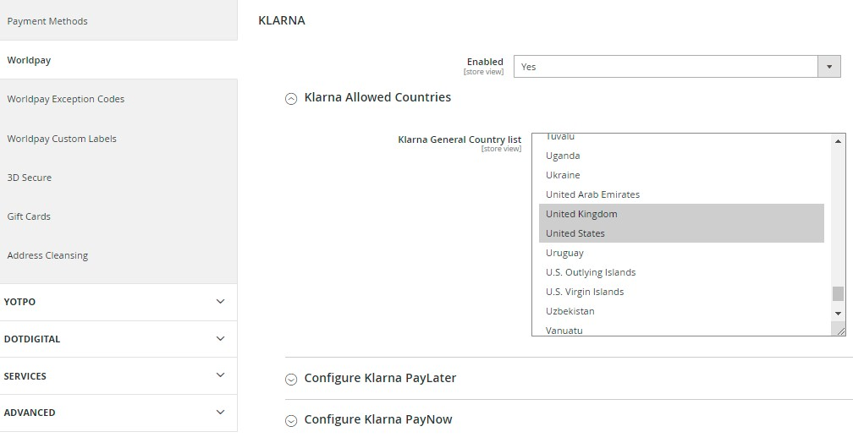

1. Use the information in the table below to complete the configuration.

|  |  |
| --- | --- |
| **Configuration** | **Description** |
| **Enabled** | When set to Yes, Klarna is available at checkout. |
| **Klarna Allowed Countries** | Countries supporting Klarna currently are SE, NO, FI, DE, NL, AT, CH, UK, DK, US. |
| **Configure Klarna PayLater** | Klarna Paylater countries: SE, NO, FI, DE, NL, AT, CH, UK, DK, US. Subscription days: 30 days for UK/ US and 14 days for Europe. |
| **Configure Klarna PayNow** | Klarna Paynow countries: SE, DE, NL, AT. |
| **Configure Klarna Sliceit** | Klarna Sliceit countries: SE, NO, FI, DE, AT, UK, DK, US. |

1. Follow these steps to add the configurations to manage alerts/show customized messages:
   1. Go to Store/Settings/Configuration/Sales/Worldpay Exception Codes
   2. Under Customize Checkout Messages, click the add button and add the configurations below.

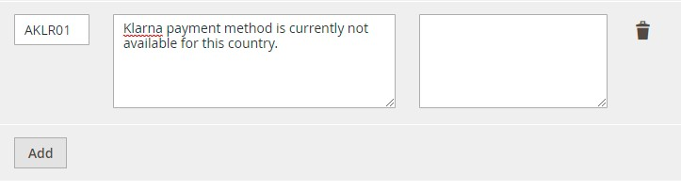

* 1. Click **save config** after adding the configurations.

iv. Use the information in the table below to add the configurations above.

|  |  |  |
| --- | --- | --- |
| Message Code | **Actual Message** | **Custom Message** |
| **AKLR01** | Klarna payment method is currently not available for this country. |  |

* + - 1. Under Customize Admin Worldpay Configuration Messages, you must click on **add** button and then add the below configurations.

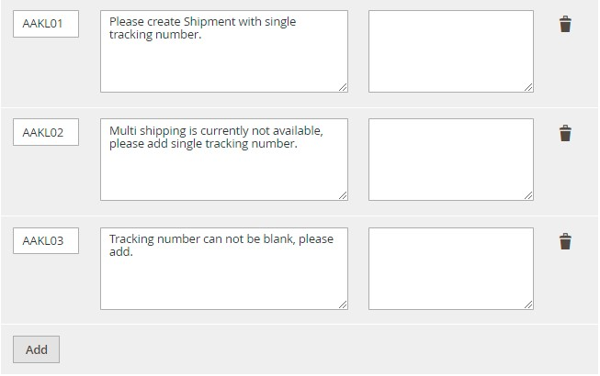

* + - 1. Click **save config** after you add the configurations.

Use the table below to add the configurations above.

|  |  |  |
| --- | --- | --- |
| **Message Code** | **Actual Message** | **Custom Message** |
| **AAKL01** | Please create Shipment with single tracking number. |  |
| **AAKL02** | Multi shipping is currently not available, please add single tracking number. |  |
| **AAKL03** | Tracking number cannot be blank, please add. |  |

1. In some cases, you may want to make capture/partial capture request. Do the following:
   1. To make capture / partial capture request, go to Sales/Orders.
   2. Search for the order ID shared by the shopper (For example: 000001415.).

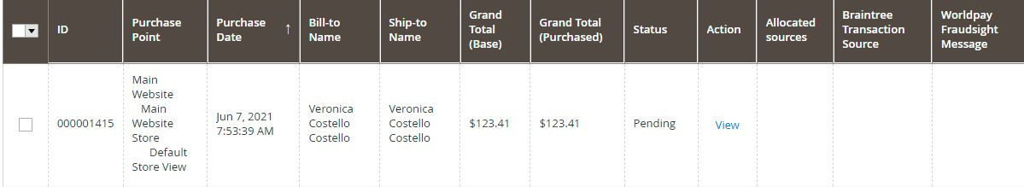

* 1. Click View, and the page below appears with the option ‘Invoice’ to capture/partial capture request.

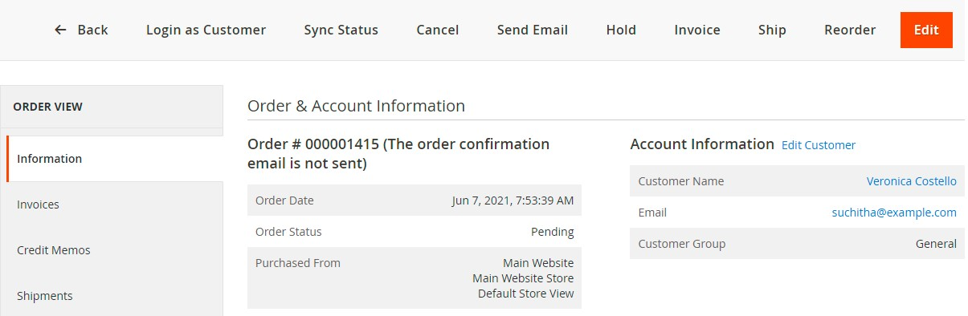

* 1. Points to remember when you create the Invoice:

1. It is compulsory to create an invoice with a tracking number, except for digital items (For example, downloadable videos, digital gift cards and bundle items, when you wish to ship together).

Note: Magento will not let you create shipment for orders with bundle items (where bundle items are selected ship ‘together’ in catalog > products > ordered bundle item). Please follow below steps to create invoice with shipment:

Go to in catalog > products > search ordered bundle items > click on edit.

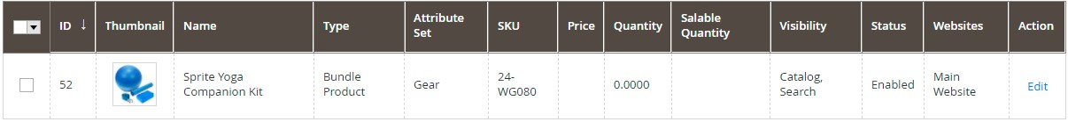

Select bundle items group > select ship Bundle items Separately, as below

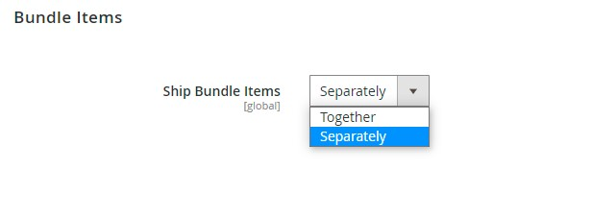

**Save** the changes and, go to **System** and do update **Index management** and flush **cache management**.

2. Tracking number should be created by selecting ‘create shipment’ option on invoice page and not using ‘Ship’ option on Order view page.

Note: You cannot create multiple tracking numbers, as we do not currently support multi shipment.

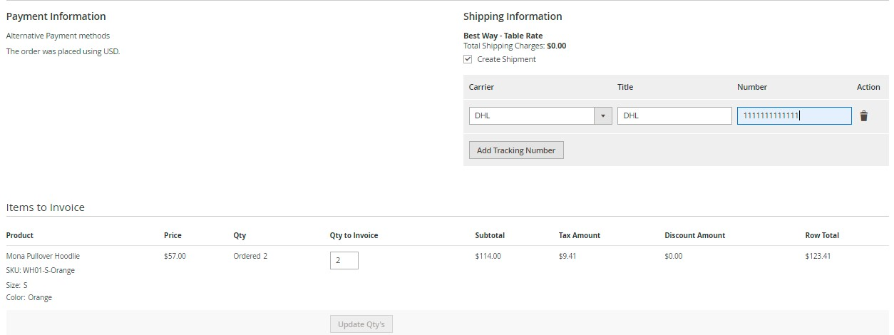

**Submit Invoice**, to create invoice and shipment.

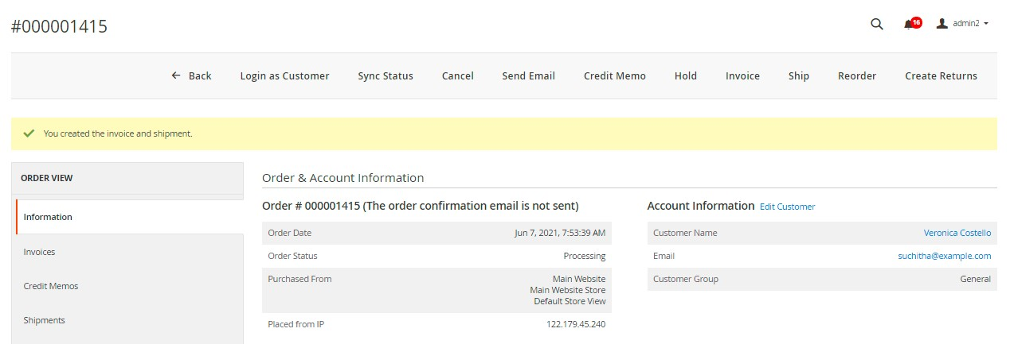

Note: In Order Modification request, only items with tracking ID are displayed.

### The shopper’s experience

Once Klarna is enabled, shoppers see it as an option at checkout:  
  
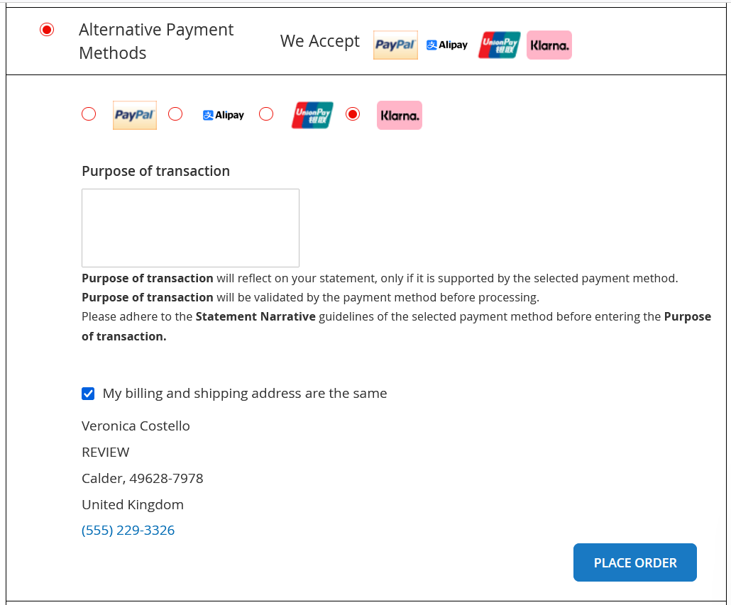

After clicking the **Place Order** button, the shopper sees HPP page and click on continue.

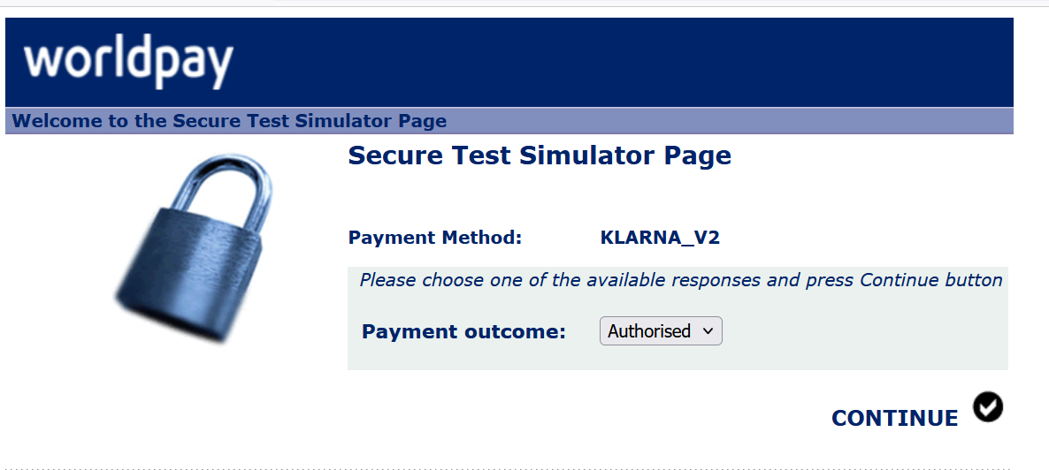

**Above screenshot is a Test simulator page and Production/Live flow will have different page for payment processing.**

**DISCLAIMER:** For KLARNA_SLICEIT in Production mode, shoppers must select the installment option before CONTINUE.

If the payment is approved by Worldpay, the customer sees a success page: 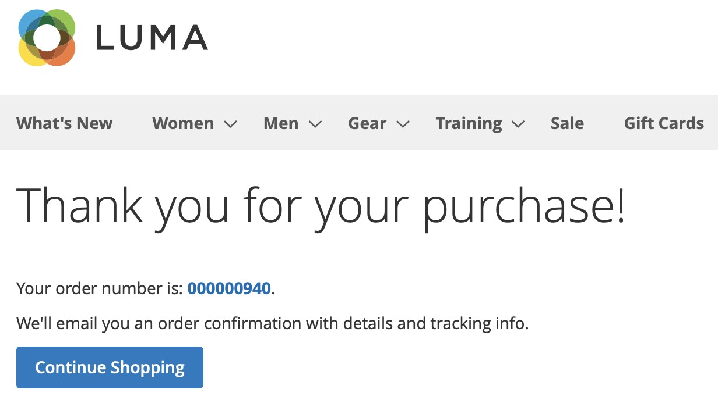

# 

# How to configure instant purchase

Use this feature to enable Instant Purchase on product-detail pages. This feature is for credit and debit cards only on the Worldpay gateway.

Note – Magento 2 core vault data model has been updated with token generated by Worldpay.

## How to set up Instant Purchase

1. Go to Stores/Configuration/Sales/Instant Purchase and enable the default Magento option for Instant Purchase:

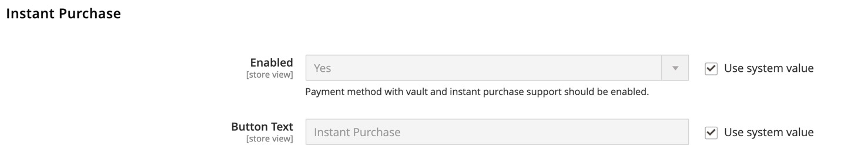

1. Go to Stores/Configuration/Sales/Worldpay/Quick checkout and enable *Instant Page Checkout*:

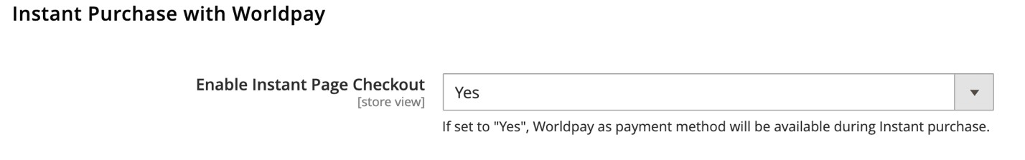

##### The shopper’s experience

1. If the shopper has saved their credit card in the *My Account* section based on previously placed orders, go to Store front/login/Product Details Page.

1. Once on the page, click **Instant Purchase**.

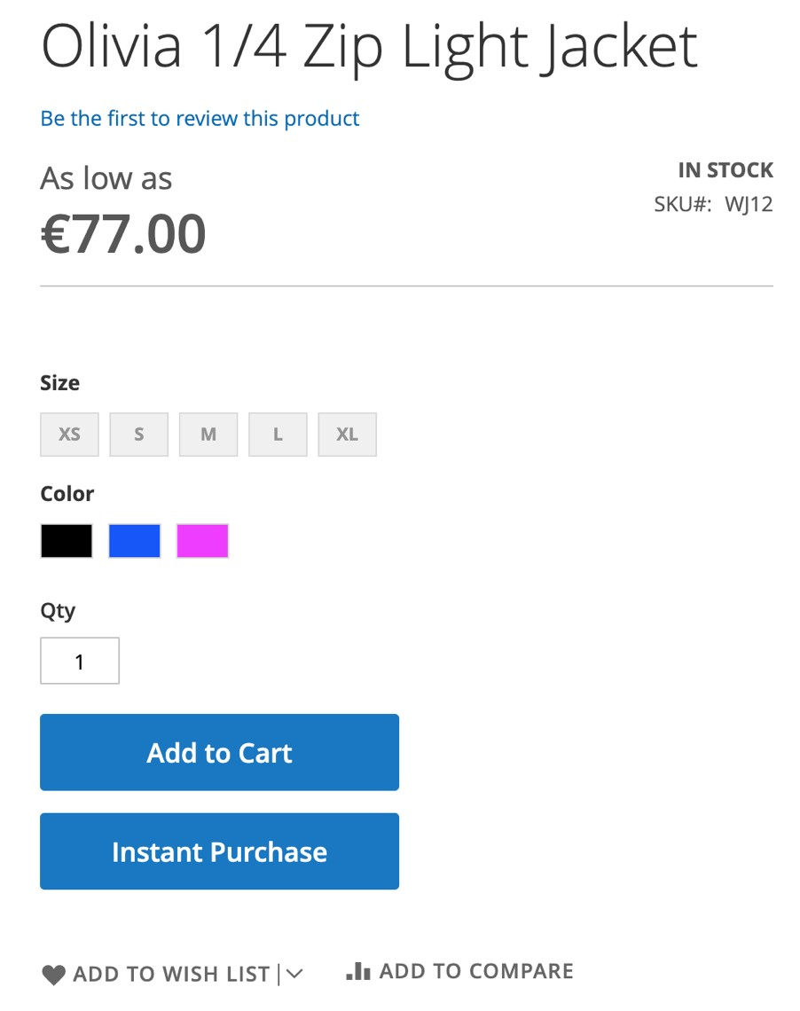

1. An Instant Purchase window opens, with the shipping and billing addresses set as default, along with the payment method.

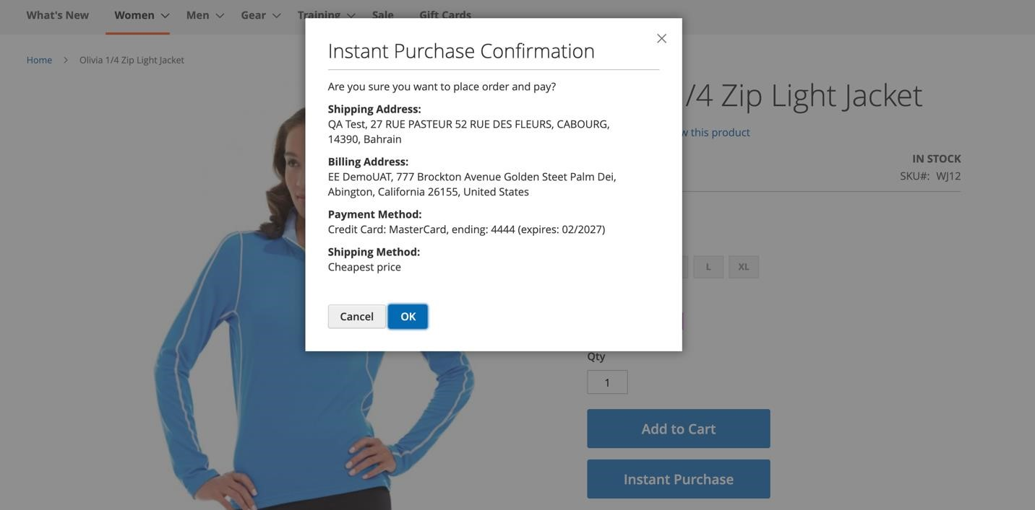

1. The order is placed directly from the product-detail page:

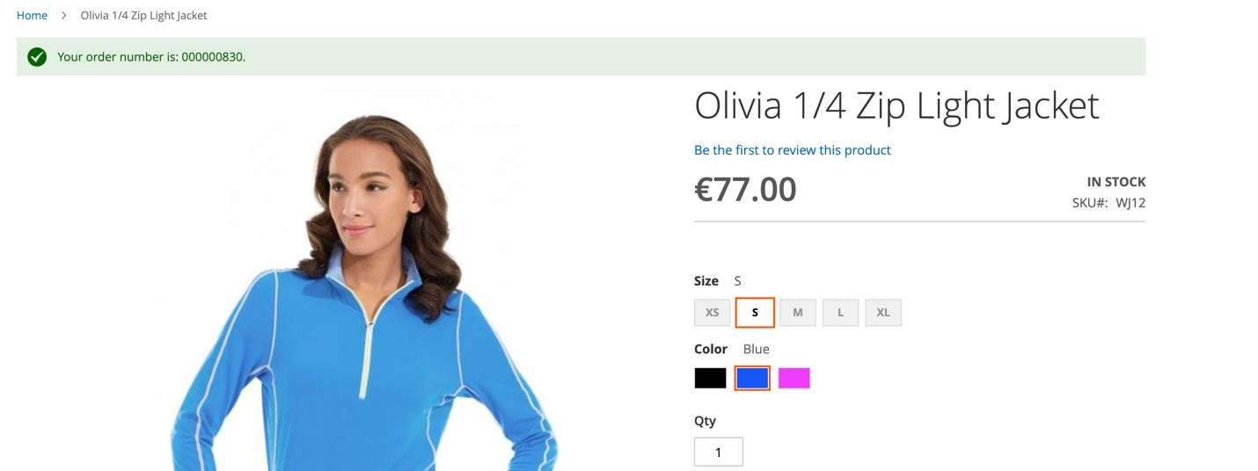

Worldpay plugin feature for Instant page checkout supports Strong Customer Authentication 3DS2.

# Multiple partial capture

Worldpay supports partial payment capture for credit card and mobile wallet orders and PayPal.

In general, a payment can only have funds captured once, and that applies to partial captures too. If you make a partial capture, the rest of the authorization is cancelled. To capture the remaining amount, you must submit a new order to the Worldpay payment service for authorization.

**Prerequisite**: Worldpay supports one-time partial captures by default. For multiple partial captures you must ask Worldpay to enable multiple partial capture for your account.

## Implementing multiple partial capture

You can enable or disable multiple partial capture in Stores/Configuration/Sales/Worldpay.

1. Go to Stores/Configuration/Sales/Worldpay/General Configuration and set Auto Invoice to No. (If it is set to Yes, a full capture request is sent to Worldpay automatically from the Magento side).

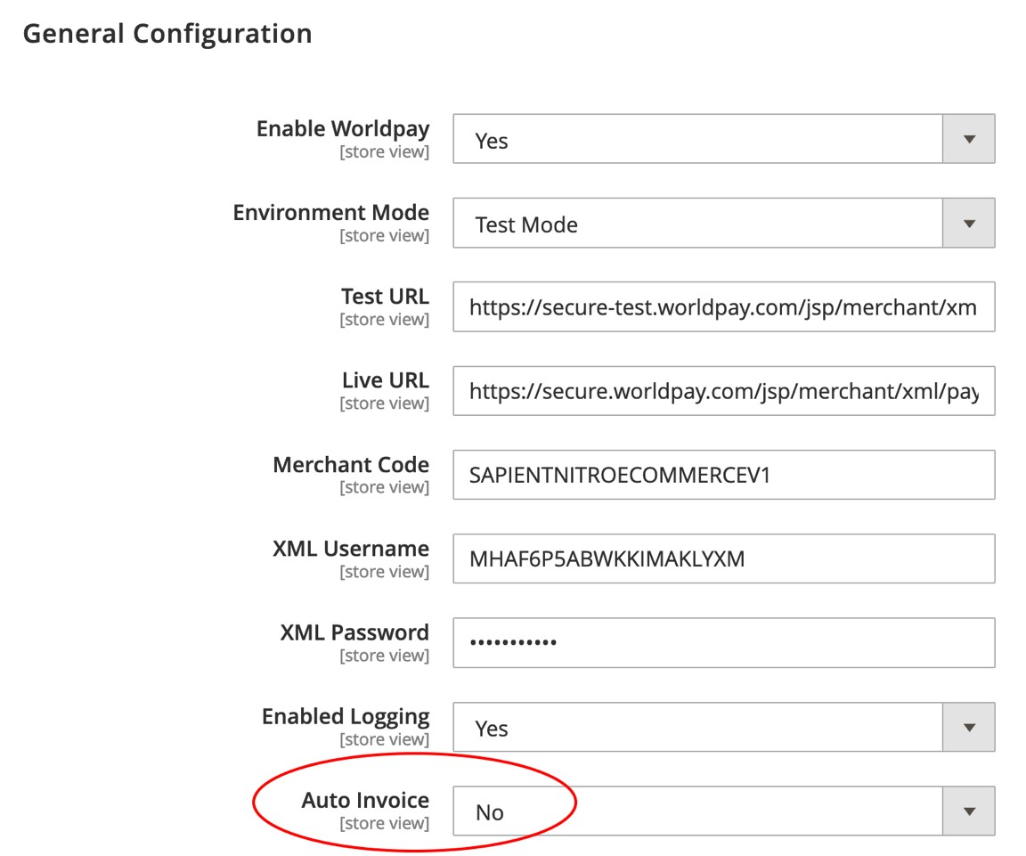

1. Go to Stores/Configuration/Sales/Worldpay/Multiple Partial Capture and set *Partial Capture* to **Yes**. This enables partial captures to be made multiple times at the line-item level within a single order.

## How to execute partial capture from Magento

Go to Sales/Orders:

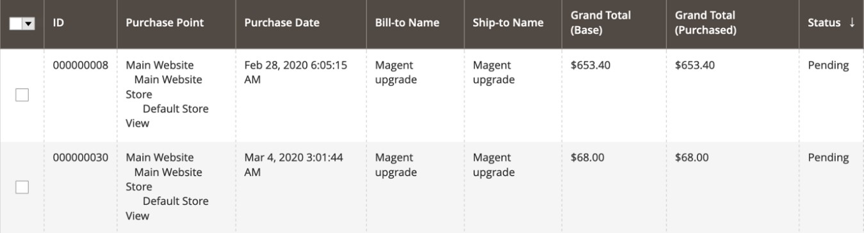

1. Click and open an order with *Pending* status. Click **Invoice** to prepare for partial or full capture:

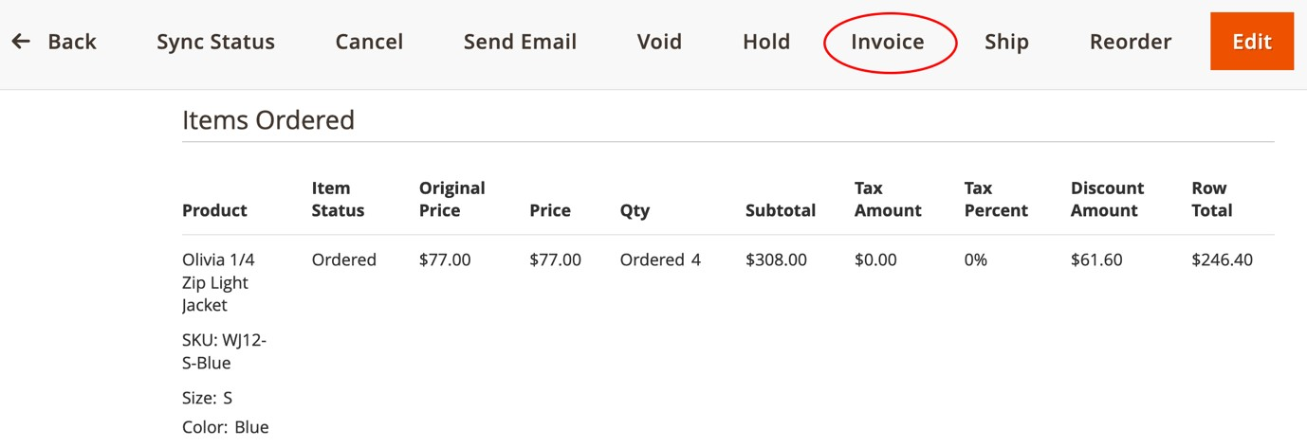

Notice that the **Qty** (quantity) **Ordered** is 4 but that the *Qty to Invoice* is an editable field. This is for partial capture and invoicing.

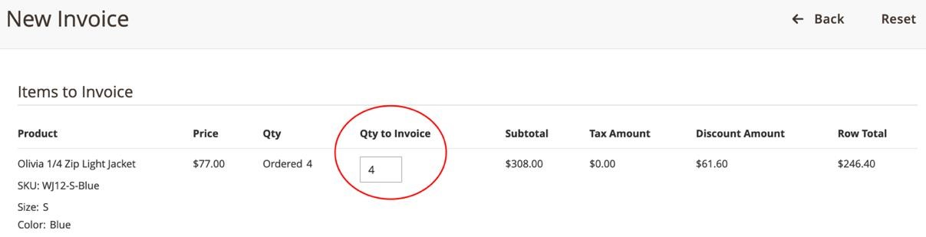

Below, the *Qty to Invoice* is updated to 2 and the **Update Qty`s** button is enabled:

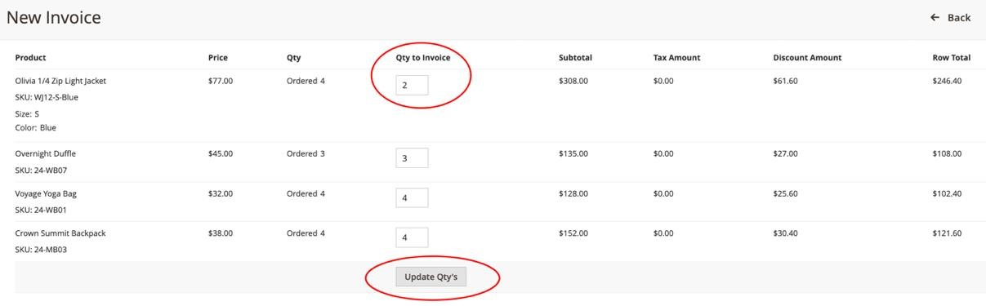

Shown below, with the quantity to be invoiced/captured updated to 2, the corresponding *Subtotal*, *Discount Amount* and *Row Total* also automatically update. The **Submit Invoice** button is enabled to start the invoice/capture.

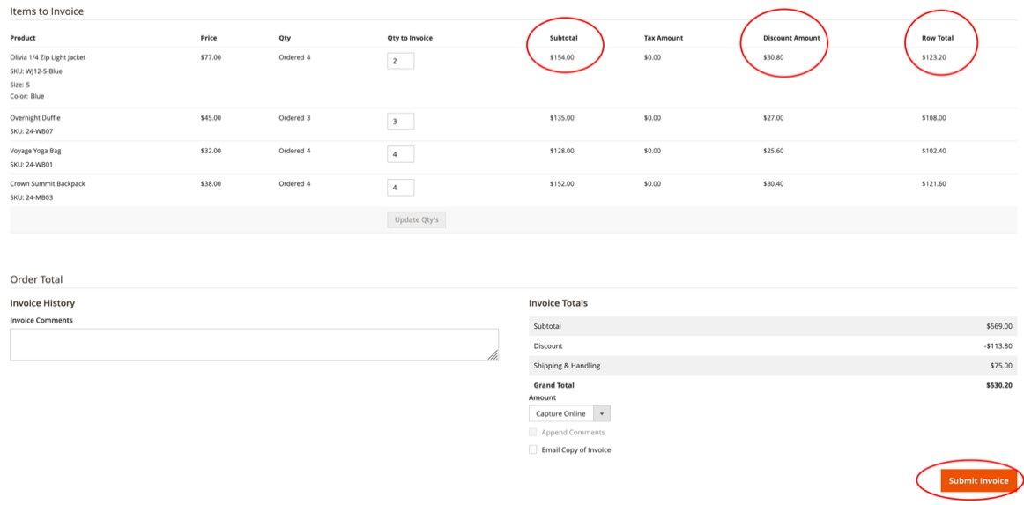

**Note:** Worldpay supports partial capture for payments made by credit card (Direct/HPP), PayPal, Google Pay and Apple Pay.

# Merchant profile override

This enables you to override the global merchant profile (Worldpay Merchant code) based on payment method. If the override is not set, then Magento uses the global merchant profile for all transactions.

To configure these settings, go to Stores/Configuration/Sales/Worldpay/Merchant Profile Override Configuration:

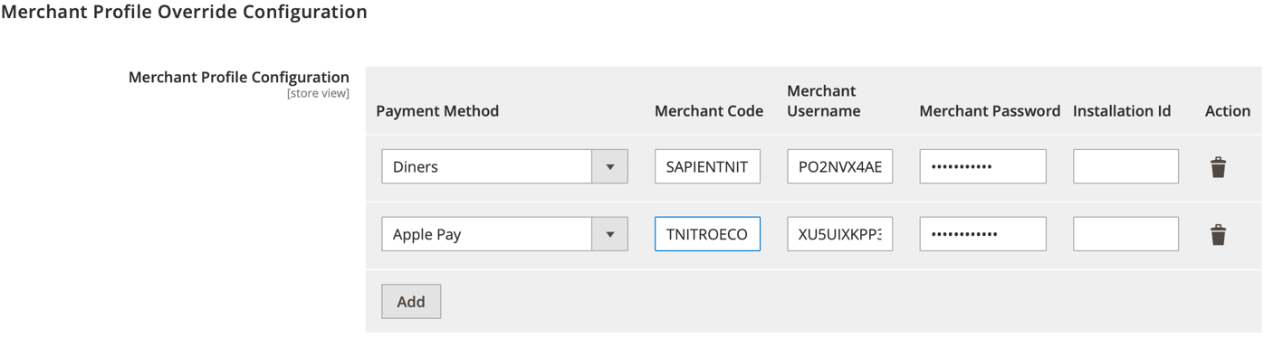

This enables you to use a different merchant code to process Diners and Apple Pay orders.

## How to synchronize order status with Worldpay

To synchronize order status with Worldpay, use the following configurations:

|  |  |
| --- | --- |
| **Configuration** | **Description** |
| **Sync Order With Status** | You must select the Magento order status to be available for status synchronization with Worldpay status. |
| **Time Window** | You must set *n Number of hours*. All orders placed in last n number of hours are considered for this synchronization. |

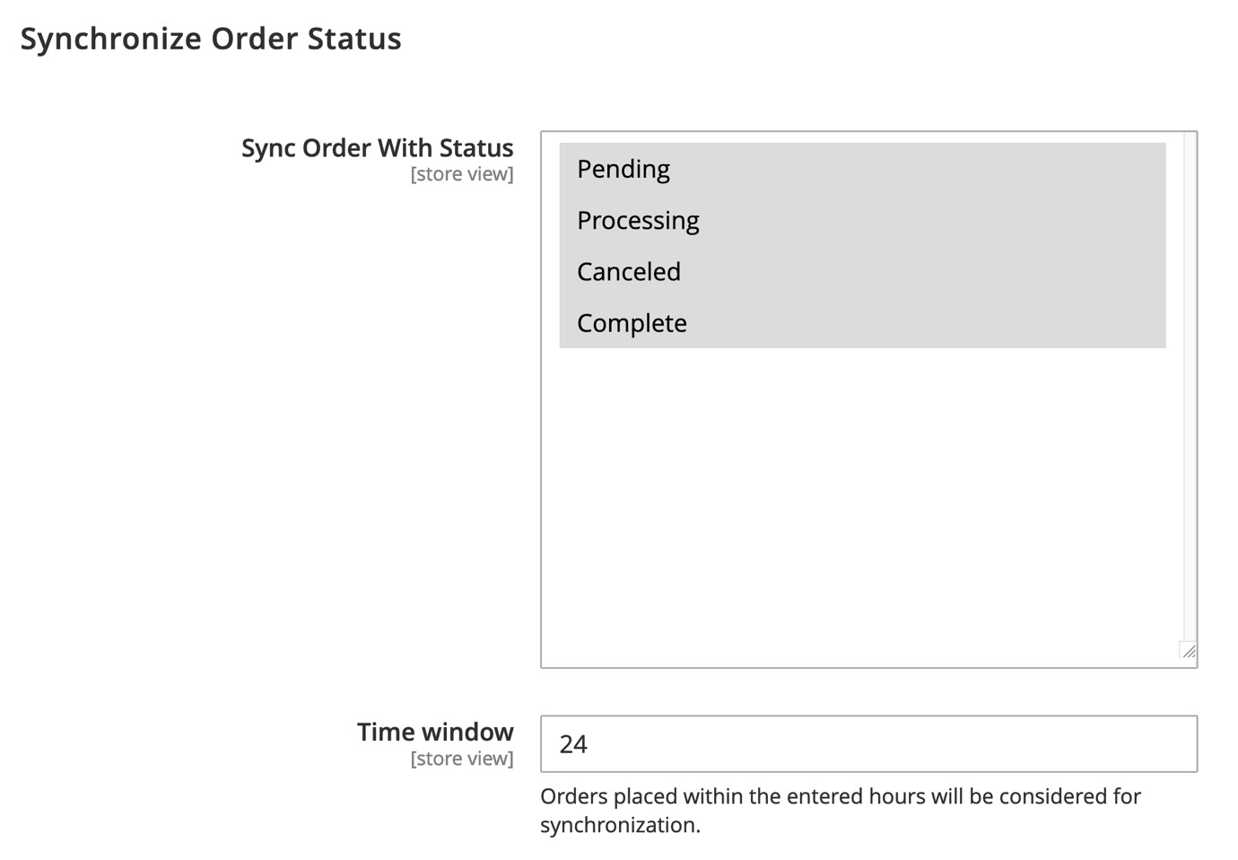

**Note**: This job will synchronize the order status with Worldpay for all orders placed in past 24 hours except those been placed in past 30 minutes:

**Job Group**: *worldpay_orders*

**Job Name**: *order_sync_status*

During a rare fail-over of the notification channel update, Magento might not update orders as expected. You can set up a cron job to update them as a fail-over mechanism.

Cron jobs can update and synchronise any type of order (direct, redirect, MOTO, etc) on the Worldpay server. This is provided that the order was placed during the past 24 hours. However, you cannot update cancelled orders with a cron job.

### Executing the cron job for Worldpay-specific orders

During normal operation, Magento includes plenty of cron jobs. You can run all the cron groups, or you can run single groups. To avoid running all the groups, run the Worldpay_orders group. This updates Worldpay orders only. Run the command below to execute the script that will update only Worldpay orders:

php bin/magento cron:run --group="worldpay_orders"

When the job is done you see the results in the CLI screen:

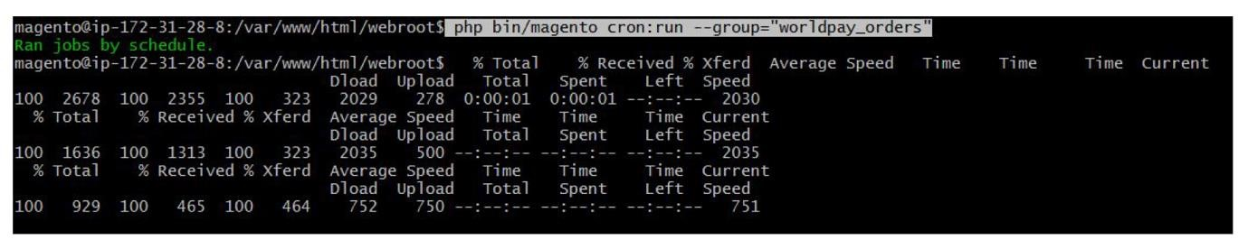

For more details about order inquiries, please visit the [Worldpay support site.](https://developer.worldpay.com/docs/wpg/manage/inquiryrequests#order-inquiry)

### How to set up cron jobs in periodic time

To schedule cron jobs in periodic time, you must set them up on your server. First, use this command line to configure cron:

crontab –e

You can use the following command to execute a Worldpay cron job every minute (adding in your php.ini file path where indicated).

*/1 * * * * php -c {php.ini_path} {magento_path}/bin/magento cron:run-group="worldpay_orders"

You can adjust the time setting to suit your requirements.

## Dynamic currency exponents

Use this feature to configure the expected exponent value for different currencies. This value applies when sending requests to Worldpay.

**Note**: The exponent value determines how many decimal places there are when processing a currency. For example, GBP has an exponent value of 2.

### How to setup dynamic exponent

Go to Stores/Configuration/Sales/Worldpay/Miscellaneous:

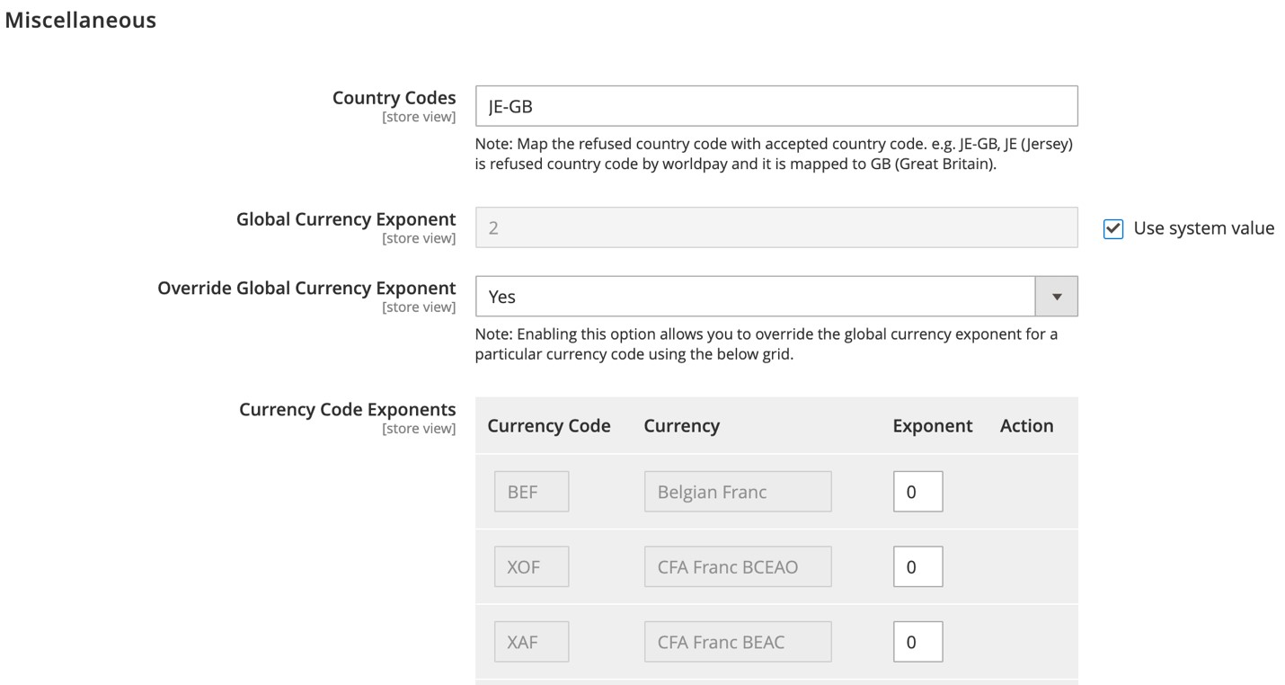

|  |  |
| --- | --- |
| **Configuration** | **Description** |
| **Global Currency Exponent** | You can define a global value that applies to all currencies. |
| **Use system value** | The default exponent defined at the Worldpay end is 2. Select this option, to define the global value as 2. |
| **Override Global Currency**  **Exponent** | Enable this option to override the global exponent value for any particular currency. |
| **Currency Code Exponents** | Use this feature to configure exponents to various currencies. This configuration is applied only when *Override Global Currency*  *Exponent* is enabled. Currency which is not added to this list will take global exponent value 2. |

### How to setup currency code exponents

Go to Stores/Configuration/Sales/Worldpay/Miscellaneous/ Currency Code Exponents

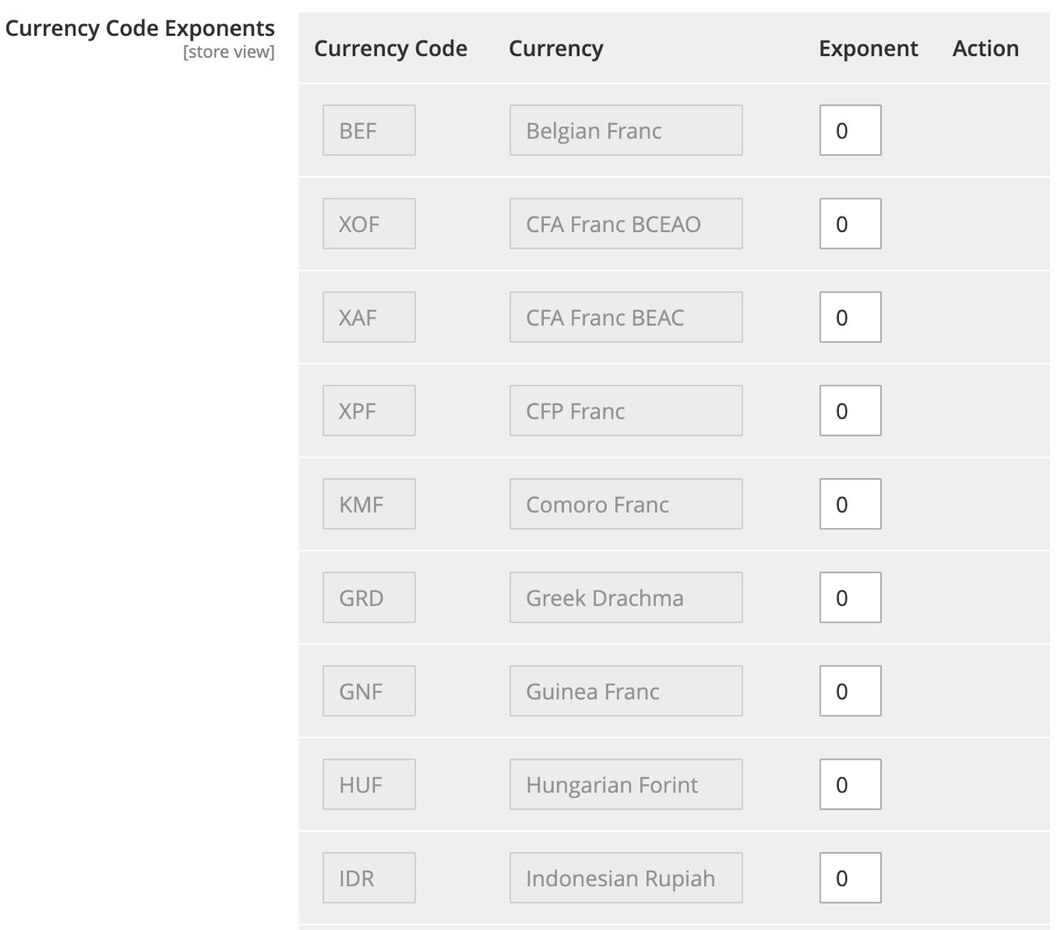

|  |  |
| --- | --- |
| **Configuration** | **Description** |
| **Currency Code** | A unique ISO currency code, used by the worldwide payment gateway. |
| **Currency** | A unique ISO currency name, used by the worldwide payment gateway. |
| **Exponent** | This enables you to configure the exponent value for each currency. |
| **Action** | If you need to add a new currency code exponent during future development, a delete icon appears so you can delete the incorrect new value. |

**Note**: For more details, [read the online guide to currency exponents.](https://developer.worldpay.com/docs/wpg/reference/usefultables#iso-country-codes)

## Subscriptions and recurring payments

You can use the plugin to configure different subscription plans (weekly/monthly/quarterly, etc.) at a product level. Your shoppers can then place orders by subscribing to the associated payment plans.

### How to configure subscription and payment plans

**Prerequisite**: Ask Worldpay to activate recurring payments on your merchant code.

To configure subscriptions:

1. Go to Stores/Configuration/Sales/Worldpay/Subscription Settings and set *Subscriptions Enabled* to **Yes.**

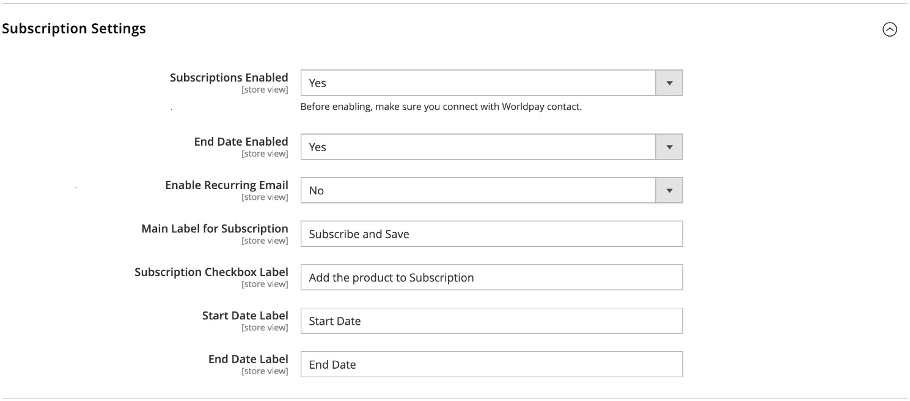

1. Go to Catalog/Products. Open a product and expand the *Subscriptions* section:

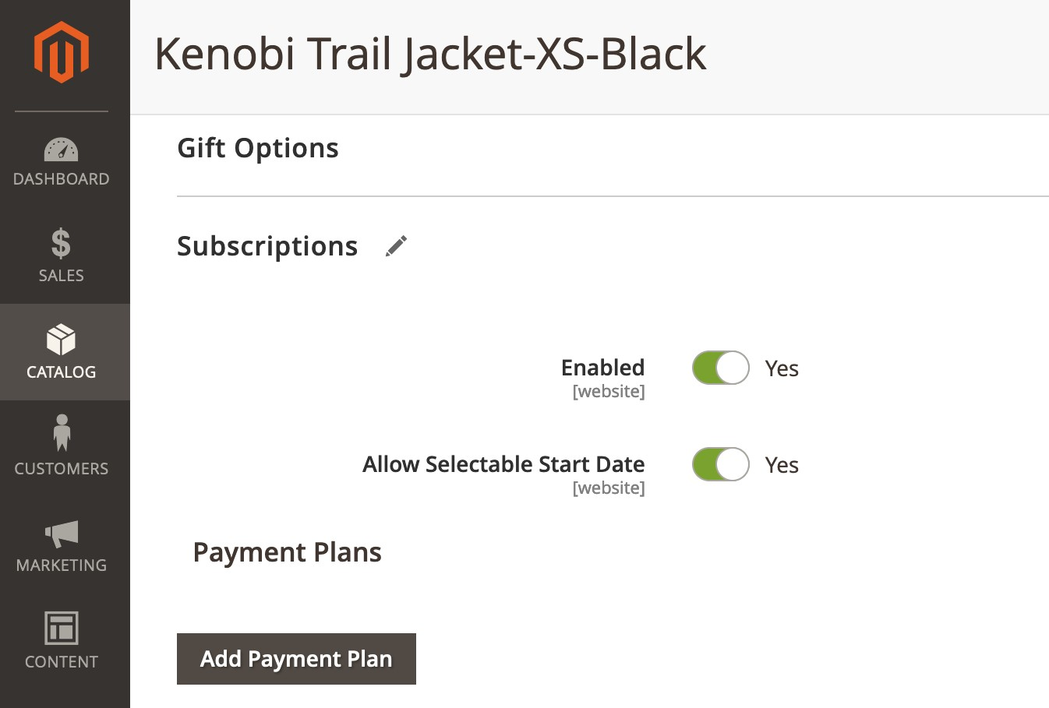

|  |  |
| --- | --- |
| **Configuration** | **Description** |
| **Enabled** | If set to Yes, subscription is enabled at product level. |
| **Allow Selectable Start Date** | If set to Yes, the shopper can set a start date for the subscription to begin. |
| **Add Payment Plan** | Click to add payment plans for the shopper to subscribe to. |

1. Click **Add Payment Plan** to create a payment plan the shopper can subscribe to:

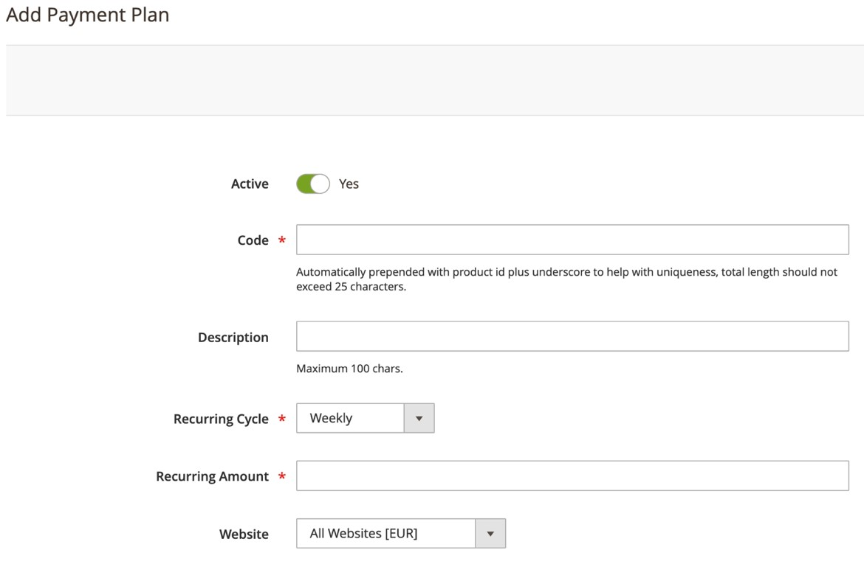

|  |  |
| --- | --- |
| **Configuration** | **Description** |
| **Active** | If set to Yes, the subscription is enabled at product level. |
| **Code** | The code retains the payment plan’s uniqueness. If the code entered is a monthly plan then the final sample code is Product ID_monthly-plan to maintain uniqueness. |
| **Description** | An optional field to describe the payment plan. |
| **Recurring Cycle** | Select a cycle (weekly / monthly / quarterly / semiannually / annually). Future orders and payment capture are executed based on the cycle. |
| **Recurring Amount** | The recurring amount overrides the product price if the shopper opts for subscriptions. |
| **Website** | This payment plan is applicable to the whole website. (Default option.) |

1. After you create the payment plan, the plan appears in the *Subscription* section. To change the order of payment plans, use Magento’s drag-and-drop feature.

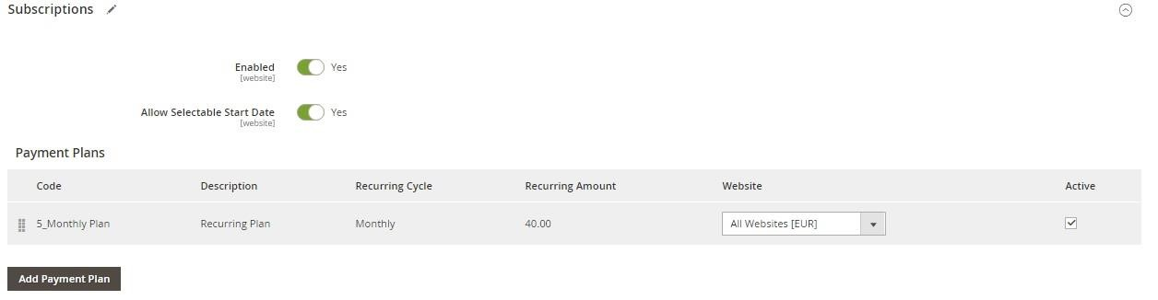

### The shopper’s experience

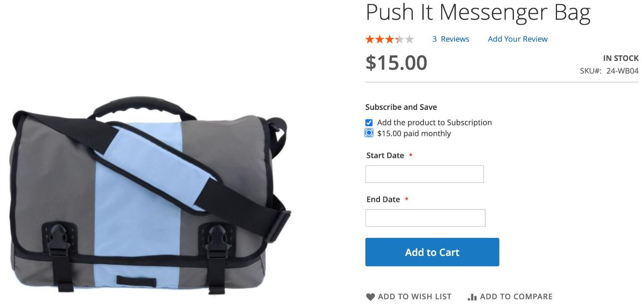

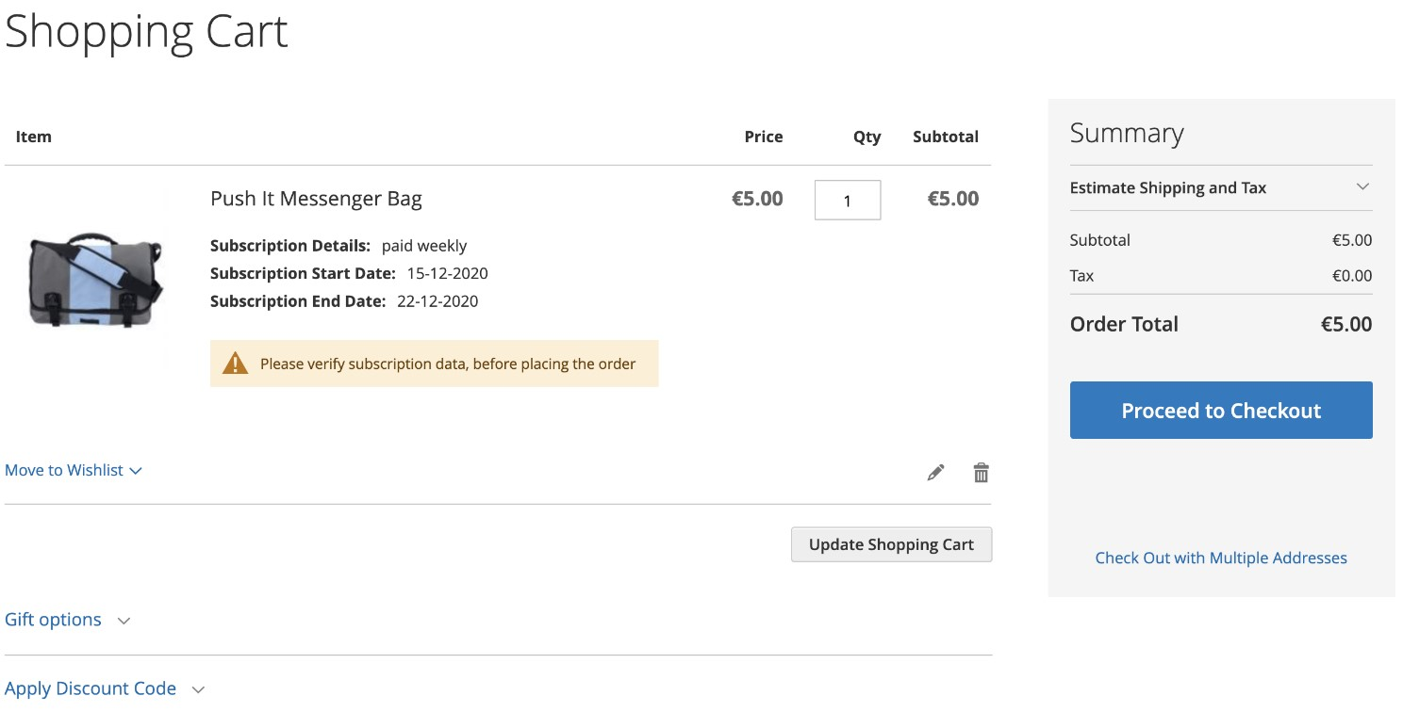

On the product-detail page, the shopper can select a payment plan. If the shopper selects Add a Payment Plan, all the active payment plans created under How to configure subscription and payment plans will be available.

The product price is updated based on the selected plan (as you can see above), and the shopper can set the subscription start date/end date if this is enabled. (How to configure subscription and payment plans). The shopper can then complete the subscription after adding the product to their cart.

The shopper can see their subscription orders in My Account/My Subscriptions, where they can edit or cancel subscriptions and update their address.

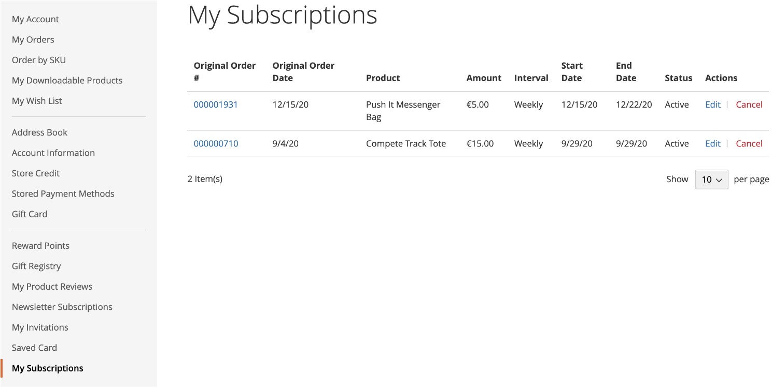

### Recurring orders

When a subscription order is placed using stored credentials/tokenization, then all future orders and transactions related to that subscription are handled as recurring orders.

Shoppers cannot place a subscription order unless they select the Save Your Card option. This prompts Worldpay to create an authorization token. Magento saves this token for future recurring orders.

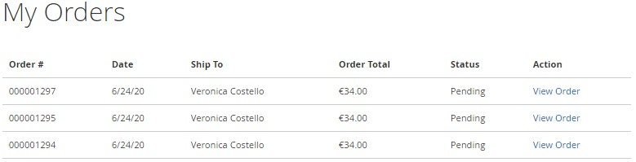

To set up recurring orders:

1. You must set up the cron job *worldpay_recurring_transactions* to run every 24 hours.

This cron job checks all the subscriptions whose start date or next order date are queued over the next five days. The job creates recurring orders for all the subscriptions.

Once Magento creates a recurring order, it sends an authorization request to Worldpay and, if successful, follow-up capture requests are triggered. After successful capturing/invoicing, recurring orders are fulfilled.

## Country-code spoofing

Worldpay payments are based on country codes, and if a country’s code is not accepted by Worldpay, then no payment methods appear in the checkout page. To overcome this, there is a country-code spoofing option.

Use this option to override a refused country code by mapping it to an accepted country code.

### How does it work?

Magento assigns a country code to orders based on the customer’s billing address. Worldpay then fetches the accepted payment methods for that country code.

Because Worldpay does not recognize country codes for areas such as Jersey (JE) and the Isle of Man (IM), you can opt to implement country-code spoofing. This ensures that a refused country code is mapped to an accepted country code.

To configure this, go to: Stores/Configuration/Sales/Worldpay/Miscellaneous:

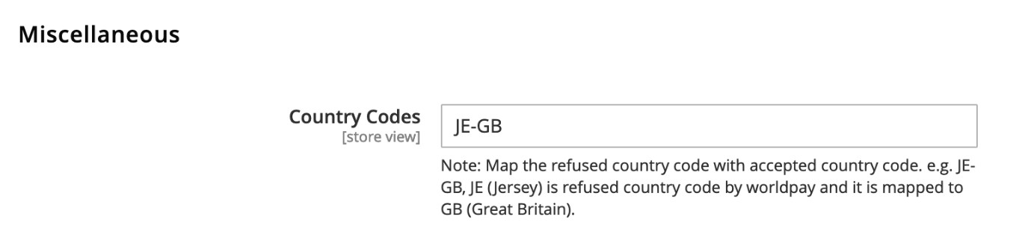

As shown above, enter the text **JE-GB** where JE is the refused code and GB is the code you want to map. To enter multiple country-code spoofs, separate your entries with commas.

If an order is placed with a refused country code, the shopper sees the error message below:

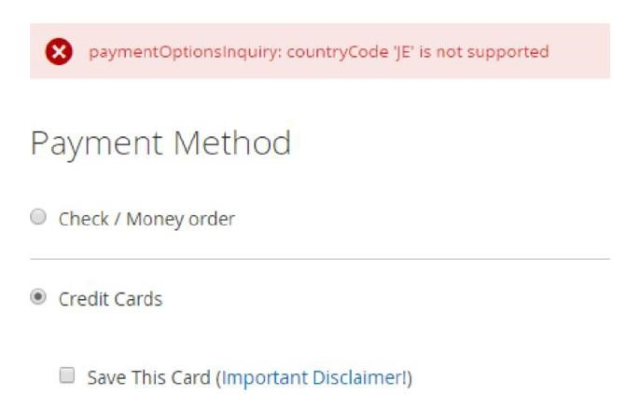

## Configurable alert messages

With this feature you can customize various alert messages that appear during checkout and in the My Account and Admin sections.

### How to set up configurable alerts

Go to Stores/Configuration/Sales/Worldpay Exception Codes to choose the types of alerts you want to customize:

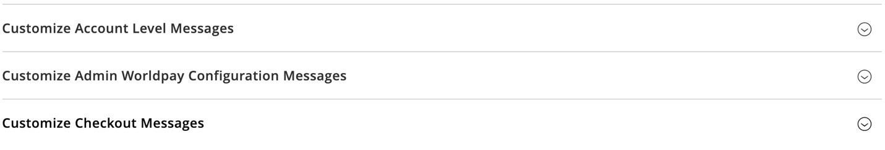

* **Customize Account Level Messages**: Customize the messages shoppers see in their My Account section
* **Customize Admin Worldpay Configuration Messages**: Customize admin-level messages
* **Customize Checkout Messages**: Customize the messages shoppers see during checkout These three sections have identical configuration panels:

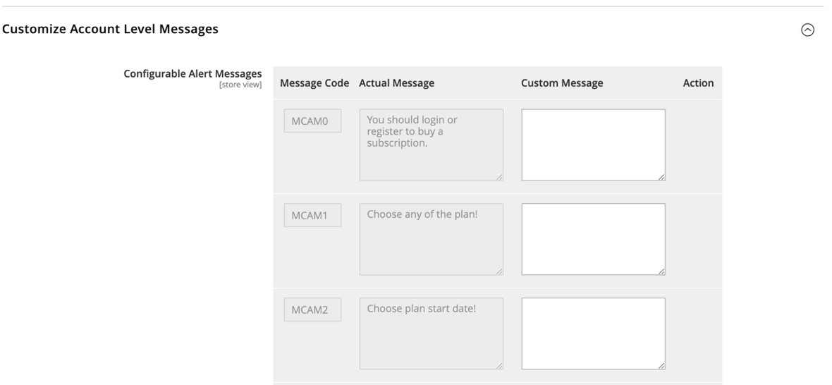

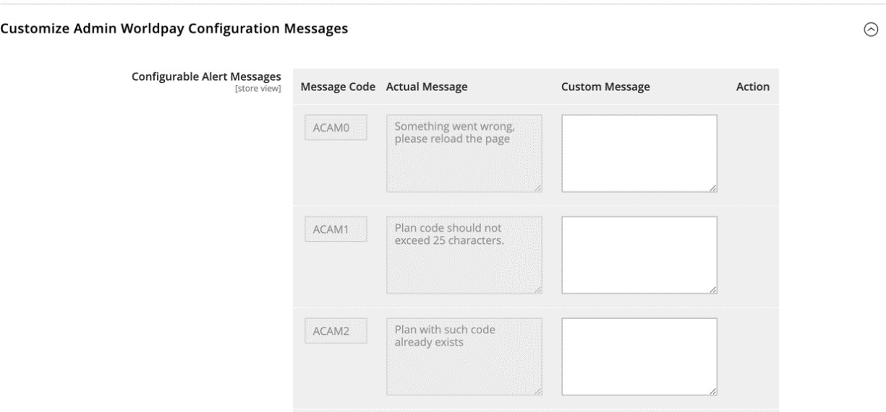

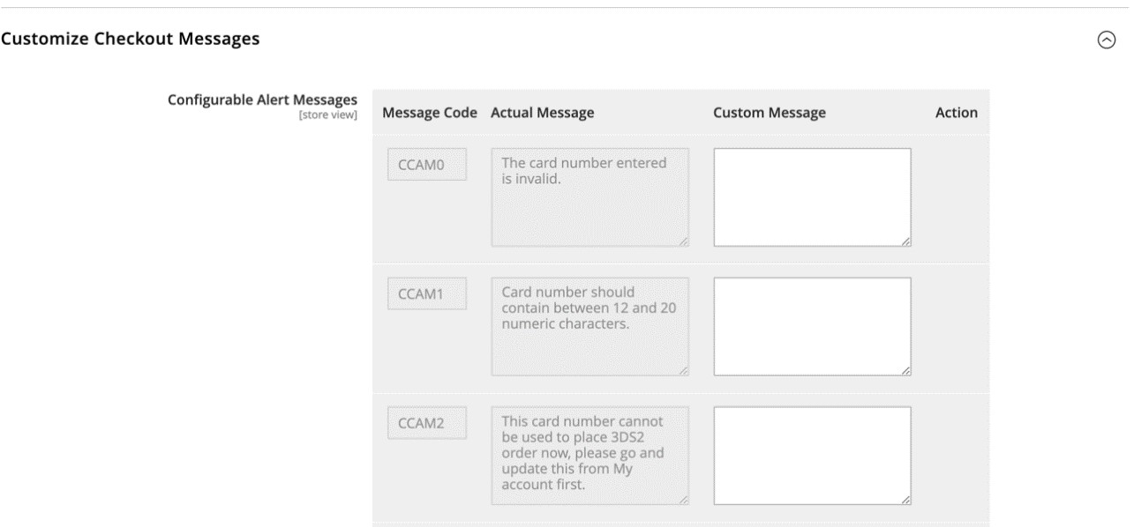

|  |  |
| --- | --- |
| **Configuration** | **Description** |
| **Message Code** | A unique code used within the script to assign the alert message. This is a mandatory field. |
| **Actual Message** | The default message that the plugin displays. This is a mandatory field. |
| **Custom Message** | Enter the text that will replace the default message. This is an optional field but it does not accept entries made of white spaces (space or tab). |
| **Action** | If you need to add a different message in future, a delete icon appears so that you can delete the current, incorrect message. |

### The shopper’s experience

Go to StorefrontLlogin/Add to Cart/Proceed to checkout:

**Actual message**

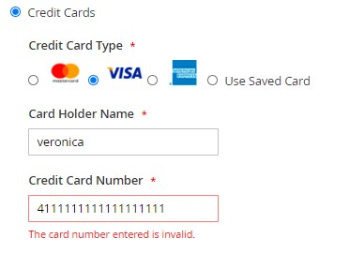

**Custom message**

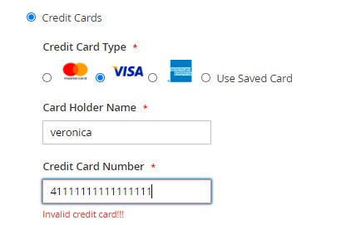

**Note:** This feature only applies to the Worldpay plugin. Magento messages are not affected.

## Extended response codes

If Worldpay has enabled them for you, these are the extended response codes you can get if Worldpay is your

acquirer. There is also a feature at plugin level to override/customize the messages you receive from Worldpay.

### How to customize Worldpay response messages

Go to Stores/Configuration/Sales/Worldpay Exception Codes:

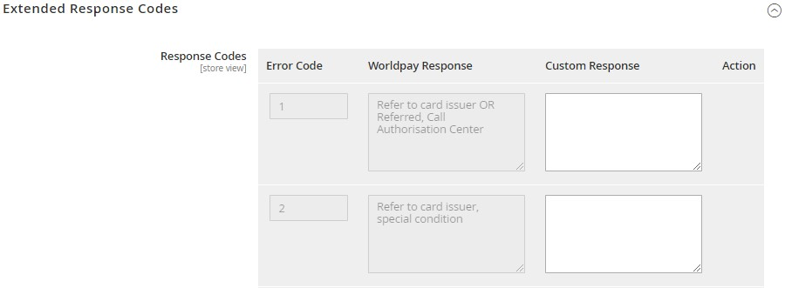

1. In the Extended Response Codes, you can review and customize the messages triggered by various response codes:

|  |  |
| --- | --- |
| **Configuration** | **Description** |
| **Error Code** | The unique ISO code within the response sent by Worldpay. |
| **Worldpay Response** | The messages sent by Worldpay with each ISO code. |
| **Custom Response** | This enables you to override the messages Worldpay sends. |
| **Action** | If a new message is needed during any future development, a Delete icon appears so you can delete any old or incorrect messages. |

### The shopper’s experience

Go to Store front/login/Add to Cart/Proceed to Checkout.

In the screenshot below, the magic code REFUSED5 returns this gateway response message from Worldpay:

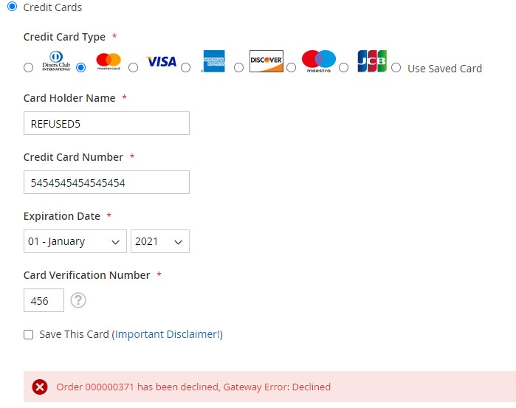

In the screenshot below, the magic code REFUSED13 returns this custom gateway response message from Worldpay:

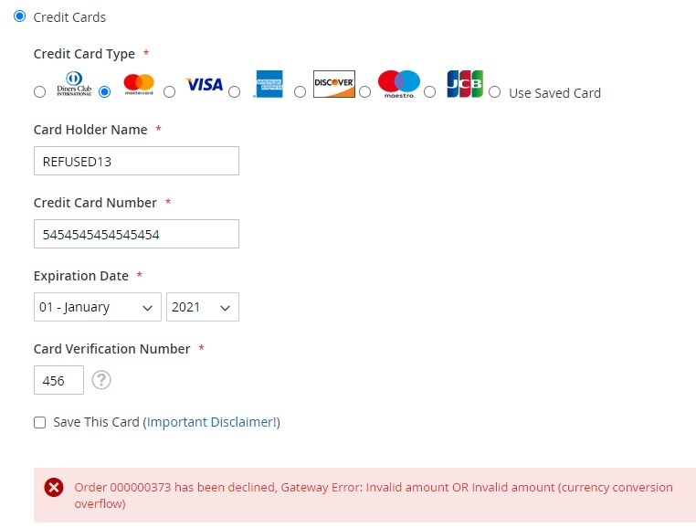

See the online [Test Values](https://developer.worldpay.com/docs/wpg/reference/testvalues) and [Useful Tables](https://developer.worldpay.com/docs/wpg/reference/usefultables) guides for more details, and to access more codes.

## Configurable labels

This section describes how to customize labels shown to the user and shows developers how to implement these messages in the plugin.

1. To begin the configuration, go to Store/Settings/Configuration/Sales/Worldpay Custom Labels.

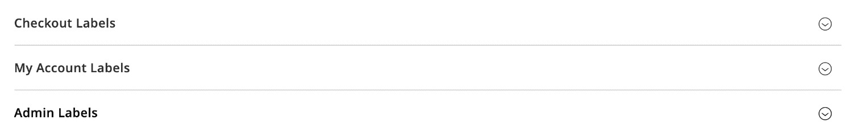

You can configure labels as per the three sections provided; checkout labels, my account labels and admin labels.

### Checkout Labels

Use this screen to configure checkout labels:

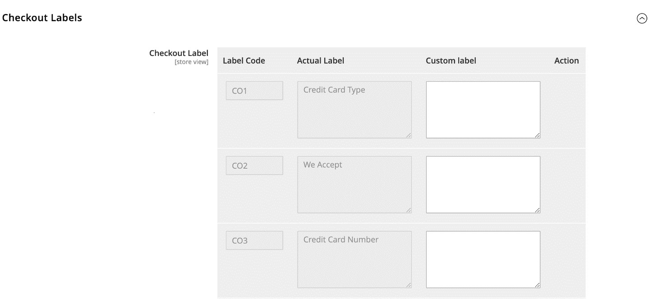

### My account labels

Use this screen to configure My account labels:

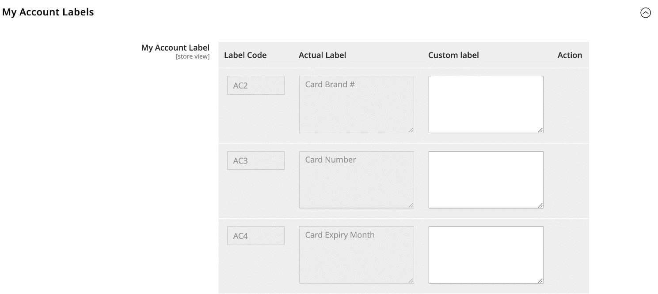

### Admin labels

Use this screen to configure Admin labels:

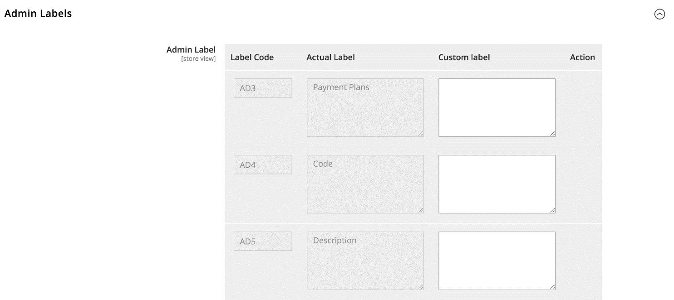

|  |  |
| --- | --- |
| **Configuration** | **Description** |
| **Label Code** | It is a unique code number assigned to labels. |
| **Actual Label** | This displays the default label description already available from Worldpay |
| **Custom Label** | This enables you to add a custom label description against actual label and this label will be displayed to the user. |
| **Action** | If new configuration is to be added by clicking the add button, there is an option to delete this configuration before clicking on save. |

You can add a new configuration at the end of each section using the **ADD** button provided, once the admin/developer adds new configuration, as a developer you can further use it in the plugin.

**Example**

As an example, consider the scenario below, the default label for credit card type as per our configuration is – *Credit Card Type*.

If you have not provided any custom label against this then the default label appears to the user.

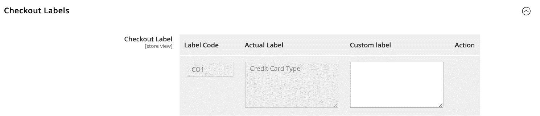

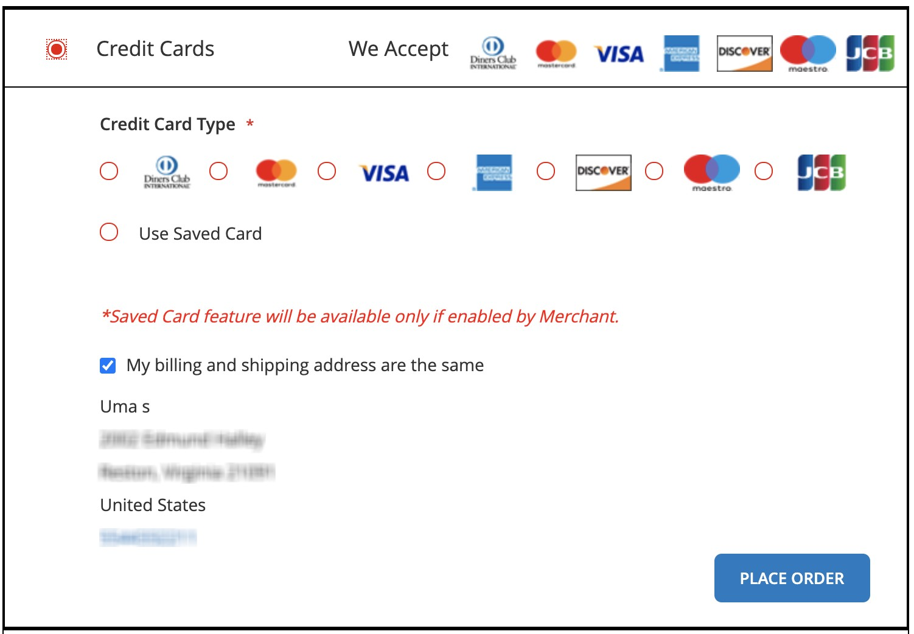

If you have provided a custom label, then this custom label is shown to the user.

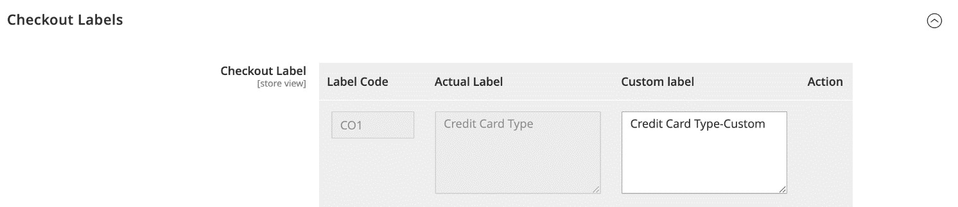

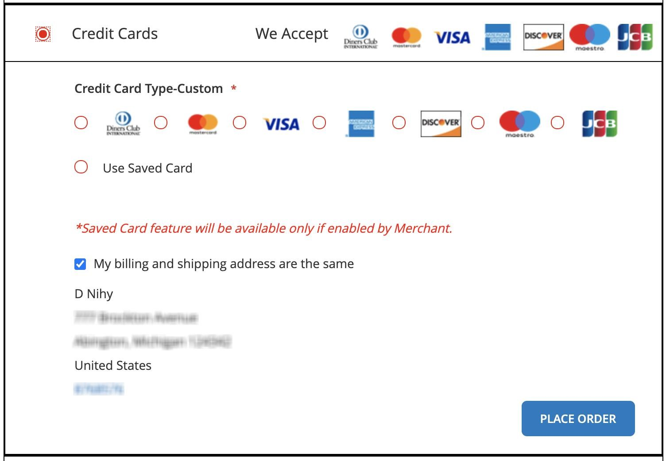

**Note**: These configurations are only applicable for default labels provided by Worldpay and not for the labels provided by Magento.

## Custom logo for payment

You can upload a new custom logo/icon for every payment method.

To begin the configuration, go to Store/Settings/Configuration/Sales/Worldpay Logo Personalization of Payment Methods

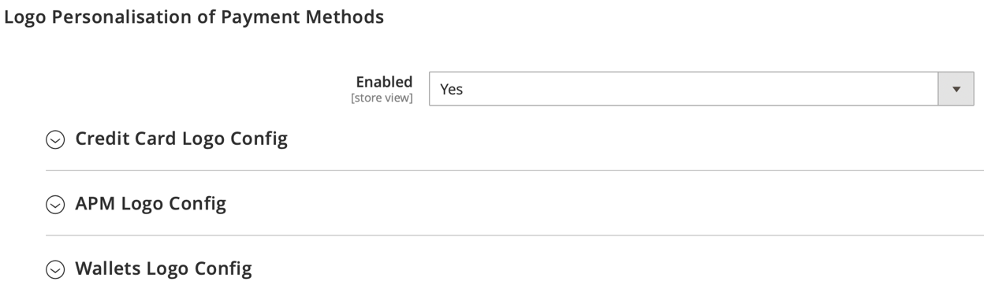

Select the payment method and upload the new logo/icon.

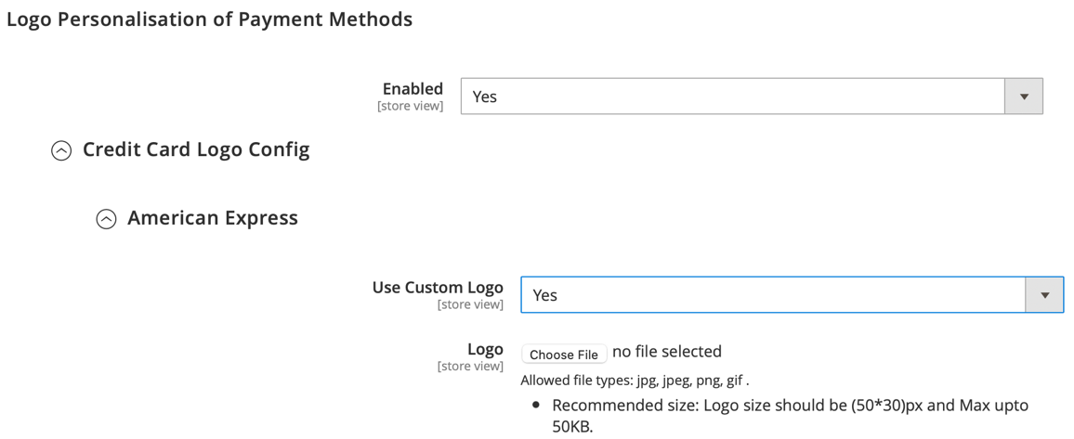

## Global APM API Call

Please enable this to display all payment methods to the shopper if different payment methods are mapped under different merchant codes and this is configured under Merchant profile override configuration section. We recommend this to be set to `Yes`.

To enable this feature, go to Store/Settings/Configuration/Sales/Worldpay Load Payment Methods from Multiple Merchant Code

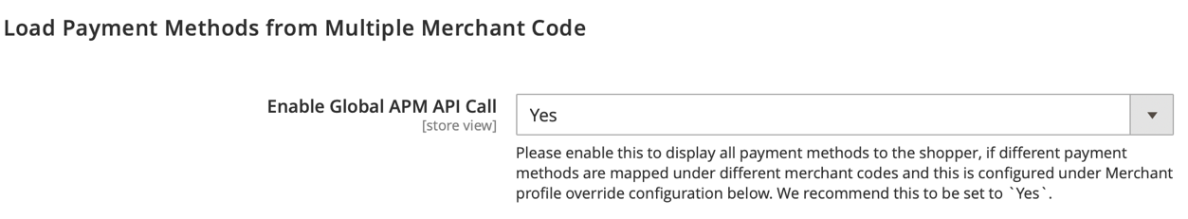

## Worldpay API security alerts

This feature enables you to receive the API security alerts and report the incident to Worldpay if the option "Do you want to report the error to Worldpay?" set to “Yes”.

To enable this feature, go to Store/Settings/Configuration/Sales/Worldpay Worldpay API security alerts

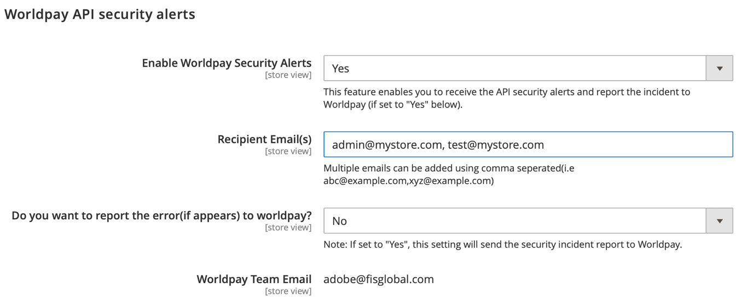

## Worldpay Multi Shipping

This feature enables you to support multi shipping feature on Worldpay payment orders.

To enable this feature, go to Store/Settings/Configuration/Sales/Worldpay Worldpay Multi Shipping

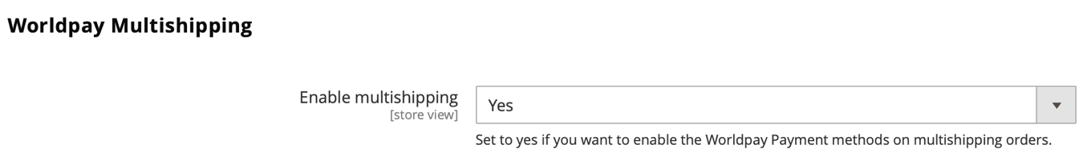

### The shopper’s experience

Go to Store front/login/Add to Cart/Cart/ Check Out with Multiple Addresses

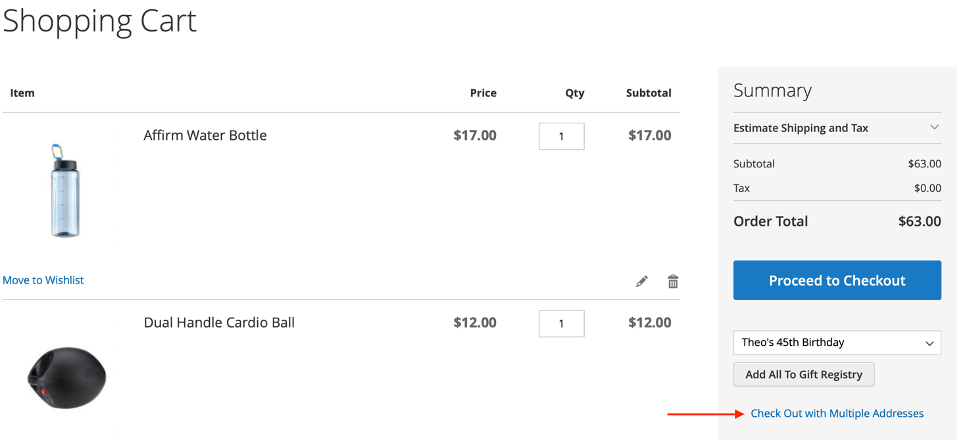

Change the shipping address and click on “Update Qty & Address button” as below then click on “Go to Shipping Information” button

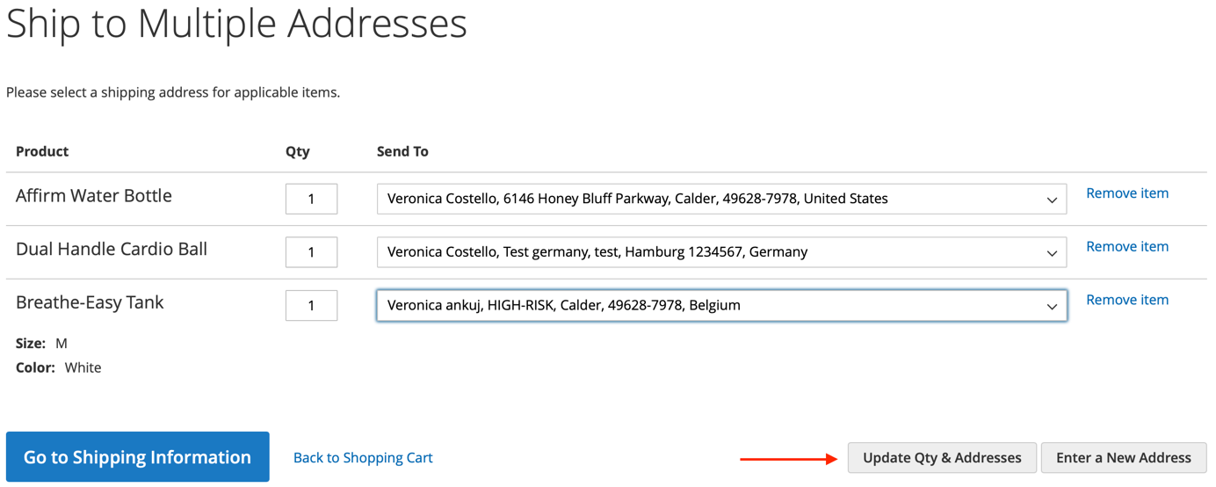

Update the Shipping method for each product and click on “Continue to Billing Information”

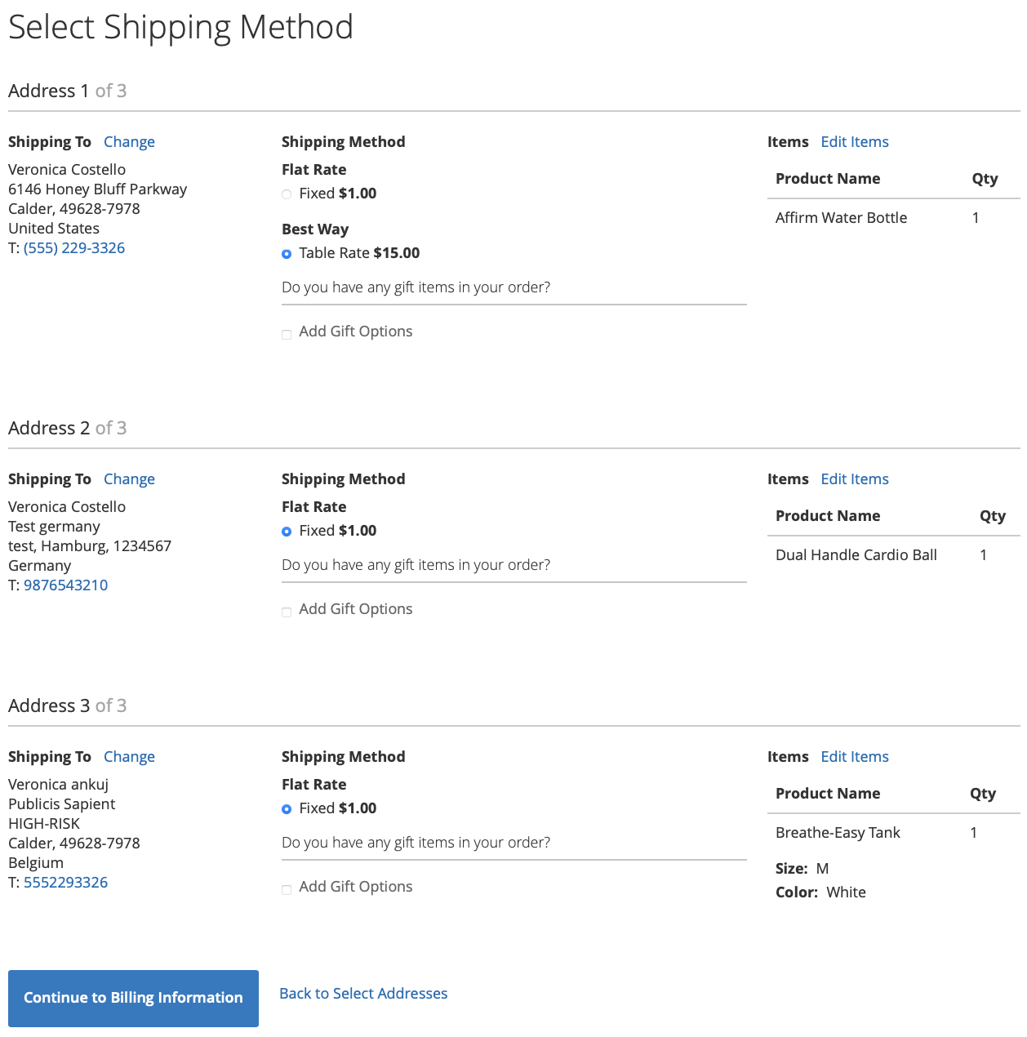

You can change the Billing address here or you can use any one of payment types for the Place Order

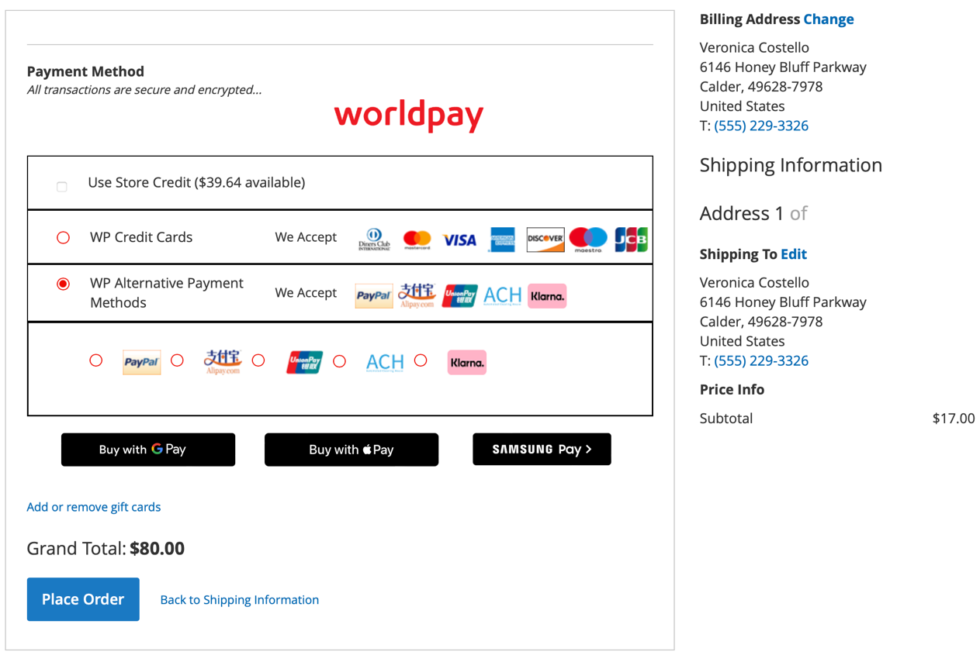

## Worldpay Pay by Link

This feature creates a payment link as an alternate way for your shopper to make payments. Shoppers can pay using a secure payment link hosted by Worldpay. This secure payment link will be shared with shopper by email.

To enable this feature, go to Store/Settings/Configuration/Sales/Worldpay Pay By Link

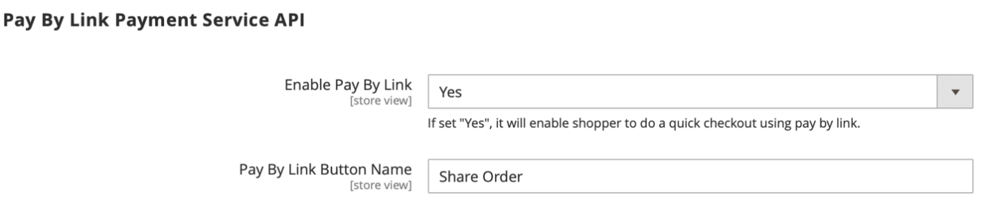

### The shopper’s experience

Go to Store front/login/Add to Cart/Cart/ Checkout Page

You can see Share Order button

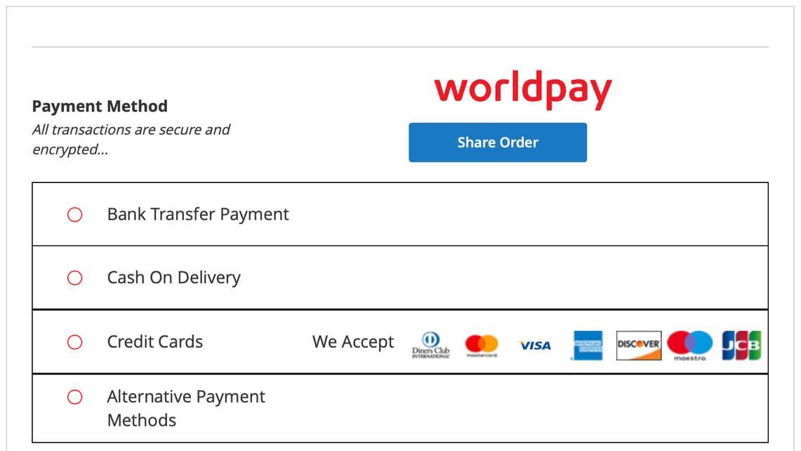

After clicking Share Order button, shopper will be redirected to order success page and a secure payment link will be share via email.

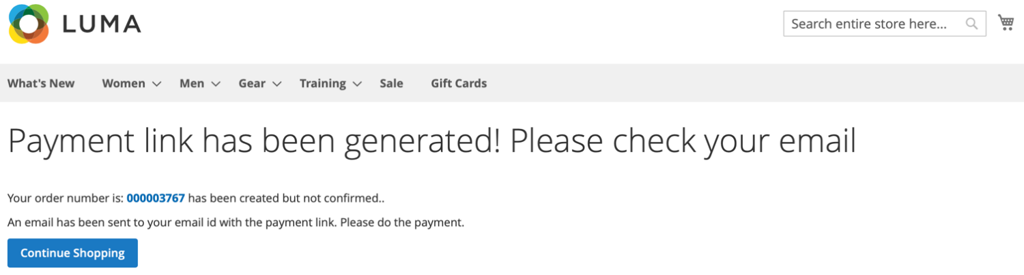

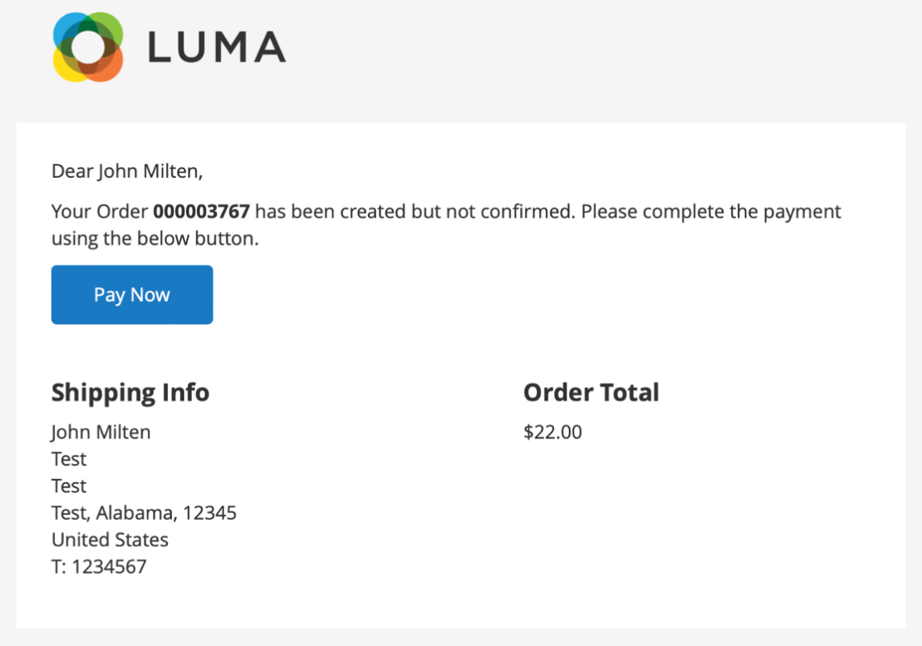

Once you click on the Pay Now button you will be redirect to Worldpay Hosted Payment page,

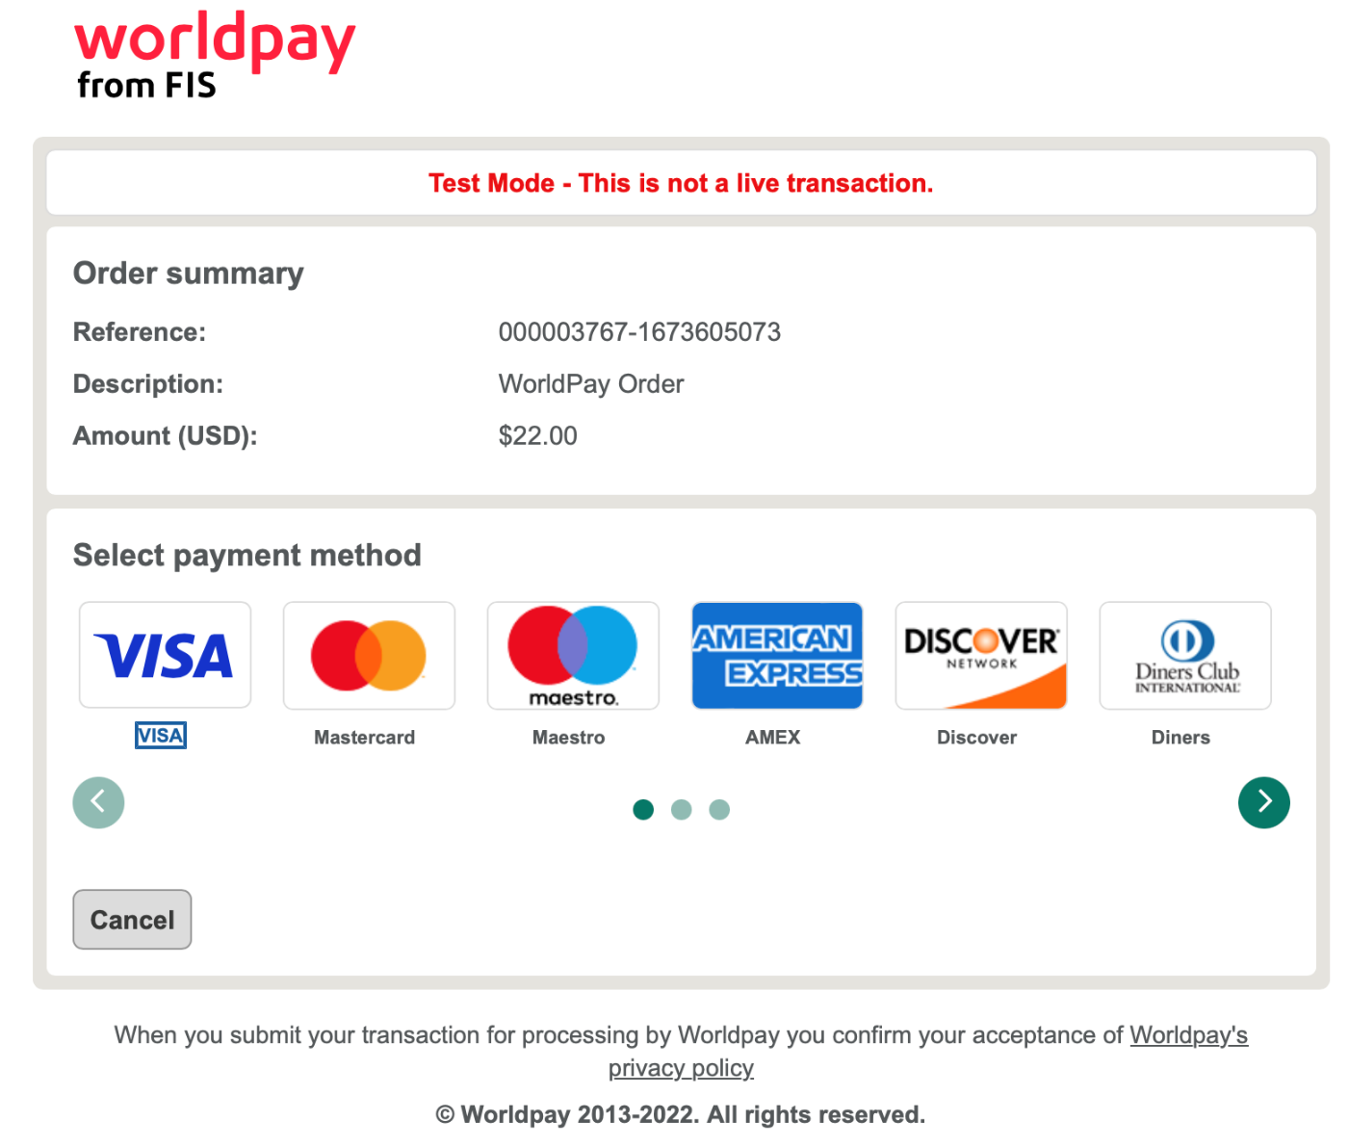

You must select the payment method which you want to proceed,

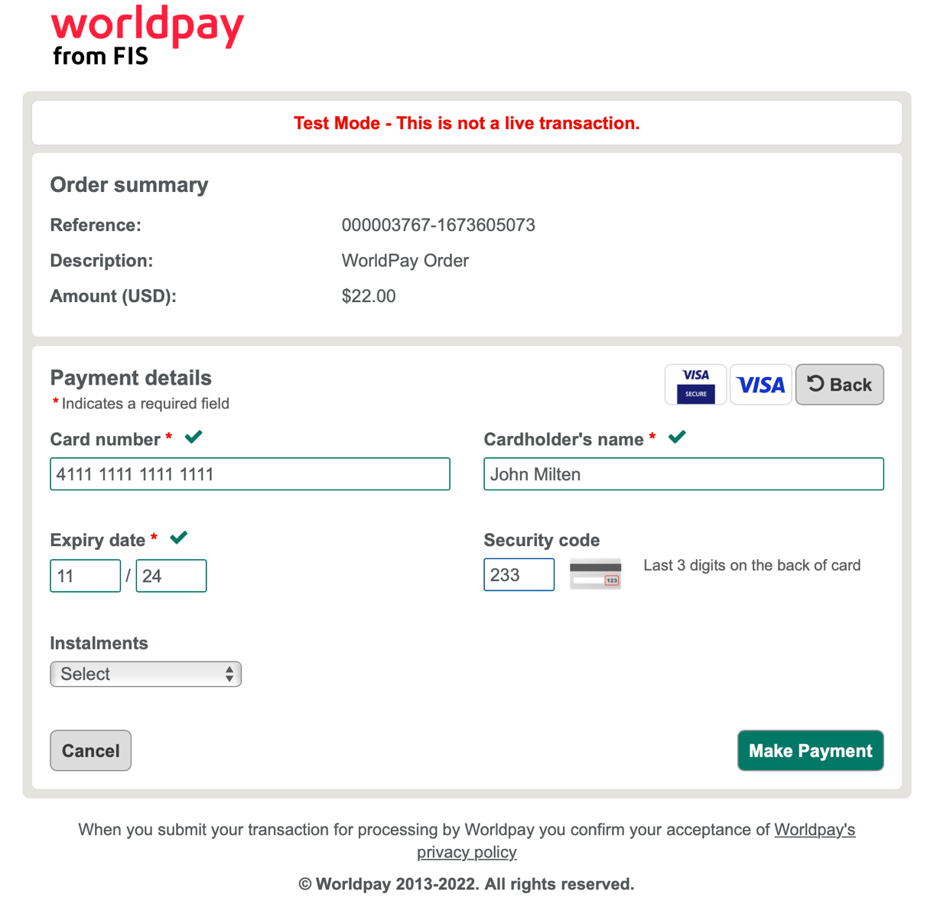

After entering the card details and successfully completing the payment, shopper will be redirected to order success page.

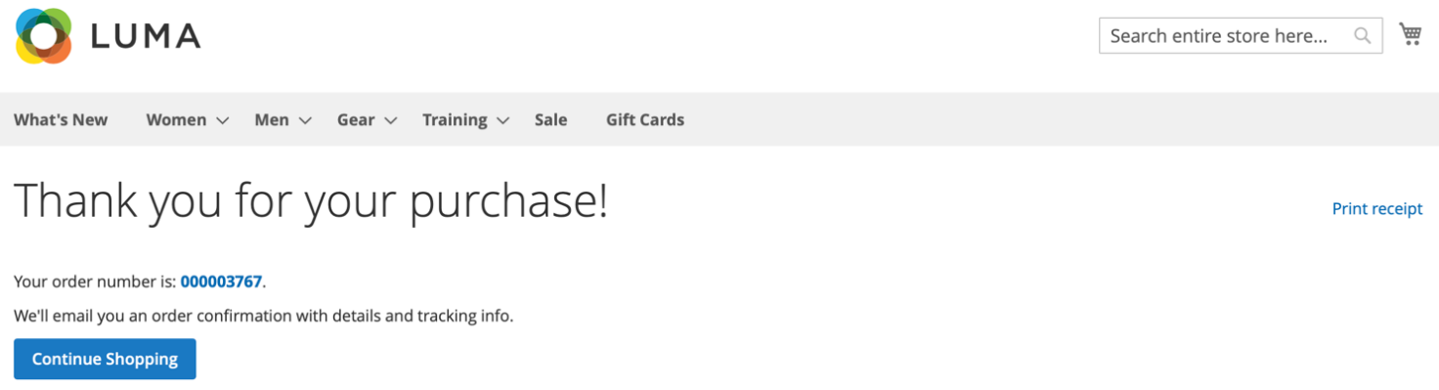

## Eftpos Payments Australia

EFTPOS AU payments is an Australian domestic card scheme, supported by Worldpay as an acquirer. It facilitates multi/dual debit transactions in real-time with a lower cost of acceptance. Merchants interested in offering EFTPOS services must have a business entity in Australia.

**Product Capabilities**

Payment Type: **Card**

Country: **Australia**

Acceptance Currency: **AUD**

Settlement Currency: **AUD**

Service Level: **C**

Value-Added Services (VAS): **3DSv2, Stored Credentials, Mobile Wallets, WPG Tokenisation**

Integration: **Direct**

Transaction Type: **Sale, Refund**

**Note: The product is still in beta mode. Some features are currently under testing or in the development phase**

### Admin Configuration

You can locate the Eftpos configuration at the following path:

Login to the admin panel -> Navigate to Stores -> Configuration -> Sales -> Worldpay

Expand the "Eftpos Payments Australia" section to access the admin configuration settings for Eftpos.

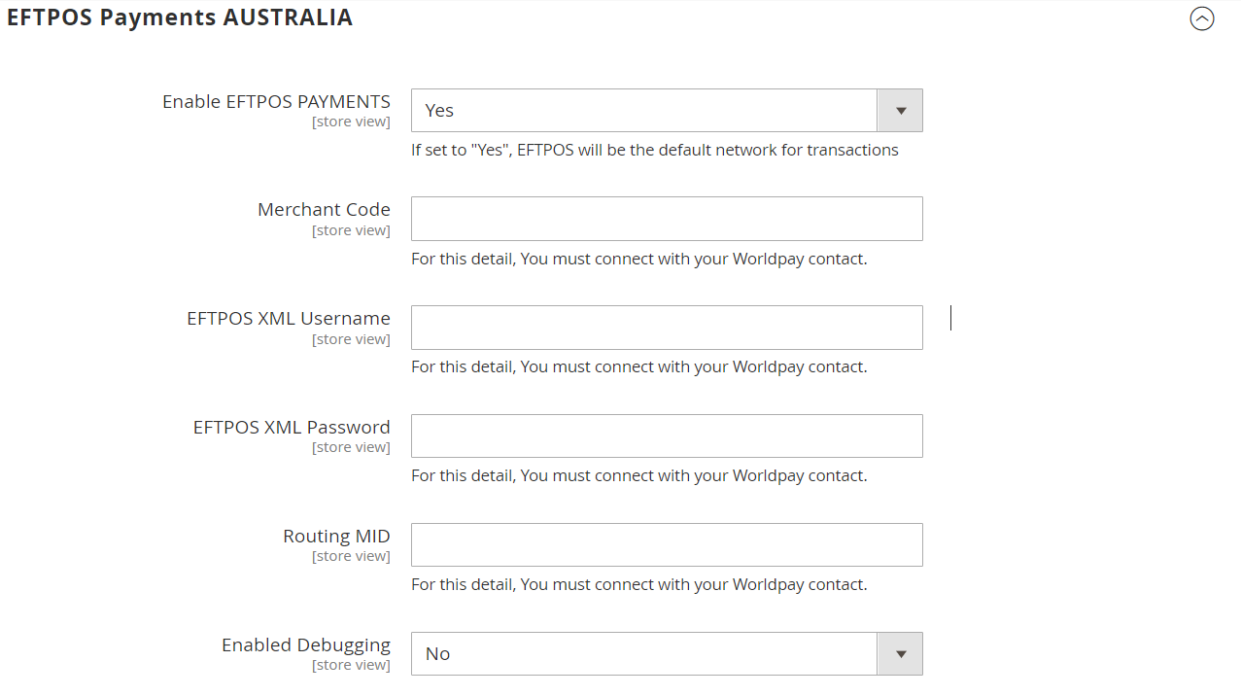

When you enable Eftpos with the mode set to "Direct," all transactions will be processed via the Eftpos AU network. It's important to note that EFTPOS does not support the "Redirect HPP" mode. Therefore, if a merchant has enabled EFTPOS and set the mode to "Redirect," Eftpos functionality will not be available.

Eftpos operates similarly to Credit/Debit Direct checkout, with the primary difference being the handling of transactions, which is managed by Eftpos.

**To obtain configuration details for EFTPOS**

1. Connect with your Worldpay relationship manager, who will facilitate onboarding with Eftpos AU.

2. Access the Merchant Admin Interface (MAI) to retrieve these details.

### Least Cost Routing

When a shopper makes a payment (with their multi-network card) you may choose to send the transaction via the debit network of their choice, achieving a lower cost of acceptance.

Worldpay can configure your routing preferences to route all eligible transactions to a specific scheme. Contact your Worldpay Relationship Manager or support team to have this set with your scheme preference. The route is set to prefer EFTPOS by default.

You can also determine scheme preference at the transaction level using the Routing MID Configuration in admin.

### 3ds Process

To enable 3DS, merchants must obtain the 3DS configuration details from MAI (Merchant Acquirer Interface). Afterwards, they need to enter these details into the 3DS configuration section found at the following path:

Login to the admin panel -> Navigate to Store -> Configuration -> Sales -> Worldpay -> Credit Card 3DS Authentication

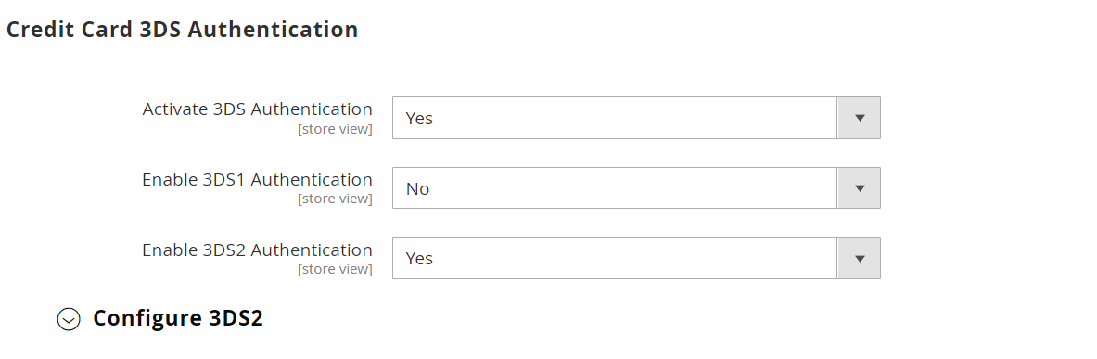

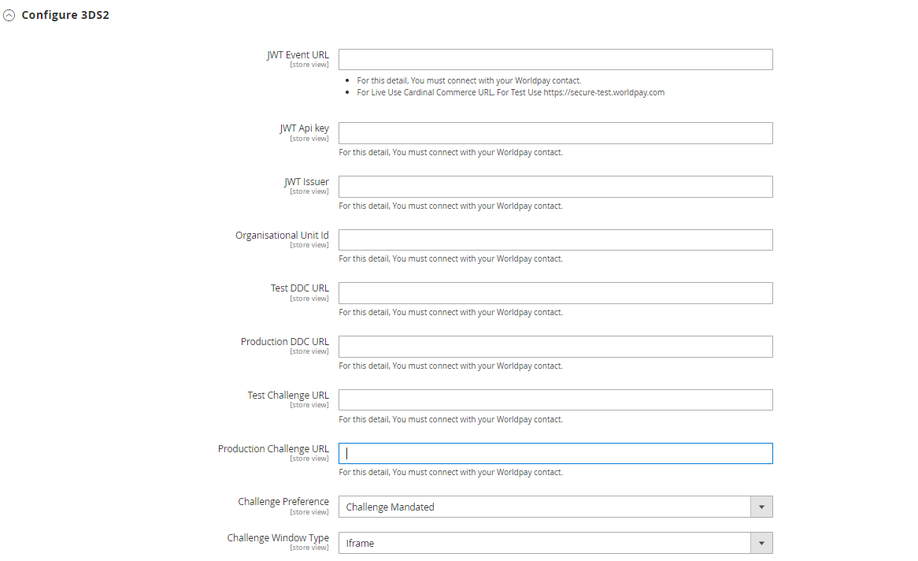

### The Shopper’s Experience:

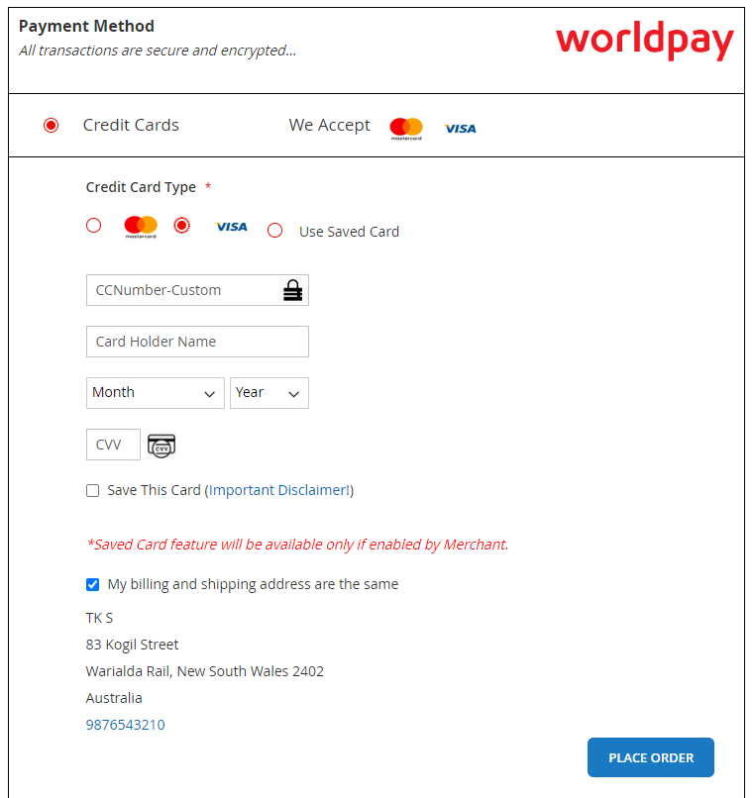

Sample XML requests and responses can be referenced at the following link:

<https://developerengine.fisglobal.com/apis/wpg/eftpos>

### Invoice Processing, Shipments, Refunds:

The process of generating invoices, creating shipments, and processing refunds is the same as for regular orders in Magento.

### Content Security Policy Compatibility

The module is compatible with Content Security Policy. If you need to add new domains, use your website’s csp_whitelist.xml file, as described in the Magento documentation.

## How to report bugs

Please [report any bugs on GitHub.](https://github.com/Worldpay/Worldpay-Magento2-CG/releases)